Sir/Madam 6 June 2019

SUMMONS TO ATTEND A MEETING OF THE COMMITTEES
OF CASTLE DONINGTON PARISH COUNCIL

Date: Thursday 13 June 2019

Time: 7.30pm

Location: The Community Hub, 101 Bondgate, Castle Donington,
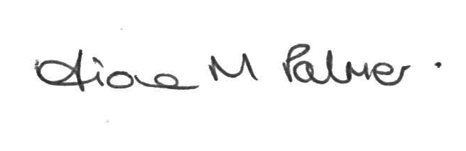
Fiona M Palmer
Clerk to the Council

Public Participation

Members of the public may make representations, give evidence or answer questions in respect of any matters included on the agenda. At the discretion of the Chairman the meeting may be adjourned to give members of the public an opportunity to raise other matters of public interest.

A G E N D A

- Apologies for absence to be received and accepted by the Parish Council

- Disclosures of Interest – Under the Code of Conduct members are reminded that in declaring disclosable interests you should make clear the nature of the interest and whether it is pecuniary or non-pecuniary

- Recreation Committee
- To review the Committee Terms of Reference
- Discussions around future leisure and recreation projects with other bodies are on-going. No further reports to date; waiting for information form other parties.

- Amenities Committee
- To review the Committee Terms of Reference
- Events
- Music in the Park – Update from briefing meeting
- Celebration of Volunteers / Community Hub Official Opening event – Update

- Planning Committee
- To review the Committee Terms of Reference
- To formulate the Parish Council’s ideas for the proposed traffic calming on High Street and Bondgate

- Planning applications
19/00076/REMM | Land to the South of Park Lane | Re-consultation - Erection of 213 dwellings and associated works (Reserved matters to outline planning permission ref 16/00465/VCUM)
18/01893/REMM | Land off Park Lane | Re-consultation - Erection of 175 dwellings, garages and associated infrastructure (Reserved matter to outline planning permission reference 16/00465/VCUM)
19/00997/FUL | 61 Huntingdon Drive | Erection of a single storey front extension
19/00970/FULM | Plot 2B, Willow Farm Business Park | Erection of building for B1(c), B2 and B8 uses (including capability of sub divisions into two units) together with associated roads, car parking, service yard, fencing and landscaping
19/01046/TCA | 9 The Spittal | Felling of three no. ash trees
19/01000/ADC | Plot 1, East Midlands Gateway | Display of four internally illuminated fascia signs and three internally illuminated totem signs

  - Planning decisions
19/00165/FUL | Unit 2, Marks and Spencer Distribution Centre | Erection of two storey portable building with steel staircase | No objection | Approved
19/00557/FUL | 42 Park Lane | Erection of a single storey porch and canopy to front elevation | No objection | Approved

