Sir/Madam 5 November 2019

SUMMONS TO ATTEND A MEETING OF THE COMMITTEES
OF CASTLE DONINGTON PARISH COUNCIL

Date: Thursday 14 November 2019

Time: 7.30pm

Location: The Community Hub, 101 Bondgate, Castle Donington,
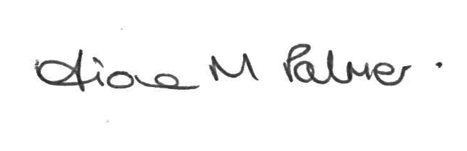
Fiona M Palmer
Clerk to the Council

Public Participation

Members of the public may make representations, give evidence or answer questions in respect of any matters included on the agenda. At the discretion of the Chairman the meeting may be adjourned to give members of the public an opportunity to raise other matters of public interest.

A G E N D A

- Apologies for absence to be received and accepted by the Parish Council

- Disclosures of Interest – Under the Code of Conduct members are reminded that in declaring disclosable interests you should make clear the nature of the interest and whether it is pecuniary or non-pecuniary

- Planning Committee
- NWLDC – Representatives to talk to the Parish Council about the public car parks, and the options for taking them on, the costs, on-going liabilities etc.
- Planning applications
19/01933/FUL | The Forge, 65a Borough Street | Proposed extension to residential curtilage and the regularisation of two outbuildings
19/02101/AIR | Land adjacent to rear Station, Beverley Road, East Midlands Airport | Proposed relocation of storage containers on land adjacent to the fire station and adjacent to fire training area
- Planning decisions
19/01788/VCU | 71 The Spittal | Variation of conditions 2, 11 and 12 of planning permission 17/00194/FUL to allow for amendments to the landscaping to the eastern boundary | No objection | Approved
19/01643/FUL | 16 Barroon | Two storey rear extension, extension and conversion of loft space and rendering of entire property | No objection as long as there are no neighbour objections | Notification of withdrawn application

- Items for including in the Precept?

- Recreation Committee
- Spital Park
- To consider quote for works to play equipment raised from the annual inspection.
- Village Hall/Moira Dale
- Update on transfer of ownership / responsibility
- Other Open Spaces
- Bentley Road/Spitfire Road open space/pathway – Update on works for new fence/tree planting
- To consider works and upgrades for CCTV/alarms/fire alarms in the Parish Council buildings – deferred from Full Council
- Items for including in the Precept?

- Amenities Committee
- Events
- Remembrance Day – Update
- Christmas Cheer – Update
- Items for including the Precept?

