Budgeting Information for 2023/24

Purpose of the report

The purpose of the report is to advise and explain the process of reviewing and setting a budget

NALC/LRALC, LCC, SLCC have been offering information, meetings and training sessions to all parish and town councils to assist with the preparation of the budgets for this year due to the unprecedented issues being experienced by everyone.

I have tried to collate some of this information to ensure that the Parish Council is able to make an informed decision regarding its budget for 2023/24 and ultimately its precept request.

Background information

Financial Year

The information below relates to the financial year beginning on 1 April 2023 and ending on 31 March 2024.

What is budgeting?

A budget is a financial plan for a specific period.
All town and parish councils, no matter of their size, have a statutory duty to produce an annual budget.

The budget must be prepared and approved before setting the precept. This allows for councils to plan for future projects, flags up any under or over send and then allows for an appropriate precept to be set.

There are different budget approaches:
- Incremental method.
- Zero based budget.
- Forecasting.

For the purposes of the Castle Donington budget and precept setting, a mixture of incremental and forecasting has been used.

The current year figures have been reviewed in terms of identifying activities that happen on an annual basis, which have happened in the current year and won’t happen again and also identifying anything that hasn’t happened in the current year but will in the future.

Part of the budget process is to assess the levels of income. For Castle Donington, there is a considerable amount of income received from hiring its facilities, and this can be used to offset the final precept requirement.

A council should provide for contingencies and consider the need for balances. Some councils may have certainty in their spending plans, but others do not, especially those with a large portfolio of facilities. Contingencies should be included for the unknown but should not be excessive. Councils might work to the principle that it is better to raise cash from a higher precept, and not use it than to set the precept too low, and so run out of cash and run the risk of incurring an unlawful overdraft.

A well managed council will look beyond the current year and think about future substantial commitments. To this end, Castle Donington Parish Council has a well documented Reserves Policy and Earmarked Reserves documents and Business Plan (Medium Term Planning).

All local councils must hold general reserves and may hold earmarked reserves. There is no limit on earmarked reserves which are held for a particular purpose. Having healthy general reserves gives a council more options, particularly in an operating environment that is uncertain (no more obvious than through the recent Covid Pandemic). The more asset-rich a council is the closer to the 12 months of general reserves it should try to achieve.

LRALC would advise that councils should not adopt a position of zero increase to its precept, based primarily on adopting a principle that it cannot increase its precept during a cost-of-living crisis.

This may be achieved by thorough budgeting processes; however, this is unlikely to actually save the average household more than a few pence a month. If a local council does agree to this principle, it needs to clearly state how this can be achieved and from where the additional cost increases will be funded from.

The Practitioner’s Guide is a helpful resource on budgeting; the latest copy is available to download at https://www.nalc.gov.uk/nalc-blog/entry/2053-practitioners-guide- 2022%E2%80%93more-interesting-than-you-thought%20

Some known and basic facts/information for this year:

Cost-of-Living Crisis

There is a lot of discussion around the cost-of-living crisis, and how an individual maybe affected by any potential increases. Consideration should be given to the increased levels of those who are able to apply for and receive assistance with their council tax. Also, councils should consider that they have the ability and powers to allow them to support local groups and charities, and therefore may wish to increase the availability of this grant funding to help during the cost-of-living crisis.

Precept Referendums

Unlike principal councils, parish and town councils are not restricted in the increases that can be applied to precepts. The Council Tax Referendum Principles do not apply to parish and town councils currently. This has been confirmed again for this forth coming year

A number of District, Borough, and County Councils have gone on record as saying that the cost-of-living crisis is causing a funding gap far worse than anything experienced previously, including austerity. Historically, these higher tier authorities have been “capped” at 2-5%. This year, it has been confirmed that these higher tier authorities are able to raise the council tax by up to 5% without the need to go to Referendum.

LCC is consulting on an increase of 5%; the agreed higher level allowed. This includes an additional (3% core and 2% Adult Social care) (part of its manifesto principles). This equates to a band D rate increase of £1.39 per week.

NWLDC is consulting on proposals to freeze its council tax portion by making further efficiency savings.

Inflation Forecast

The latest Consumer Prices Index (CPI) annual rate is 11.1%. Clearly, the economy is volatile and subject to external forces, not least global energy prices, which have been affected by the war in Ukraine, so all forecasts are inherently unreliable.

For the purposes of the Castle Donington budget, a 10% increase is added to most of last year’s figures (although not all). Utilities were increased by about 50% last year and are still looking like being over this projected increased amount. Therefore, an estimated end of year figure has been worked out, then a 10% increase added to this. All facilities should be in fixed contracts by the end of this financial year.

Salaries

The national negotiations on salaries for 2022/23 have recently concluded (October 2022). The agreement is to add £1,925 to every salary scale, which is equivalent to £1/hour. This equates to a 9.8% increase for clerks in the lowest band, and a 2.43% increase for clerks on the highest band. The majority of clerks will see a 7 – 9% increase. This is backdated to April 1st, 2022.

Service Devolution

Neither principal authority has confirmed any plans for wholescale devolution of assets or services in 2023/24, although the door is likely to be open to requests from individual parish and town councils. However, the financial situation looks bleak and nationally most principal authorities are reporting in-year overspends. Leicestershire County Council is reporting a huge funding shortfall, for example: Leicestershire County Council deficit set to increase by millions - BBC News

LCC is one of the lowest funded councils within the country. It is currently lobbying to the Fairer Funding Lobby and would welcome the support of town and parish councils. (Information to be sent to town and parish councils by LRALC).

It is inevitable that the district, borough, and county councils will focus first on their statutory obligations, so discretionary local services may be under increasing threat. It is impossible to accurately advise councils what they should put in the budget for 2023/24 to make up for services that may or may not be devolved in the future, but all parish and town councils are advised to ensure that they have good reserves so that if a service or asset is identified for devolution in 2023/24, the council at least has the option to consider it.

LCC has confirmed that it will be focusing on its core statutory duties and the principles of its election manifesto. LCC will look at ways local councils could potentially work with them to retain service provision. Town and parish councils may have the option to take on possible other devolved services. CDPC already maintains eth urban grass verges on behalf of LCC. It is hoped that this information will be available within the next 3 months.

Elections

LRALC advises councils to budget for a quarter of the cost of an election each year to help smooth out the peaks. Costs for contested elections are still being collated by LRALC (many BC/DCs have not yet set them), so councils should ensure they have costs allocated for the scheduled elections in May 2023 based on the 2019 fees plus a 10% increase.

It will not be known if the Parish Council will have an election or not until just before the election itself, it must budget for a contested election as the costs for a small parish council could be equal to a quarter of their normal annual budget. Realistically there could end up being 3 elections for Castle Donington, for the three wards.

If the money is not used it can be held in earmarked reserves for a future election, or vire to another project.

Training

All councils should ideally have a Training Statement of Intent (policy) and should allocate a budget for training for councillors and staff (in line with the agreed Training Policy) (https://www.cdpc.org.uk/policies-and-strategies.html) .

The 2023-24 budget covers an election year and the parish council’s training needs will be higher than at any other point in the election cycle due to the new councillors who will join the council therefore sufficient money should be allocated to train new councillors, but also to train new and young staff members and allow the growth of well informed and trained Team of staff and councillors.

Council Tax Base

The Council Tax Base is calculated by first identifying the total number if dwellings in a Parish. This figure then takes into account the number of discounts and exemptions. It also includes a bad debt provision of 2.5% of the base and growth has been applied for the non-collection and banding appeals. (This remains high to reflect the expectation of the high level of bad debts).

The formula is:
Precept | = | Band D Council Tax Rate
Council Tax Base

NWLDC has confirmed the Council Tax Base figures for 2023/24 is 2857.

LRALC

LRALC has been reviewing its budgets, and thus for the service provision. The following information gives a guide to the proposed increases, which are part based on confirmation population levels.
- Membership fees – Circa 30% increase.
- Training fees – Circa 10% increase.
- Internal Audit fees – Circa 10% increase.

Matters specific to Castle Donington Parish Council

Utilities

All of the Parish Council utility services are in, or will be, fixed term contracts by the end of the year, allowing maximum access to the government support grants.

Last year, the budget increase was 50% on the previous year for utilities. In some cases, this won’t be enough to cover the bills. Therefore, an anticipated spend by the year end in March, plus a further 10% increase is included for in the draft budget.

In terms of cost savings on utilities, LED lighting is installed throughout all of the Parish Council facilities. Most facilities have sensors so lights will go and off automatically. Heating in the facilities is kept to a minimum and only on when the facility is in use; otherwise, it runs with a frost stat.

Parish Council facilities/land portfolio includes:

- Community Hub – large hall, 3 hirable meeting rooms, library Parish Council offices, Community Café, Volunteer Centre office, Community reception and Community Library.
- Spital Park pavilion – large hall, 6 changing rooms, refs’ rooms, and 11 sports pitches.
- Bowls Club pavilion and Dovecote.
- Village Hall.
- Moira Dale sports pavilion – small room, refs’ room, 4 changing rooms and 3 sports pitches.
- Castle Donington college access to 2 sports pitches and changing facilities.
- Allotments 177 plots.
- Cemetery circa 2120 plots.
- St Edwards closed churchyard.
- 13 play areas.
- 4 playing fields.
- Various open spaces.
- Common land.

Future staffing requirements

Staffing is reasonably stable currently, although the age demographic means that planning for future retirements, and training of newer staff is required.

The Parish Council will inherit 2 new play areas and a very large parcel of land in relation to the housing developments off Park Lane. Plus, it has also agreed to purchase land behind Moira Dale. This increase in facilities again, will put a strain on the existing staff members in and outside of the office and is likely going to require ½ to 1 person equivalent for grounds staff. Potentially similar for the office because of the increase enquiries etc. from taking on more.

Reception at the Community Hub has had the benefit of having a number of voluntary staff helping to keep this running. This does save costs for the Parish Council but can be reliable at times and unpredictable. Currently we are running with 3 or 4 volunteers and covering the rest with office staff. This may at some point need to become a paid for position.

Caretaking and cleaning – Increased levels of usage for the Parish Council facilities increases the need for more caretaking and cleaning. Due to the Pandemic and the effect this had on bookings, then the additional facility being taken on by the Parish Council (Village Hall), the caretaking and cleaning is undertaken and costed on as use basis. It is hoped that a clearer pattern will emerge allowing these staff members to be paid on an annual hour’s contract. There is also the need for additional staff members, to cover for sickness and holidays.
It is anticipated that another 1 or 2 people may be needed to share the load for all of the facilities. This may have some effect on the costs, if use increases significantly, and in which case the increased revenue coming in would cover the additional costs for the staff.

Community Café – This is a thriving venture, and the usage is steadily increasing on a weekly basis, since reopening after the Covid Pandemic closure. There are a number of staff, paid on a part-time basis, covering the opening hours of 6 days a week. There will be a need to review the staffing requirements during the first 6 months of the year due to a forthcoming retirement (s). This should not have any effect on the expenditure requirements, just in the makeup of the necessary staff to cover the hours of use.

Community events

The Parish Council agreed to continue to put on the existing events in some form at the December Full Council meeting.

There is an opportunity to work with a local events group to help with the events, from marshalling, ideas, grant funding, sponsorship, etc.

May event
This is to continue on the first Monday in May, and will this year be themed royally in recognition of the Coronation of King Charles 111. £2000 set in budget to cover costs. Additional amount in budget to cover for a one-off item to celebrate the Coronation. Anticipated income costs included in budget setting for stallage.

Summer event
No sponsorship received to date from last year’s Download event at Donington Park.
Information and opportunity explored to allow this event to be outsourced and save the Parish Council money, potential risk and liability. This initial opportunity has been lost.
It is not safe and practicable to pick up the existing event and continue. A complete rethink of what, if anything, will be feasible for a summer event.
Small amount left from unspent sponsorship funding. £5000 put in budget to cover potential event. No income stream included as this is an unknown.

Remembrance parade
This will continue working in collaboration with the Castle Donington and District Royal British Legion. It does require the support and assistance of additional marshals. Grant allocated in budget to be paid to British Legion as a contribution towards the costs of the event. No income stream included.

Wakes street fair
This will continue to be organised in conjunction with the members of the Showmen’s Guild. It does require the support and assistance of additional marshals. Income and expenditure streams included in budget setting.

Christmas Cheer
This has grown to a size that a rethink in the format is needed. There are a number of suggestions been received from parties that are used to putting on similar events. These will be explored, and a plan brought back for future discussion. £5000 put in budget to cover potential event. No income stream included as this is an unknown.

Community Hub
There are a number of events working in collaboration with the Volunteer Centre and Community Library.
These will continue to be provided and put-on as many receive grant funding or are cost neutral. No expenditure included in budget setting.

Facility information

Turf allotments
- 177 allotments
- 2 currently vacant with viewings taking place
- 11 on the waiting list
- 2 inspections/year
- Grounds team update on issues
- Occasional ongoing brook issues but Severn Trent not very helpful – still under investigation
Income for the year (to date) = £4781

Barroon Cemetery
- 2022 Full earthen graves
- 29 Half Earthen graves
- 73 Cremated Remains plots
- Garden of Remembrance – not numbered
- 27 Interments
- 18 Memorials
- 20 Exclusive Rights of Burials – new and transfers. Transfers can quite often be time consuming as there is a legal process that needs to be followed and can involve various lengthy stages. One still ongoing from March 2022.
- 2 Inspections/year but can be more if required
- Contacting EROB owners regarding various issues – unsafe headstone, unauthorised memorials/adornments etc
- ICCM membership invaluable
Income for the year (to date) = £16,695

Bookings

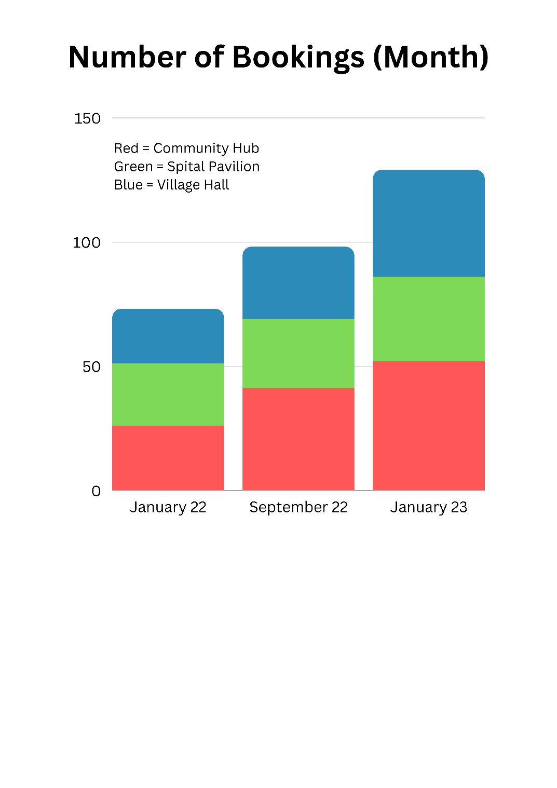
Community Hub
Income for the year (to date) =£6,613
Rent for the year (to date) = £4,192
Café income for the year (to date) = £16,748

Spital Park
Income for the year (to date) = £12,194

Moira Dale
Income for the year (to date) = £9,584

Business Plan

A draft review of the costings page has been undertaken to highlight the changes in circumstances in certain cases and for purposes of budget setting. The Business Plan needs a full review. This is part of the medium-term planning processes and will take place in the new council year (after the elections in May).
A copy of the draft revised figures and approved plan is attached for Councillors’ information.

Existing and on-going contracts

Grounds Maintenance contractor has confirmed a 2% increase. The figure in the budget is the figure quoted by them.
Dog bins and feminine hygiene contractor has confirmed no increase this year.
The Christmas lights contract is up for renewal. Quotes have been requested but not received to date.
Computer related – contract prices are all in the budget proposal. No major increases have been confirmed by any of the companies.
Hanging baskets – contract for renewal this year. Quote obtained for a four-year term at a cost of £3150 included in the budget proposal.

Climate change

Policy to be explored and created in the new council year (after the elections in May).
Carbon footprint of buildings – An energy performance assessment is required for all buildings. This is to allow for future efficiencies to be explored.
Electric charging points – need and availability being explored.
SUV – photovoltaic panels – need and availability will continue to be explored.
Wildflower planting areas – will continue to evolve, working in conjunction with the grounds maintenance contractors.
Tree planting to be explored for existing and new areas of land. This can take place in the new council year (after the elections in May) and when the new land is acquired.
Bulb planting working in collaboration with local residents to improve the visual aesthetics of the village and improve carbon footprint.

Grant requests

Castle Donington Museum has requested an increased grant again this year. £3000 has been requested. The Parish Council increased the grant this year from £1250 to £3,000 as a one-off increase. This has been included in the budget proposals for £2,000 (midway compromise).

No other increased grant requests have been received to date.

Cost-of-living grants – It may be possible to support the local community by offering more small grants to local charities and groups.

Play area improvements

A lot of the play areas are getting to an age that there may be a requirement for some new equipment. Within the Business Plan, it is recommended that this work can be funded through the Section 106 agreements.

Signage

The Parish Council facilities all need new signage. Costs have been sought and are reasonable. Costs at the Community Hub will be shared with the other main users of the facilities.

New land

The Parish Council has agreed to purchase land behind Moira Dale playing field. This is progressing.
A large area of land will be transferred to the Parish Council from the developments off Park Lane.

Both these areas will need careful planning and collaborative working with outside bodies to achieve their potential at minimal ongoing costs.

New play areas

Two new play areas will be transferred to the Parish Council from the developments off Park Lane. These will be installed by the developers and a small amount of funds for ongoing maintenance will be given by the developers, but they will increase the levels of work for grounds staff, annual inspections and ongoing maintenance and vandalism.
Section 106 funding

Money is due from the developments off Park Lane. This comes through in phases at the agreed trigger points.

Cemetery footpaths

As part of the ongoing maintenance plans and the Business Plan, it may be possible to look at improving the footpath surfaces over the next few years. This can be investigated more when the funds are available and in the new council year (after the elections in May).

Fees for Parish Council services

Separate report

Local Council Award Scheme (LCAS)

This scheme is now live again and should be explored in the new council year (after the elections).

This scheme has been designed to celebrate the successes of the very best councils and to provide a framework to support all local councils to improve and develop to meet their full potential. The scheme offers councils the opportunity to show that they meet the standards set by the sector, assessed them by their peers, and put in place the conditions for continued development.

The scheme has been designed to provide the tools and encouragement to those councils at the beginning of their development journeys, as well as promote and recognize councils that are at the cutting edge of the sector. It is only through the sector working together, to share best practices, drive up standards and support those who are committed to improving their offer to the communities that individual councils and the sector as a whole will reach full potential.

Recommendation

The recommendation to the council is to approve the budget and precept are circulated. Price per Band D resident 2023-24 being £155.69. Equivalent to 14p per week increase.

