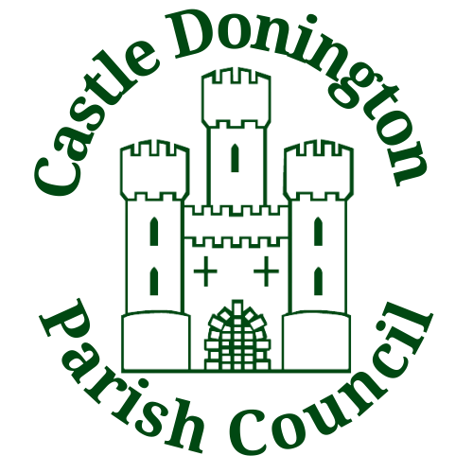

Venue Hire Prices
2024 – 2025

Community Hub Main Hall

All prices below include VAT.
Price Per Hour £19.50
Children’s Party Package (4-hour) £70.00
Friday, Saturday and Sunday Evenings Between 18:00 – 22:30 Price Per Hour £37.50

Additional Items
Use of Kitchen £11.00
50 Chairs £11.00
75 Chairs £22.00
100 Chairs £30.00
55 Inch TV £11.00
85 Inch TV £22.00
Secure WIFI £11.00
Stage £30.00
Tea/Coffee Making Per Person £0.70

Community Hub Meeting Rooms

All prices below include VAT.
Meeting Room 1 Per Hour £11.00
Meeting Room 2 Per Hour £11.00

Additional Items
Tea/Coffee Per Person £0.70
Secure Wi-Fi £11.00

Spital Pavilion Hall

All prices below include VAT.
Price Per Hour £17.50
Children’s Party (4 Hour) £53.50
Friday, Saturday and Sunday Evenings Between 18:00 – 22:30 Price Per Hour £36.00

Additional Items
Use of Kitchen £11.00
50 Chairs £11.00
75 Chairs £22.00
WIFI £11.00

Castle Donington Village Hall

All prices below include VAT.
Price Per Hour £17.50
Children’s Party (4 Hour) £53.50
Friday, Saturday and Sunday Evenings Between 18:00 – 22:30 Price Per Hour £36.00

Additional Items
Use of Kitchen £11.00
50 Chairs £11.00
75 Chairs £22.00

