Sir/Madam 14 January 2021

**SUMMONS TO ATTEND THE MEETING OF**

**CASTLE DONINGTON PARISH COUNCIL**

Time/Date:  ***7.00 p.m.*** ***on Thursday 21 January 2021***

Location: **Via ZOOM**

**Due to the Covid-19 virus and the guidance around social distancing and self-isolation, the Parish Council will be holding its meeting virtually through ZOOM.**

Join Zoom Meeting

<https://us02web.zoom.us/j/87218378817?pwd=WVdmLzZqc3loNVVpOTdKM09henJ4QT09>

Meeting ID: 872 1837 8817

Passcode: 022346

Any members of the public wishing to join or take part in the meeting, in public participation, please email the clerk at clerk@cdpc.org.uk by 12noon the day of the meeting.

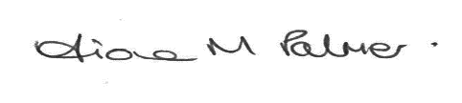

Clerk to the Council

***Public Participation***

*Members of the public may make representations, give evidence or answer questions in respect of any matters included on the agenda. At the discretion of the Chairman the meeting may be adjourned to give members of the public an opportunity to raise other matters of public interest.*

***AGENDA***

1. Apologies for absence to be received and accepted by the Parish Council
2. Disclosures of Interest – Under the Code of Conduct members are reminded that in disclosing an interest the nature of the interest should be clear in respect of items on the agenda
3. To consider and review all fees charged

* Recreation
* Allotment
* Cemetery
* May Market
* Wakes
* Music in the Park
* Community Hub

4. To approve the Precept 2021-22 **Appx A**

1. To approve the allocation of funds for the Rolling Programme 2021-22, including separate reports for the Section 106 and Bloor Homes funds

**Appx B**