Update on Traffic Matters From The Last Meeting

Website:
A dedicated page on the website has been created for All Things Traffic. It is constantly updated once new reports have been sent to us along with notes from the last meeting. You can find the page by clicking the link or going onto the Parish Council website and clicking on the popover.
Traffic Calming:
Work is to commence on the 27th of August.
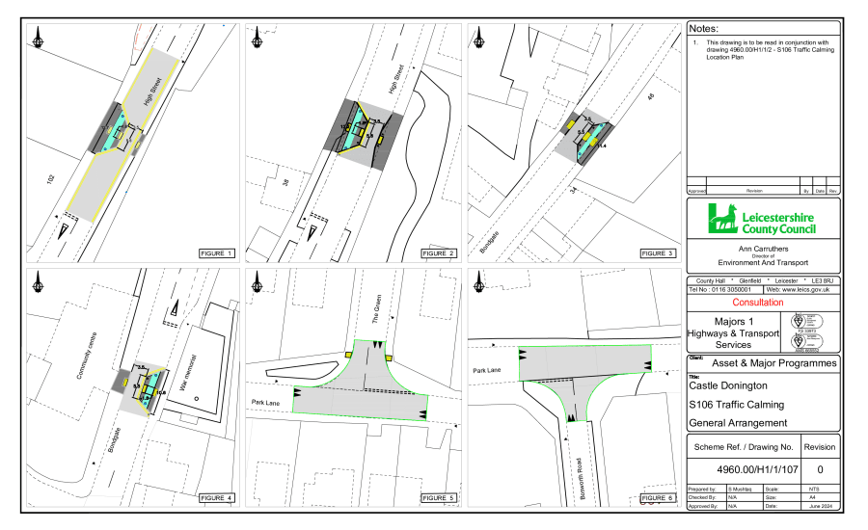
Police Traffic Survey Requested:
The Police completed 3 traffic speed surveys last November on Bondgate and the average speed recorded was 27mph. Hilltop was also completed in November 2023 with an average speed of 31.6mph, along with Broad Rushes in January 2023, with an average speed of 40mph.
Currently, Park Lane is the only area for a speed survey to take place during the school holidays this year. All other roads are listed as no survey due to pending scheme – as per LCC or no need for another survey at this stage.
Request For Average Speed Cameras:
After requesting the possibility of average-speed cameras along the Relief Road we received this response from LCC:
“With regards to your request for Average speed cameras (ASC), these are funded outside of the partnership by Leicestershire County Council, however the Police operate and enforce on our behalf. Much notice has been taken of them in Leicestershire as part of a trial that the County Councils cabinet agreed in 2017, which went operational at 7 locations throughout 2018 and 2019. Many Council Members and Parishes have asked for ASC's to be implemented within their communities to combat speeding, but also to react to general community concerns.
Cabinet members were provided with a report on the 20th October 2020 regarding the County Councils formal position to establish a Community Speed Enforcement Initiative following the trial of average speed cameras. A proposal was made to introduce community speed enforcement in communities, inclusive of a rolling programme of sites where cameras could be moved around the County. A link to the report provided to cabinet is available on the following link https://democracy.leics.gov.uk/uuCoverPage.aspx?bcr=1 However, at present the future of average speed camera installation is unknown due to the funding element.
The County Council continues to make safety improvements on its road network where this can be justified. Currently, however it is only able to make essential safety improvements, where the recorded injury accident record demonstrates that improvements should be made. With these being limited to areas with a proven casualty history higher than national average or higher than otherwise would be expected. At present the County Council's resources around road safety are being directed at remedial works at high risk locations, which have evidence of a poor accident history, with the worst recorded personal injury accident records as reported to us by the Police.
After investigating your concerns, we can advise that there have been no personal injury accidents reported to us by the Police on the Castle Donington Relief Road and 2 accidents on Hill Top within the last 5 years, which is a good indication most motorists are aware of the road layout and are appropriately using them.
Our accident data for Station Road shows there were 4 slight personal injury accidents reported within the 30mph speed limit and 2 slight accidents reported within the 40mph speed limit within the last 5 years. It should be noted that there is no evidence to suggest these accidents were attributable to speed.
It is not easy to influence speeds of some motorists who are familiar with the highway environment and drive at a speed they consider safe for the prevailing conditions. Speed is not always a factor when accidents occur. Poor driving habits such as braking late at or on a bend and simply not paying due care and attention are just several examples. Speed limits should encourage self-compliance. We would advise all motorists to drive with care and at a reasonable speed for the road layout and encourage all parties to have caution and awareness when driving. There is nothing the County Council can do to prevent poor driving habits.
The County Council has no legal powers to take enforcement action against drivers who exceed the speed limit and we therefore recommend you report all issues relating to speeding traffic to Leicestershire Police, who are the only authority who can act against motorists who drive above the speed limit. Residents can log their concerns using this link https://www.speedorsafety.com/community. They will then investigate commensurate with their other duties.”
Response From NWLDC About Noise Monitoring:
After requesting for noise monitoring the following has been received from Lee Mansfield at NWLDC.
“The vast majority of large or big bore exhausts are illegal for use on public roads. The fact they may have passed an MOT test is irrelevant as this only checks for exhaust gasses and emission legislation compliance. Big bore and sports exhaust systems are usually fitted to increase the sound emitted and this contravenes the Type Approval of the vehicle, which is an offence. There is no requirement for police to measure the sound level from the exhaust system, it only requires an opinion that the system is not standard and that it is noisier than a normal vehicle of the same specification. It is not an offence to sell these exhausts systems, but it is an offence to fit one to your vehicle and drive it on a public road. Motorists who do so would be reported to court and may face a fine and court costs. As the police do not need to know the sound level from the exhaust, the positioning of sound monitoring equipment will not be done by NWLDC as requested by the Parish Council. The most important thing is for reports to be submitted detailing the date, time of the issues and how it was impacting you.”
After speaking to Police Officer James Martindale he questions this as finding out the relevant noise levels could help with the case brought against a driver as hard evidence, not just his word when in court.
Village CCTV Update:
We had an update from Lee Mansfield on the 2nd July:
“Firstly the project is introduce permanent CCTV into Castle Donington is a project I have been involved in for a couple of years now and I share your frustration with the delay in getting the installation completed. At one stage in 2023 it did look like we were going to overcome the legal issues around obtaining permissions from the land owner to site the data box in our preferred location, however this did not happen. I have asked Paul Collett to work with BT and Proudcastle to find an alternative location for the data box. The project consists of six cameras, two fixed cameras and four cameras with an ability to move and tilt up and down and left and right. All cameras will be monitored from the CCTV control room at Whitwick Business Centre. The camera locations detailed in the project plan are both Borough Street and Clapgun Street, however we are happy to review their proposed location, if that is something you think would be useful.”

After this, we questioned why the number of cameras had changed and then Lee replied.
“The change to the original plan, which showed 8 cameras is camera 1 (located near to the bus stop on Bondgate) cannot be installed for technical reasons (we cannot get a good enough signal unfortunately)

Cameras 2 through to 8 on the plan you refer to remain in the plan.”

They have scheduled a site visit with BT and are going to look at the feasibility and cost of the camera within the bus station however they cannot confirm it will go ahead due to the budget.
PSPO Update:
The Parish Council has supported the new PSPO for the area of the Castle Donington and this week it is going in front of the cabinet, this meeting is scheduled for Tuesday 23rd July at 5pm.
The Last PSPO totalled 180 warnings issued by police.
