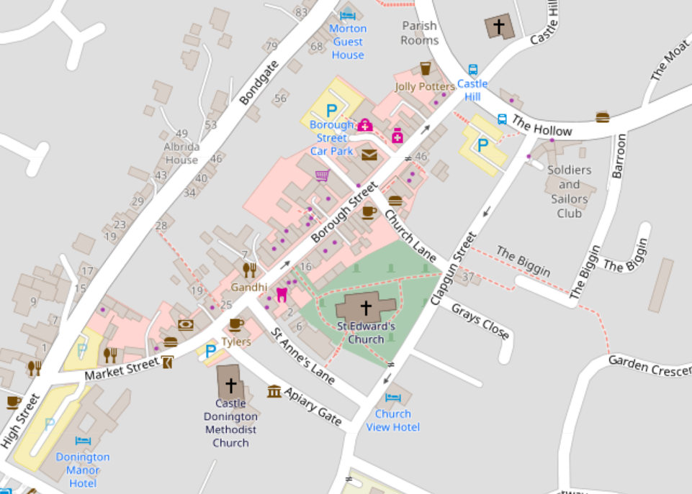
Castle Donington Wakes Emergency Contingency Plan 2024
1
2
3
4
5
Fire Assembly Point
Major Incident Assembly Point At Moira Dale
Hard Closure
1
Emergency Positions

Wakes Dates and Times
Wednesday 23 October 12:00 - 17:00 Setup Time or as per road closure
Thursday 24 October 18:00 – 22:00
Friday 25 October 18:00 – 22:00
Saturday 26 October 14:00 – 22:00

Contact Numbers
Wakes/Event Marshal 07805 478872 Martyn Lee
Asst Event Marshal 07970 466310 Rob Holman
Clerk/ Event Manager 07805 478897 Fiona Palmer
Deputy Clerk/Asst Event Mgr 07721 069259 Jayne Wintle
Police 101/999
CD First Responders TBC

Event Incident/Accident

Event Control Actions:
1. In the event of an incident, Event Control (Leader) is to be advised immediately.
2. Event Control to assess and prioritise information received and implement contingency plan accordingly.

Wakes Officials Actions
1. Assistant Event Marshal (Steward 2) to move to Market Street entrance with Bondgate to clear path for emergency services.
2. Event Marshal (Steward 1) to move to Barroon to clear path for emergency services.
3. Event Control to check that all correct emergency services have been alerted
4. Designated Assistants (Stewards 1-5) to follow Emergency Action Plan as issued in Pre-Brief, including notification to Showmen
Showmen Actions:
1. Stop and unload all rides.
2. Switch off all music and sound effects
3. Do Not Switch off lights.
4. Inform steward
5. Instruct the Public to leave the area via emergency exit routes
Give specific street name and use public address system if available.

Emergency Exits
1. The Hollow/Barroon
2. Church Lane
3. St Anne’s Lane
4. Apiary Gate
5. Market Street
6. Borough Street
7. Hillside

Hard Closed Emergency Routes
A. Market Street
B. Barroon
C. Church Lane
D. St Anne’s Lane

To be opened in emergency via Event Marshal/Deputy Event Manager/steward

Access for Emergency Vehicles
Barroon
Market Street → Borough Street

Assembly Point
In event of fire St Edwards Church Yard is the designated Assembly Point; in event of Major incident Moira Dale field is the designated Assembly Point. Stewards to guide public to appropriate Assembly Point.

First Aid
1. First Aider on setup day - Call 999
2. First Aid for Wakes - CD First Responder
3. First Aid Station - Event Control
4. Accident Book - Event Control

Lost Children
Event Control
See attached Staff Briefing Pack for further details

