**Valley Beat**

**Newsletter**

**#YouSaidWeDId**



**Issue: June 2024**

**Your Local Team**

* PS 3035 Aaron Bell
* PC 70 James Martindale
* PC 2238 Riannon Simpson
* PCSO 6517 Tony Gallagher
* PCSO 6178 Nicola Russell
* PCSO 6683 Pat McDonald

Your Dedicated Neighbourhood Team (DNT) is a group of local police officers dedicated to serving your community. The team is made up of officers based in your area, supported by the wider Policing family.

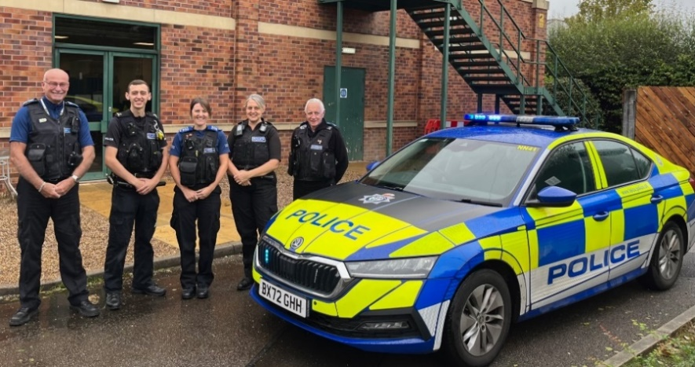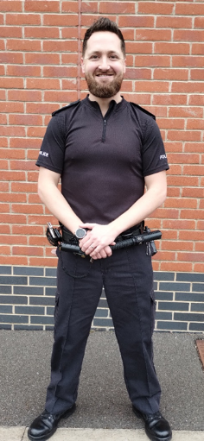

*Your new NN43 Sergeant*

**What Matters to You**

***Priority 1) ‘Share the Road’ campaign.***

*You Said:* There is a lack of respect to some road users, including horse riders, cyclists, and walkers.

*What we have been doing:* Various drivers have been stopped and educated due to unsafe overtaking, a handful of liveries have been visited to gather intelligence to identify where / when were most needed. Operation Snaffle has been conducted in Long Whatton in partnership with the fire service to educate drivers. Many more updates to come.

Your priorities are chosen quarterly and are based upon information gathered through NHL (Neighbourhood Link), social media, local engagement, and emerging crime trends. You have stated that the following key themes are important to you. #YouSaidWeDid

***Priority 2) Off-road bikes***

*You Said:* Off road bikes are causing a huge annoyance to members of the public. They are extremely noisy and pay no attention to the law.

*What we have been doing:* We have been working with partner agencies and landowners to improve site security and to reduce the entrance and exit zones to known locations. We are looking into creating awareness signage to reduce the likelihood of off roaders being in your area and have been patrolling known hotspots and engaging with those present.

educate riders where applicable.

***Priority 3) Theft from HGV’s***

*You Said:* You were concerned regarding the velocity of thefts in Castle Donington.

*What we have been doing:* Firstly, we established that the thefts predominantly relate to theft from HGV’s. We have increased patrols in hotspot areas, have created new signage that will be implemented in due course. Have worked with large scale companies such as Aldi distribution centre, to increase awareness of this type of criminal activity and have worked with other forces to ensure that offenders caught committing this crime are dealt with for all offences present.

educate riders where applicable.

**Page 2**



**Crime Figures**

To find out about crime that occurs within your area, please use the below link.

<https://www.police.uk/pu/your-area/leicestershire-police/valley/>

*Note: published crime and anti-social behaviour data will exceed 30 days old.*

This month we have worked in partnership with NWLDC and have implemented a billboard van on Arundel Avenue, Castle Donington. This is another tool we have utilised to tackle vehicular related anti-social behaviour in Castle Donington and Kegworth. The billboard has all relevant information relating to the Public Space Protection Order currently in place. A further collection of vehicles have also been identified in breach of the PSPO and will be receiving tickets in due course.

To enable the Police to get a better understanding of how you feel about car cruise activity, specifically across the NN43 Valley Beat, we kindly ask that you complete the following short survey. The survey can be accessed via the following link. - [Your Views - Car Cruising - NN43 Beat (neighbourhoodlink.co.uk)](https://survey.neighbourhoodlink.co.uk/Survey/HASH/4BDA686B72EC816B9192D63D2DEC0E5A)

As part of our ‘share the road’ campaign, we have worked alongside the Rural Policing team and have conducted a specific operation dedicated to educating drivers. Operation Snaffle refers. During Operation Snaffle a volunteer horse rider and cyclist travel on the roads and identify vehicles passing too close, too fast or on some occasions both. The identified vehicles are then stopped by uniformed officers and drivers are given the opportunity to learn from mistakes and take a seat in Leicestershire Fire and Rescues Hazard Express Van. Whereby, they viewed several virtual reality videos, one of which puts them in the saddle to experience what riders go through when passed too close. Alternatively, if they preferred, they also had the option of being prosecuted for careless and inconsiderate driving.

**What we have done #YouSaidWeDid**

**Contact us-**

**Page 3**

**Community Engagements**

**Tuesday 04th June — Castle Donington Community Hub — 1000AM-1200PM (Drop-in session)**

**Friday 07th June – St Andrews Church, Kegworth (During Flower Festival) – 1030AM-1130AM (Drop-in session)**

**Friday 14th June – Breedon Stores, Main St, Breedon – 0230PM-0330PM (Drop-in session)**

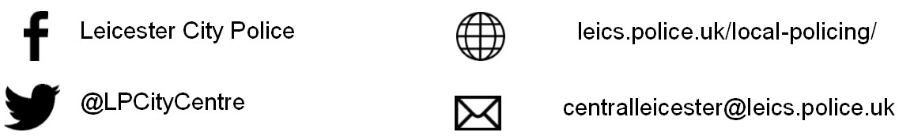

**@NWLeicsPolice**

**www.Leics.Police.uk**

**North West Leicestershire Police**

**Northwest.lpu@leicestershire.pnn.police.uk**



Your Views Survey

**NEIGHBOURHOOD LINK:**

Neighbourhood Link is a community messaging service from Leicestershire Police that provides news and information about policing activity or initiatives, crime prevention advice as well as major incidents affecting your area. In order to receive messages, you will need to register your details. Registration is free and simple to follow.

• Sign up at: <https://www.neighbourhoodlink.co.uk>

• Already have an account? Simply request a reminder if you have forgotten your username or password

• You can unsubscribe from the service at any time

Neighbourhood Link is not able to receive messages and you should not use it to contact the police. In an emergency always dial 999. If you wish to contact Leicestershire Police in other circumstances, for example to speak to local police or seek advice on police matters, you can call us by dialling 101 on your telephone or using any of the below sites.

Please also take the time to let the Valley Beat understand your concerns by completing the surveys to the right. Simply scan your camera over the top and click the link.



Confidence Survey