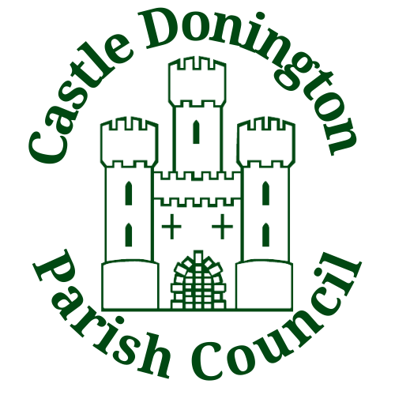

Sports Pitch Hire
2023 – 2024

Sports Facilities Letting Fees

All booking fees are for clubs based within the Parish.
All bookings from clubs outside of the Parish will incur 10% additional charge on standard rate.
Spital Pavilion and Field
- Bookings including room hire incur VAT charges.
- Bookings of field only do not incur VAT charges.
Moira Dale Pavilion and Field
- Bookings including room hire incur VAT charges.
- Bookings of field only do not incur VAT charges.
Football & Rugby Charges
Block bookings of 10 or more – Room hire is plus VAT and field use is VAT exempt (split of 20% for room hire, 80% for field use) £63.50 + £2.54 VAT
Individual bookings – Room hire, and field use £68.00 + £2.72 VAT
Floodlights – Per Hour
(50% reduction for non-commercial Junior Clubs) £18.50
CDFC (Spital Park) Flood Lights – Fixed Annual Fee £1135.00
CDFC (Spital Park) – Fixed Annual Fee £7800 + VAT
CDFC (Moira Dale) – Fixed Annual Fee £2000 + VAT
Training (building used)
1 Hour or part thereof £26.00 + VAT
Junior rugby training (no building used) £12.50
Block Booking Junior Matches (building used/pitch marked)
Inc. Under 18’s £29.00 (block booking policy split VAT otherwise VAT on full amount)
Block Booking Junior Matches (no building used/no pitch marked)
Inc. Under 18’s £25.50 (No VAT)
Individual Junior Matches & one-off booking £31.50 + VAT
Cancellation Fee £15.00
Moira Dale Cricket Fees

All bookings from clubs outside of the Parish will incur 10% additional charge on standard rate.
Cricket Charges
Junior Matches £25.00 + £1.00 VAT
Adult Matches £40.00 + £1.60 VAT
Outside Parish Adult Matches £44.00 + £1.76 VAT
Cancellation Fee £15.00

In certain circumstances the Parish Council reserves the right to waive the above charges or to refuse the hire of some or all the facilities.

