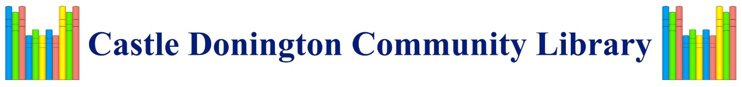

I WISH TO BECOME A FRIEND OF

CASTLE DONINGTON COMMUNITY LIBRARY

OR MAKE A ONE-OFF DONATION

Name and address of your bank:

Please pay to Co-Operative Bank

Sort Code 08 92 99

Account 67298499

For the credit of Castle Donington Community Library

First Payment to be made on

DD/MM/YY ……………………………………….

(Please circle below or enter your own amount)

The sum of £ per month/per annum

Single Friend £20 pa/£2 pm or Joint Friends £30 pa/£3 pm (same household)

**Please tick if you wish us to approach your bank to set up standing order**

**Or** the sum of £ as a one-off donation

From account:

|  |  |
| --- | --- |
| Sort Code: | Bank account in the name(s) of: |
| Account Number: |  |

**Boost your donation by 25p of Gift Aid for every £1 you donate**

Gift Aid can be reclaimed by CDCL from the tax you pay for the current tax year.

Please tick the box if you wish to Gift Aid your donation.

I wish to Gift Aid my donation and any donations I make in the future or have made in the past four years to CDCL. I am a UK taxpayer and understand that if I pay less income Tax and/or Capital Gains Tax than the amount of Gift Aid claimed on all my donations in that tax year, it is my responsibility to pay any difference.

Please notify CDCL if you wish to cancel this declaration, have changed your name or home address or no longer pay sufficient tax on your income and/or capital gains.

If you pay Income Tax at the higher or additional rate and want to recieve the additional tax relief due to you, you must include all your Gift Aid donations on your Self- Assessment Tax return or ask HMRC to adjust your tax code.

|  |
| --- |
| Title: First name: Surname: |
| Home address: |
|  |
|  |
| Postcode: Date: |
| Email Address: |
| Signature: |