north west leicestershire VALLEY BEAt

Police update MARCH 2023

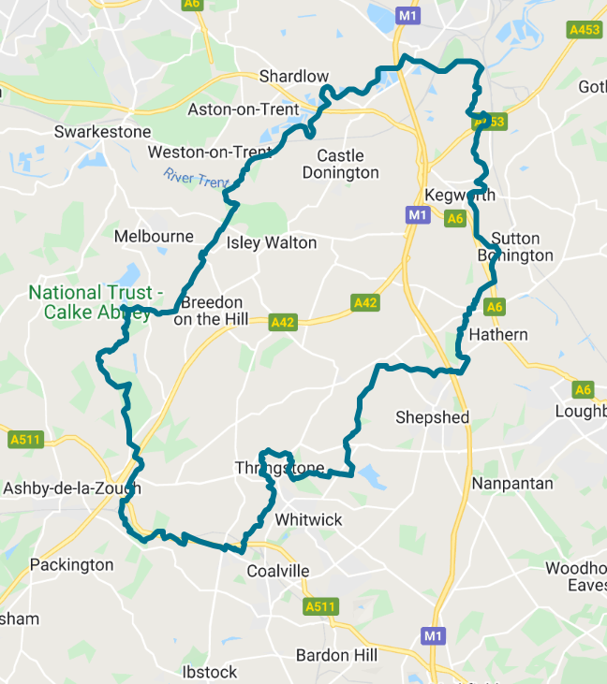**BEAT TEAM MEMBERS**

PS 1341 Leeland

PC 70 Martindale

PCSO 6178 Russell

PCSO 6683 McDonald

PCSO 6517 Gallagher

**REPORTING A CRIME**

Please report an incident/crime on 101 for non-emergency or 999 in an emergency.

Did you know you can report crime and incidents using our online portal.

Please visit https://www.leics.police.uk/

Click on REPORT.

**CRIME FIGURES**

(please click the link to show the latest available crime figures in the Valley Beat Area)

<https://www.police.uk/pu/your-area/leicestershire-police/valley/>

**Car cruise A453 – Update**

The last organised car cruise on the Valley beat occurred at the A453 Kegworth EMG on the evening of Sunday 26th March 2023 on A453. Frequency of incidents has reduced since the start of 2023.

**VALLEY BEAT AQUISITIVE CRIME AND ASB FIGURES MARCH 2023**

**Belton Parish**

No reports

**Breedon on the Hill Parish**

10/03 Attempt theft from motor vehicle The Crescent

23/03 Theft of caravan The Croft (Tonge)

**Castle Donington Parish**

07/03 Theft from HGV Warke Flat

07/03 Theft from HGV Moto

09/03 Theft fuel Moto

10/03 Theft fuel Moto

11/03 Theft of tools (van) Bosworth Rd

11/03 Criminal Damage bus stop/planter High St

12/03 Theft motor vehicle Willow Rd

13/03 Criminal Damage to motor vehicle Hallam Fields

14/03 Theft fuel Moto

19/03 ASB/Public Order The Spittal

20/03 Theft from HGV Arundel Av

20/03 Criminal Damage to motor vehicle Bosworth Rd

20/03 Criminal Damage to door The Spittal

20/03 Harassment The Spittal

20/03 Criminal Damage to HGV Moto

23/03 Theft from HGV Moto

23/03 Theft cycle Arundel Av

23/03 Attempt Theft from HGV Willow Rd

27/03 Attempt theft from HGV Moto

28/03 Theft of number plate Co-op

**Cavendish Bridge Parish/Sawley**

16/03 Theft cycle Sawley Marina

**Coleorton Parish**

22/03 Theft oil Loughborough Rd

28/03 Arson to motor vehicle The Moor

**Diseworth/Long Whatton Parish**

13/03 Burglary business Green Ln

13/03 Theft from motor vehicle Green Ln

29/03 Theft from trailer Hyams Ln

**Hemington/Lockington Parish**

11/03 ASB motorbikes Netherfields Ln

**Kegworth Parish**

04/03 Theft stores Co-op

04/03 Criminal Damage Packington Hill

04/03 Theft stores Co-op

05/02 Theft stores Co-op x 2

06/03 Theft stores Co-op

08/03 Theft stores Co-op

08/03 Theft of motor vehicle Suthers Rd

11/03 Theft stores Co-op

13/03 Criminal Damage motor vehicle Station Rd

13/03 Theft stores Co-op x 2

14/03 Theft stores Co-op

15/03 Theft stores Co-op

15/03 Theft of motor vehicle Suthers Rd

16/03 Theft from HGV Ashby Rd

19/03 ASB motorbike Borrowell

20/03 Theft motor vehicle Packington Hill

21/03 Theft stores Co-op

23/02 Theft of motor vehicle Packington Hill

25/03 Theft from motor vehicle x 2 Hollands Way

25/03 Theft of garden ornament Whatton Rd

26/03 Theft stores Co-op x 2

30/03 Theft stores Co-op

**Osgathorpe Parish**

No reports

**Staunton Harold Parish**

No reports

**Swannington Parish**

No reports

**Worthington / Newbold Parish**

04/03 Criminal Damage to Chapel Rempstone Rd (Griffydam)

29/03 Criminal Damage to motor vehicle Bottom Rd

19/03 Tyres slashed motor vehicle Vicarage Cl, (Newbold)

20/03 Criminal Damage to wall Main St

31/03 Theft of plant pot Main St

**CRIME PREVENTION**



# **Keeping your shed or garage safe and secure**

Many people don’t secure their shed or garage in the same way they do their homes - often using an easy-to-break lock or padlock to protect valuable contents such as a car, bike or lawnmower.

An opportunistic burglar will try a shed or garage first because they can find the tools they need to break into the main house.

## Shed and outbuilding security: first steps

First off, check that your insurance covers the contents of your shed or outbuildings from theft.



### Think like a thief

Take a look at your shed and consider how you would break in. It’s worth having a good padlock on the door with no exposed screws. Pay attention to hinges, as these are sometimes easily removable. If you have windows then these could be vulnerable unless they’re secured with wire mesh or grills. And keep it locked at all times.

### Alarm it

Consider a battery-operated shed alarm. They look low key but they respond to movement or door contact with an extremely loud siren.

### Lock it, hide it or mark it

Don’t give them the opportunity or the tools to commit a crime. Lock everything away securely. Tools can be locked inside a locker or box or secured with a chain.

Secure your bike to the ground or a lockable stand within a locked shed or garage. Look for ground anchors and other locks designed to fix to floors and walls.

It’s always worth draping an old sheet or blanket over the top of mowers or bikes to keep them covered from view.

Although it might sound like stating the obvious, never leave your garage or shed door unlocked if you’re not around.

Property marking your items is advisable and some tools can be painted with your name or postcode. Forensic marking is also an option.

The top five most common items stolen from sheds

1. Bikes
2. Mowers
3. Sports equipment
4. Power tools
5. Garden tools

Crime prevention tips and advice can be found on the Leicestershire Police website using the link attached below.

[**https://www.leics.police.uk/cp/crime-prevention/**](https://www.leics.police.uk/cp/crime-prevention/)

**BEAT SURGERIES 2023**

|  |  |  |  |  |
| --- | --- | --- | --- | --- |
| **Who’s going** | | **Date & Time** | **Location** | **Event title** |
| *APRIL 23* |  | |  |  |
| PCSO 6178 Russell  PCSO 6683 McDonald | Saturday 1st April @10.00am – 12.00pm | | Sawley Marina, Sawley, NG10 3AE | Drop in session |
| PCSO 6178 Russell  PCSO 6683 McDonald  PCSO 6517 Gallagher | Thursday 13th April @ 08.30 to 09.30am | | Hemington Primary School, Main Street, DE74 2RB | Drop in session outside school gates |
| PCSO 6178 Russell  PCSO 6683 McDonald | Wednesday 27th April @ 10.00am to 12.00pm | | The Moorlands, Coleoton, LE67 8GA | Patch Walk with NWLDC |
| *MAY 23* |  | |  |  |
| PCSO 6178 Russell  PCSO 6683 McDonald | Friday 5th May @17.00-18.00pm | | Worthington Post Office, St Matthews Avenue, LE65 1SH | Drop in session outside of store |
| PCSO 6178 Russell  PCSO 6683 McDonald | Wednesday 31st May @14:30-15.30pm | | Breedon Shop, Main Street, Breedon, DE73 8AP | Drop in session outside store |
|  |  | |  |  |
| JUNE 23 |  | |  |  |
| PCSO 6178 Russell  PCSO 6683 McDonald | Monday 12th June @ 1030am - 12noon | | Falcon Inn, Main Street, Long Whatton | Coffee morning |
| PCSO 6178 Russell PCSO 6683 McDonald PCSO 6517 Gallagher | Wednesday 29th June @ 1000am - 1200pm | | Bosworth Road, Castle Donington, DE74 | Patch Walk with NWLDC |

Please feel free to pop along to one of our a 2023 beat surgeries per the above calendar. We are happy to listen to your concerns/comments and to offer practical help and advice.

**COUNTY LINES UPDATE**

# **76 arrested during County Lines Intensification Week activity**

Leicestershire Police has carried out 41 warrants, arrested 76 people and made safeguarding visits to 58 vulnerable people during a national week of action targeting County Lines drug dealing.

They also recovered cash, drugs, firearms and other weapons as part of County Lines Intensification Week from Monday 27 February and Sunday 5 March 2023.

It is a national week of activity by police forces to disrupt the supply of drugs and to raise awareness of Child Criminal Exploitation (CCE).

County Lines is the name given to drug dealing where organised criminal groups from cities exploit young people from smaller towns and rural areas into moving and supplying drugs. The ‘county line’ is the mobile phone line used to take the orders of drugs.

Those being exploited are expected to move and store drugs and money, sometimes via coercion, intimidation and violence.

Through activities including warrants, ANPR operations, priority patrols in hotspot areas, Leicestershire Police:

* Mapped five new County Lines
* Made 76 arrests – with 15 individuals charged with 36 separate offences
* Executed 41 warrants
* Led two ANPR operations – leading to 13 arrests, 41 stop checks, and 10 vehicles recovered
* Recovered 33 weapons including a firearm
* Seized over £12,500 in cash
* Seized over £200,000’s worth of drugs
* Reached 5238 school pupils and 151 educational professionals with interactive preventative workshops
* Safeguarded 21 individuals

Partnership work was also key to the weeks success, this included joint operations at train stations with the British Transport Police (BTP), safeguarding visits and force run sessions in schools. Another campaign partner is Turning Point, who help people overcome drug and alcohol misuse.

There is a newly designed leaflet campaign for those who may come across CCE victims in their workplace as well as a social media campaign designed to use graphics of the items typically used by the drug dealers to recruit young people into working for them.

The social media campaign, targeting trusted adults on Facebook and Instagram, reached close to 220,000 people, with the forces other County Lines social media posts reaching a further 278,000.

The force’s activity was supported by national surge funding.

There was further promotion of the Are you Listening film which is about four young people who are being exploited. Although all of its characters are fictional they represent real experiences.

In the film, the signs of CCE are being made obvious to adults however the adults fail to listen to what they are being told and miss opportunities to help.

Here is where to watch the film and to learn more about spotting the signs of CCE and County Lines activity: [Are you Listening? | Leicestershire Police (leics.police.uk)](https://www.leics.police.uk/police-forces/leicestershire-police/areas/leicestershire-force-content/c/campaigns/2020/are-you-listening/)

Detective Inspector Dan Granger, who oversaw the week of activity, said: “The results from County Lines Intensification Week speak for themselves.

“The recovery of significant amounts of drugs, cash and weapons along with charging a number of people has an immediate and tangible impact. Alongside this, the improved intelligence gained during the activity along with the educational offerings provided, particularly to schoolchildren, supports us in protecting communities moving forward.

“The success of the week was only possible due to the drive and enthusiasm of those involved, showing a real determination to safeguard vulnerable people and bring offenders to justice.

In the film, the signs of CCE are being made obvious to adults however the adults fail to listen to what they are being told and miss opportunities to help.

Here is where to watch the film and to learn more about spotting the signs of CCE and County Lines activity: [Are you Listening? | Leicestershire Police (leics.police.uk)](https://www.leics.police.uk/police-forces/leicestershire-police/areas/leicestershire-force-content/c/campaigns/2020/are-you-listening/)

Detective Inspector Dan Granger, who oversaw the week of activity, said: “The results from County Lines Intensification Week speak for themselves.

“The recovery of significant amounts of drugs, cash and weapons along with charging a number of people has an immediate and tangible impact. Alongside this, the improved intelligence gained during the activity along with the educational offerings provided, particularly to schoolchildren, supports us in protecting communities moving forward.

“The success of the week was only possible due to the drive and enthusiasm of those involved, showing a real determination to safeguard vulnerable people and bring offenders to justice.

**Where to go for help and advice:**

To find out more about county lines visit: <https://www.leics.police.uk/advice/advice-and-information/cl/county-lines/>

There is a website specifically for young people to get help and advice on how to stay safe in Leicester, Leicestershire and Rutland [Making our community a safe place to live - LiveSafe](https://livesafe.org.uk/)

**VALLEY BEAT TEAM**

|  |  |  |
| --- | --- | --- |
| PS 1341 LEELAND | PC 70 MARTINDALE |  |
|  |  |  |
| PCSO 6517 GALLAGHER | PCSO 6178 RUSSELL | PCSO 6683 MCDONALD |
|  |  |  |

**NEIGHBOURHOOD LINK**

Neighbourhood Link is a community messaging service from Leicestershire Police that provides news and information about policing activity or initiatives, crime prevention advice as well as major incidents affecting your area.

Through this service you can receive messages from your local Neighbourhood Policing Team, local police or, in the event of a major incident or event affecting the whole of Leicestershire, from a partnership of agencies known as the Local Resilience Forum.

In order to receive messages, you will need to register your details. Registration is free and simple to follow.

• Sign up to Neighbourhood Link https://www.neighbourhoodlink.co.uk/

• If you are already registered you can amend your details

• Request a reminder if you have forgotten your username or password

• You can unsubscribe from the service at any time

Neighbourhood Link is not able to receive messages and you should not use it to contact the police. In an emergency always dial 999. If you wish to contact Leicestershire Police in other circumstances, for example to speak to local police or seek advice on police matters, you can call us by dialling 101 on your telephone.