Castle Donington parish council
Minutes of the Full Council Meeting held on Thursday 22 December 2022 at 7.00pm at The Community Hub, 101 Bondgate, Castle Donington

present : Cllrs S Ambrose-Jones, M Barker-Lane, C Burton, G Dalby, M Kitchener, B O’Dowd, M Rogers (in the chair), A Saffell, K Shatford, R Sizer and A Sowter.

Cllr R Canny – NWLDC. 2 Police Officers. 3 Members of Public.

4823/22 APOLOGIES: Cllrs L Cope (personal) and C Hills (personal).

4824/22 DECLARATIONS OF INTEREST:
Cllr A Sowter declared a non-pecuniary interest in relation to agenda item 10a) planning application 22/01868/LBC.
Cllr A Saffell declared a pecuniary interest in relation to agenda item 8a) for payment to his company.
Cllr A Saffell declared a non-pecuniary interest in relation to agenda item 10a) planning applications 22/01857/TCA and 22/01868/LBC.

4825/22 POLICE MATTERS
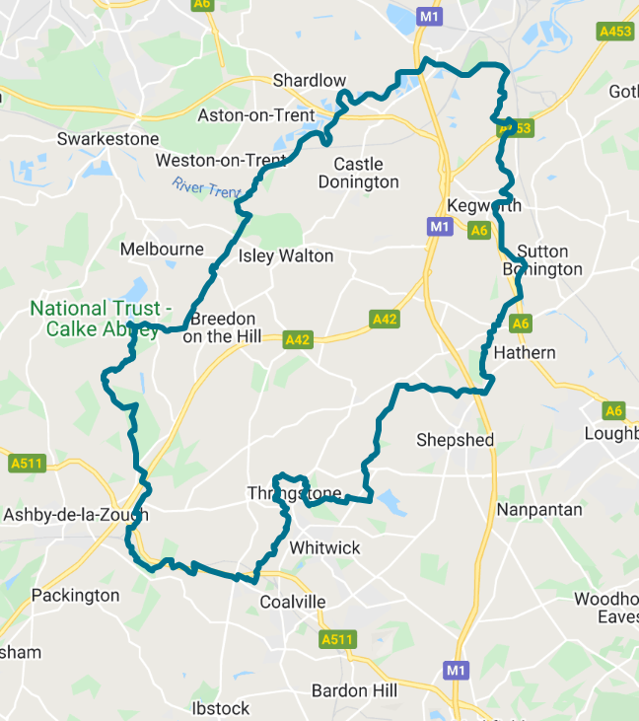
BEAT TEAM CONTACTS:
If you need to contact a member of your beat team and the enquiry isn’t urgent then the easiest way to do this is via email. You can either do this through the Leicestershire
Police website or on the details below:
PC 70 Martindale – james.martindale1@leicestershire.pnn.police.uk
PC 1391 Coleman – adrian.coleman@leicestershire.pnn.police.uk
PCSO 6178 Russell – nicola.russell@leicestershire.pnn.police.uk
PCSO 6683 McDonald – patrick.mcdonald@leicestershire.pnn.police.uk

CRIME FIGURES: (please click the link to show the latest available crime figures in the Valley Beat Area)
https://www.police.uk/pu/your-area/leicestershire-police/valley/

- PC Martindale introduced himself to the meeting advising that he had taken over from PC Harrison and that PC Cole is retiring. The Chairman wished PC Cole all the best in his retirement. RESOLVED: To receive the information.
- Monthly newsletter had been emailed to councillors. There has been a recent spike in thefts with strategies/control plans being put in place to address the matter. RESOLVED: To receive the information.

4826/22 CONFIRMATION OF MINUTES
To confirm the minutes of the following meeting of the Parish Council:
- Full Council – 24 November 2022. RESOLVED: To approve the minutes with minor amendments.

4827/22 CHAIRMAN’S REPORT
- Golden Wedding flowers presented to Mr and Mrs J Pincombe. Letter of thanks received. RESOLVED: To receive the information.
- 70th Wedding anniversary flowers presented to Mr and Mrs B Townsend. Letter of thanks received. RESOLVED: To receive the information.
- Sailors and Soldiers – Rev Roy Monks would like to obtain the building and has some funds available, approximately half of the asking price, and has asked if the Parish Council and other parties would be interested in a partnership. A meeting was held with interested parties and is in the early stages, need to think about what the building is to be used for apart from Sunday services before progression can be made. Discussion of various ideas took place. RESOLVED: To receive the information.
- The Clerk and Chairman met with Tom Clowes, Clowes Developments, in order to reenergise contact with the housing developers. A few points were raised including: -
  - The issue of the mud is being monitored until they have completed the surface treatments by High Street/Hilltop.
  - Clowes Developments, as a gesture of good will, is looking to repair the herringbone wall and is working with the NWLDC Conservation Officer.
  - Clowes Developments has a commericial operator for one of the plots; this is still of a confidential nature at present.
  - Cllr Ambrose-Jones raised the issue of Long Well leaking from the side requesting if the developer could sympathetically look at repairing the Well. RESOLVED: To contact Clowes Developments with the request.
  - The land the other side of the Western Permitier relief road is owned by Clowes and two residential developers. There have been early discussions with planners regarding its future use. Any assistance by NWLDC Cllrs of diversion of development would be welcomed. RESOLVED: To receive the information.
- A session called “Become a Councillor” is scheduled mid-January at NWLDC. It is an event aimed at offering infroamtion to memebrs of the public who might be thinking about the role of councillor either at NWLDC of local parish councils. Councillors requested to pass on the information to any interested parties. RESOLVED: To receive the information.

4828/22 REPRESENTATIVES REPORTS INCLUDING REPORTS FROM lcc

AND nwldc COUNCILLORS:
- Cllr R Canny (NWLDC)
  - Constructive meeting with the new CEO had taken place raising various concerns with quick replies and actions including Conservation Officers regarding the wall on Bondgate. RESOLVED: To receive the information.
  - All NWLDC Officers were copied in an email that had been sent to all MPs regarding a Bill going through parliament outlining changes to planning rules & regulations which could affect Castle Donington. One part is to get rid of the 5-year land supply that is currently required and to put more empasis on local people having their say through local and neighbourhood plans. RESOLVED: To receive the information.
- Cllr A Saffell (NWLDC)
  - Still waiting the results of the St Modwen planning enquiry. RESOLVED: To receive the information.
  - Question of a fallen wall on Bondgate was raised. It was confirmed that is was private land. RESOLVED: Cllr Saffell to request NWLDC to serve notice on the resident to repair.
  - Raised the question with CEO to obtain from NWLDC finance as to how much money is raised through council and business tax in the northern parishes, how much is spent in the northern parishes and what is the population of the northern parishes is for the whole district? RESOLVED: To report to future meeting.

4829/22 CLERK’S REPORT
- Royal British Legion – Letter of thanks had been received for support of the Poppy Appeal and Remembrance event. RESOLVED: To receive the information.
- Queen’s Platinum tree – The Parish Council agreed to the planting of a tree in memory of the Queen’s Platinum. Prices obtained for two oak trees 8/9 ft and 10/12 ft with decision to be made as to where it should be planted. RESOLVED: Larger tree to be purchased and suggestions to be submitted of where to plant prior to the next meeting.
- Daffodil planting – A number of local residents have been planting daffodils around the village entrances. It is proposed to join forces with NWLDC next season to obtain additional bulbs. RESOLVED: To receive the information.
- EMA at their recent forum meeting discussed producing and supplying signs to discourage airport parking in local villages. Parish Council logos had been requested to create a draft sign and to liaise with LCC to ensure compliance with a possible 20/30 signs to be given to Castle Donington at no cost. RESOLVED: To receive the information.

4830/22 ACCOUNTS
- RESOLVED: To approve payments scheduled for December including payment of wages for December as circulated to all councillors at a total cost for the month of £43,788.76.
- RESOLVED: To review and receive receipts for December as circulated to all councillors at a total cost for the month of £10,260.22.
- RESOLVED: To review and approve bank statements and bank reconciliation for December.
- Balances – To confirm additional money to be transferred to the Public Sector Deposit Fund through CCLA, as the HSBC accounts are not achieving much of a return, whereas those with CCLA are. RESOLVED: To approve money to be transferred to the Public Sector Deposit Fund through CCLA.

4831/22 AUDIT – ANNUAL REVIEW OF KEY POLICIES AND PROCEDURES
- Standing Orders – are based on the NALC model. RESOLVED: To re-adopt the policy.
- Financial Regulation’s – the Internal Auditor mentioned the procedure for dealing with payments needed slightly rewording from two members of staff to the Clerk and Bookkeeper. RESOLVED: To re-adopt the policy with the amendment.
- Financial Reserve’s policy – the Internal Auditor highlighted that in previous years the Parish Council hadn’t had sufficient general reserves. The policy states that the Parish Council should have 50% of precept as reserves or 6 months working capital. Neither were met last year so the Parish Council needs to continue to work towards this limit when setting the budget. LRALC standard guidance states, that following Covid the requirement is between 3 and 12 months reserves particularly those Parish Councils’ who have larger property portfolios, and other activities, need to be nearer to the 12 months due to loss of income offset against budgets. Currently need to work towards 50% as recommended by the internal auditor. RESOLVED: To adopt the policy and work towards the increase as recommended by the Internal Auditor.
- Mission Statement – RESOLVED: To re-adopt the Mission Statement with no changes.
- Priorities – additions had been recommended by the Clerk to include environment awareness, etc. RESOLVED: To re-adopt the Priorities document including amendments.

4832/22 PLANNING APPLICATION
- RESOLVED: To make the following comments in respect of plans received during December.
PLAN NO | ADDRESS | DETAILS | OBSERVATIONS
22/01839/AIR | Adjacent to DHL West Apron and Adjacent to East Apron, East Midlands Airport | Proposed waste de-icer storage tanks - adjacent to stand 125 DHL west apron and equipment storage area to the west of the east apron, airfield. | No objection subject to environmental concerns taken into consideration
22/01258/FUL | 17 Market Street | AMENDED APPLICATION - Change of use to beauty salon (sui-generis) with associated internal and external alterations (retrospective) | Object until the Conservation Officer concerns are addressed
22/01259/LBC | 17 Market Street | AMENDED APPLICATION - Change of use to beauty salon (sui-generis) with associated internal and external alterations (retrospective) | Object until the Conservation Officer concerns are addressed
22/01515/FUL | Donington Car Centre | Proposed extension to existing workshop to provide additional office space and welfare facilities and installation of solar panels to the existing roof | No objection
22/01857/TCA | 6 Barn Close | Removal of two yew trees (Unprotected trees in a conservation area) | FOR INFORMATION ONLY - To accept the information but CDPC would request the trees are replaced with 4 more (double removed)
22/01868/LBC | 4 Apiary Gate | External and internal alterations (air source heating system) | No objection

4833/22 PLANNING DECISIONS
- RESOLVED: To receive planning decisions received during December.
PLAN NO | ADDRESS | DETAILS | OBSERVATIONS | DECISION
22/01385/LBC | Cavendish Cottages, Cavendish Bridge | Installation of two Velux GPL 2570H top hung conservation windows | No objection | Approved
22/01525/ADC | 13 Market Street | Display of non-illuminated fascia sign and hanging sign to front elevation | No objection as long as the Conservation Officer and Highways are satisfied | Approved
22/01560/FUL | 13 Market Street | Proposed alterations to shopfront and 8 no. new outdoor air conditioning condensing units, replacing 5 no. existing units to rear elevation | No objection | Approved
22/00183/FUL | 35-37 Borough Street | Replacement of roof coverings | No objection | Approved

Meeting closed 7.41pm

Signed __________________________

Print Name _______________________ Date _____________________

