north west leicestershire VALLEY BEAt

Police update DECEMBER 2022

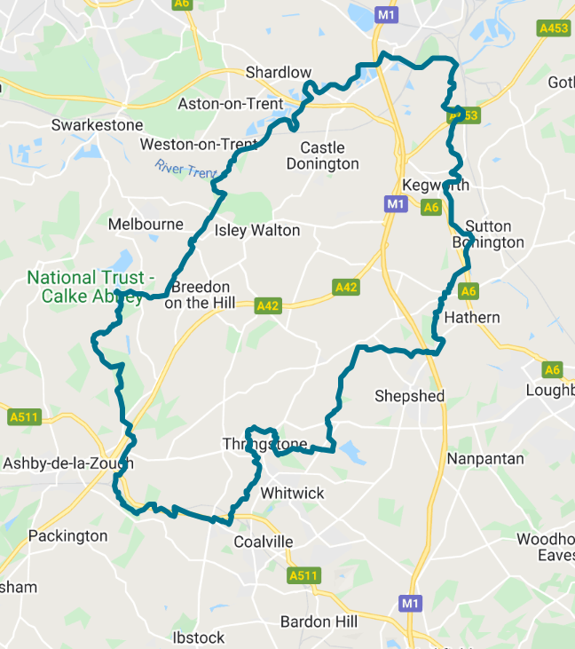**BEAT TEAM MEMBERS**

PS 1341 Leeland

PC 70 Martindale

PCSO 6178 Russell

PCSO 6683 McDonald

PCSO 6517 Gallagher

**REPORTING A CRIME**

Please report an incident/crime on 101 for non-emergency or 999 in an emergency.

Did you know you can report crime and incidents using our online portal.

Please visit https://www.leics.police.uk/

Click on REPORT.

**CRIME FIGURES:** (please click the link to show the latest available crime figures in the Valley Beat Area)

<https://www.police.uk/pu/your-area/leicestershire-police/valley/>

**VALLEY BEAT CRIME FIGURES FOR DECEMBER 2022:**

**Swannington Parish**

Theft of number plates 28/12

Burglary (commercial) 31/12

**Worthington/Newbold Parish**

Theft of number plates 27/12

**Belton Parish**

No reports

**Staunton Harold**

No reports

**Coleorton Parish**

Theft of a cat converter 02/12

Criminal damage to motor vehicle 22/12

**Kegworth Parish**

Theft of parcels from doorstep 06/12

Theft stores (Co-op) 06/12

Theft stores (Co-op) 13/12

Criminal damage to motor vehicle 15/12

**Osgathorpe Parish**

Criminal damage to field 14/12

**Castle Donington Parish**

Theft fuel Moto 05/12

Theft jump leads 05/12

Theft fuel Moto 06/12

Public Disorder 06/12

Attempt theft from HGV 12/12

Theft of plant (roller) 15/12

Theft of motor vehicle (Ford) 16/12

Theft oil Moto 16/12

Attempt theft from motor vehicle 16/12

Theft fuel Moto 17/12

Public Disorder (road rage) 18/12

Burglary (garage) 20/12

Attempt burglary 20/12

Theft wheelie bin 20/12

Theft of motor vehicle (BMW) 24/12

Theft of door key 30/12

**Breedon on the Hill Parish**

No reports

**Hemington/Lockington Parish**

Criminal damage to motor vehicle 23/12

**Diseworth/Long Whatton Parish**

Theft of a CCTV camera 06/12

Theft of wood chipper 13/12

Theft of cat converter 13/12

Theft of a number plate 23/12

**Car cruise A453 – Update.**

The last organised car cruise occurred on the A453 Kegworth EMG to Moto and at Arundel Avenue, Castle Donnington on the evening of Saturday 7th January 2023. Officers attended both locations to disperse attending vehicles out of the county.

**Keeping your shed or garage safe and secure**

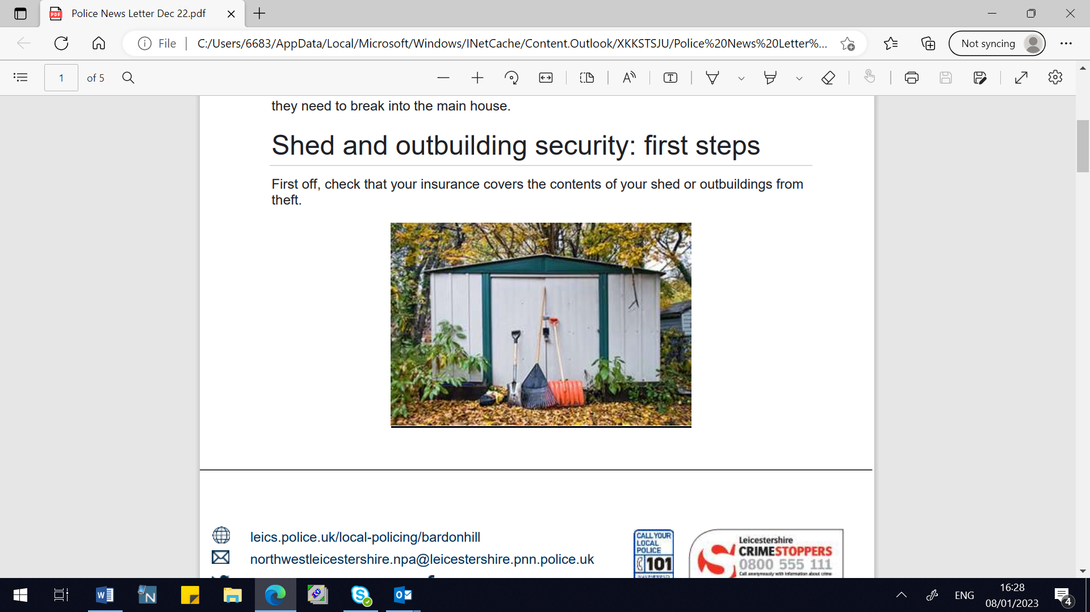

Many people don’t secure their shed or garage in the same way they do their homes - often using an easy-to-break lock or padlock to protect valuable contents such as a car, bike or lawnmower. An opportunistic burglar will try a shed or garage first because they can find the tools they need to break into the main house.

Shed and outbuilding security: first steps First off, check that your insurance covers the contents of your shed or outbuildings from theft.

**Think like a thief**

Take a look at your shed and consider how you would break in. It’s worth having a good padlock on the door with no exposed screws. Pay attention to hinges, as these are sometimes easily removable. If you have windows then these could be vulnerable unless they’re secured with wire mesh or grills. And keep it locked at all times.

Alarm it Consider a battery-operated shed alarm. They look low key but they respond to movement or door contact with an extremely loud siren.

**Lock it, hide it or mark it**

Don’t give them the opportunity or the tools to commit a crime. Lock everything away securely. Tools can be locked inside a locker or box or secured with a chain. Secure your bike to the ground or a lockable stand within a locked shed or garage.

Visit **Sold Secure** to search for ground anchors and other locks designed to fix to floors and walls. It’s always worth draping an old sheet or blanket over the top of mowers or bikes to keep them covered from view. Although it might sound like stating the obvious, never leave your garage or shed door unlocked if you’re not around. Property marking your items is advisable and some tools can be painted with your name or postcode. Forensic marking is also an option.

**PLANNED BEAT SURGERIES:**

|  |  |  |  |  |
| --- | --- | --- | --- | --- |
|  | |  |  |  |
| **Who’s going** | **Date & Time** | | **Location** | **Event title** |
| *JANUARY 23* | |  |  |  |
| PCSO 6178 Russell  PCSO 6683 McDonald | | Monday 9th January @  08.00am to 09.00am | Swannington C of E Primary School, Main Street, Swannington, LE67 8QJ | Drop in session outside of school premises. |
| PCSO 6178 Russell  PCSO 6683 McDonald | | Thursday 19th January @  16.00 to 18.00pm | Sawley Marina Long Eaton NG10 3AE | Drop in session at the Marina shop |
| PCSO 6178 Russell  PCSO 6683 McDonald | | Friday 27th January @  14.00pm to 15.30pm | The Community Hub, Bondgate, Castle Donington, DE74 2NR | Drop in session @ The Friday Club |
| *FEBRUARY 23* | |  |  |  |
| PCSO 6178 Russell  PCSO 6683 McDonald | | Wednesday 8th February @ 10.00am to 12.00pm | Diseworth Heritage Centre, Ladygate, Diseworth, DE74 2QF | Coffee morning – drop in session |
| PCSO 6178 Russell  PCSO 6683 McDonald | | Wednesday 15th February @10.00 to 11am | Castle Donington CO-OP Station Road, Castle Donington DE74 2NJ | Drop in session outside the entrance |
| PCSO 6178 Russell  PCSO 6683 McDonald | | Thursday 23rd February@  10.00am to 12.00pm | Kegworth CO-OP, Market Place,  Kegworth, DE74 2EE | Drop in session outside shop |
| *MARCH 23* | |  |  |  |
| PCSO 6178 Russell  PCSO 6683 McDonald | | Wednesday 8th March @12:00 to 13:15pm | Kegworth Village Hall, Nottingham Road, Kegworth DE74 2RH | Drop in session at the Soup and Sweet lunch club |
| PCSO 6178 Russell  PCSO 6683 McDonald | | Sunday 12th March @ 13.00 to 15.00pm | Staunton Harold Garden Centre, Staunton Harold. LE65 1RH | Drop in session outside the Centre entrance |
| PCSO 6178 Russell  PCSO 6683 McDonald | | Friday 31st March @ 14.30 to 15.30pm | St Edwards C of E Primary School. Dovecote, Castle Donington DE74 2LH | Drop in session outside school gates |

Please come along for a chat to a beat surgery which are scheduled for 2022/2023 per the calendar attached. We are always happy to listen to your concerns/comments and to offer help/advice.

Now we are into the longer/darker winter nights please ensure you are extra vigilant with your vehicle, home and personal security.

Crime prevention tips and advice can be found on the Leicestershire Police website using the link attached below.

[**https://www.leics.police.uk/cp/crime-prevention/**](https://www.leics.police.uk/cp/crime-prevention/)

**OFFICERS OF THE VALLEY BEAT TEAM:**

PS 1341 LEELAND

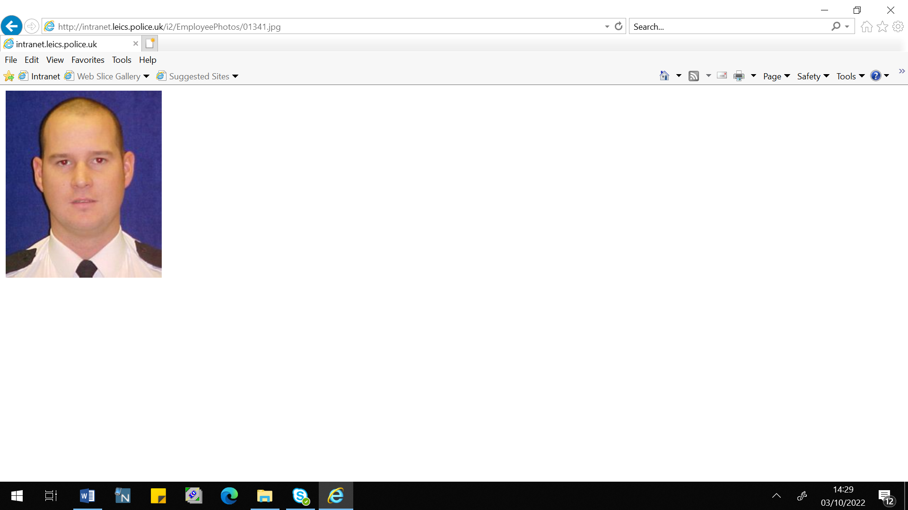

PC 70 MARTINDALE PCSO 6517 GALLAGHER

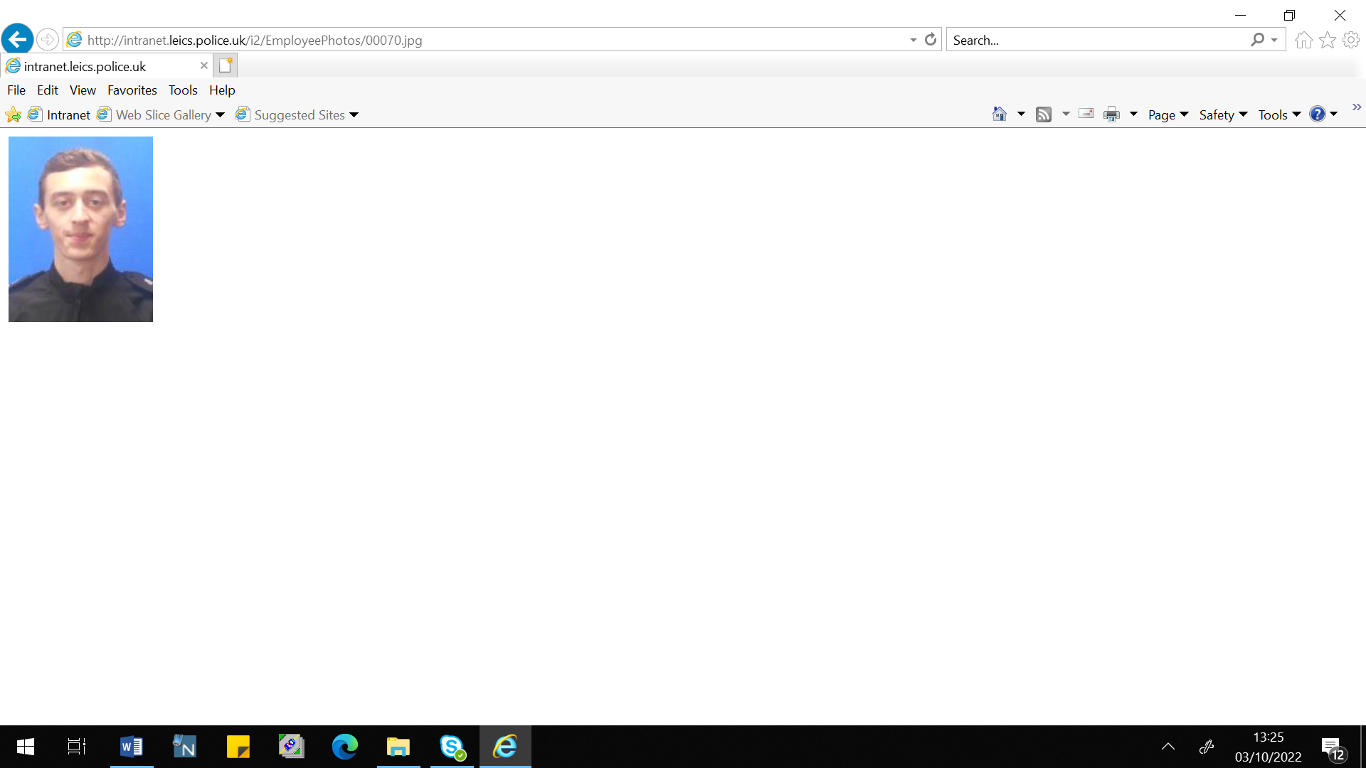 

PCSO 6178 RUSSELL PCSO 6683 MCDONALD

 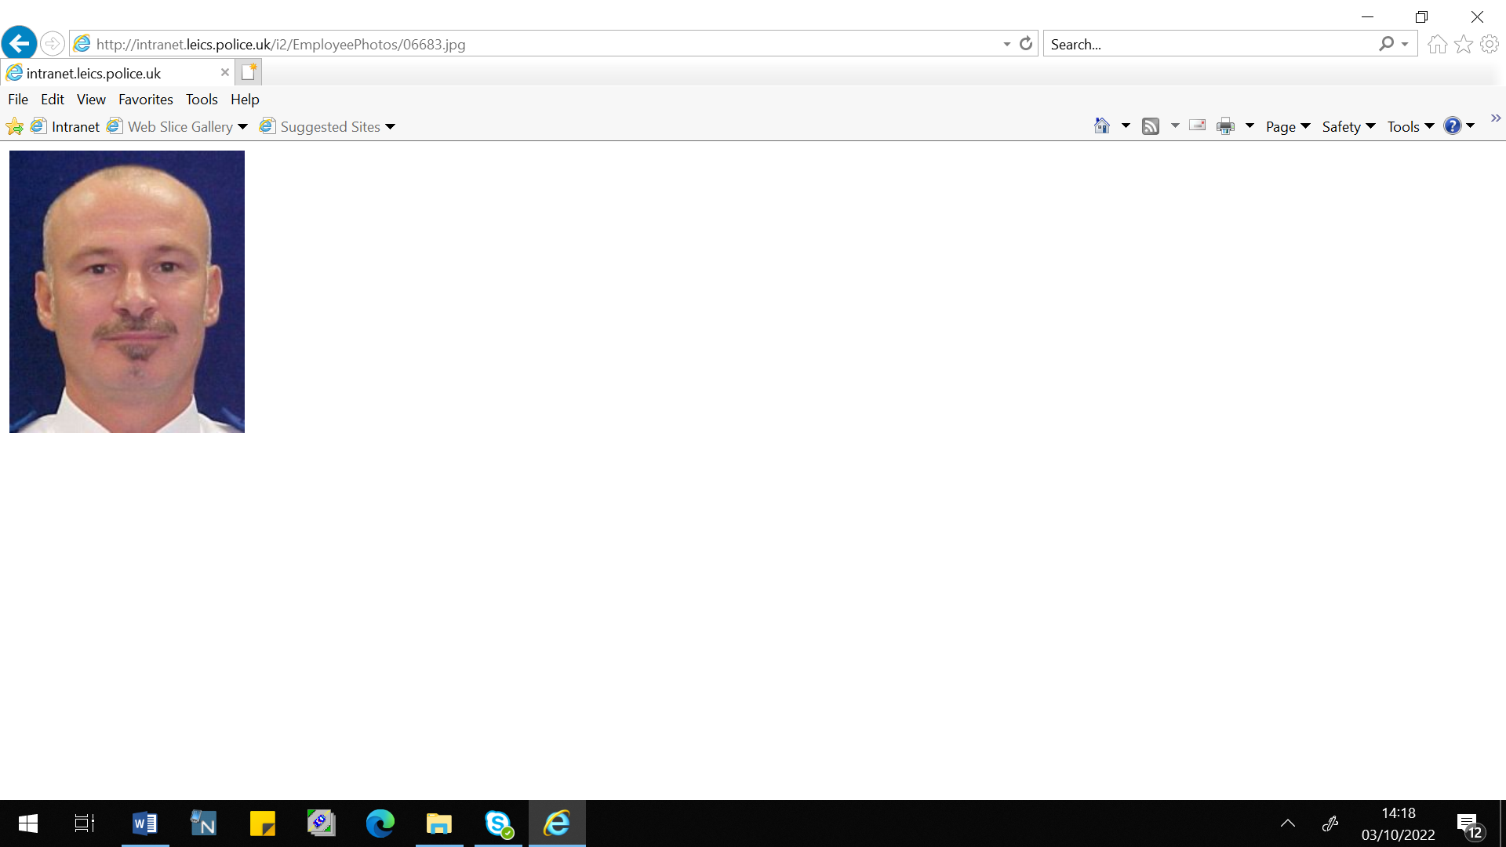

**NEIGHBOURHOOD LINK:**

Neighbourhood Link is a community messaging service from Leicestershire Police that provides news and information about policing activity or initiatives, crime prevention advice as well as major incidents affecting your area.

Through this service you can receive messages from your local Neighbourhood Policing Team, local police or, in the event of a major incident or event affecting the whole of Leicestershire, from a partnership of agencies known as the Local Resilience Forum.

In order to receive messages, you will need to register your details. Registration is free and simple to follow.

• Sign up to Neighbourhood Link https://www.neighbourhoodlink.co.uk/

• If you are already registered you can amend your details

• Request a reminder if you have forgotten your username or password

• You can unsubscribe from the service at any time

Neighbourhood Link is not able to receive messages and you should not use it to contact the police. In an emergency always dial 999. If you wish to contact Leicestershire Police in other circumstances, for example to speak to local police or seek advice on police matters, you can call us by dialling 101 on your telephone.

**Officer changes on the Valley Beat from January 2023**

After 2 decades working for Leicestershire Police PC 1391 Ady Coleman has hung up his cuffs and his radio for the last time. Ady has been on many ventures within Leicestershire Police working alongside various departments and meeting a variety of different people. Within the last decade the majority of his Policing has been within North West Leicestershire. Where he has served and protected the Valley beat to the best of his ability. We wish Ady a very happy and healthy retirement and wish him the best of luck for future endeavors.

This month we also welcome our latest addition to the beat PCSO 6517 Tony Gallagher. Tony comes with a wealth of experience particularly with rural Policing. He loves engaging with the community and will be happy to have a chat at any time. If you see him out and about please don’t hesitate to stop and chat with him.