Castle Donington Wakes Emergency Contingency Plan 2022
Major Incident Assembly Point – Moira Dale
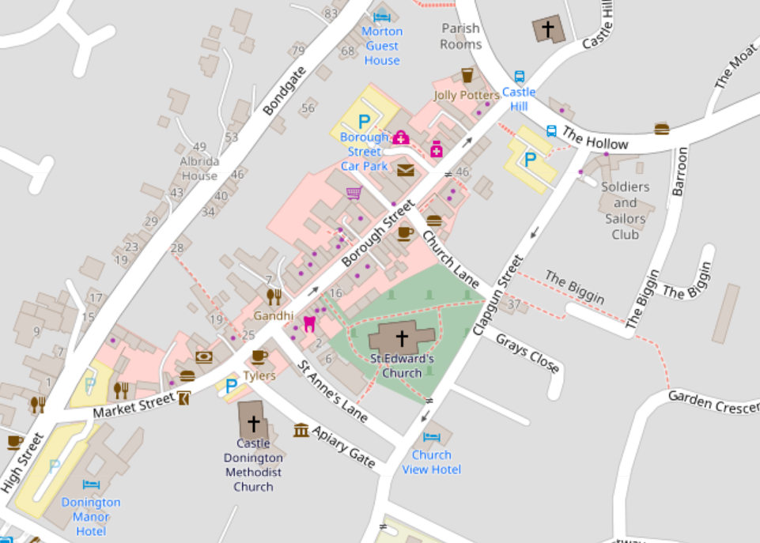
Fire Assembly Point
2
1
4
3
5
Nominated Positions
1

Hard Closures – Vehicle Block

Wakes Dates and Times
Wednesday 26 October 12:00 - 17:00 Setup Time or as per road closure
Thursday 27 October 18:00 – 22:00
Friday 28 October 18:00 – 22:00
Saturday 29 October 14:00 – 22:00

Contact Numbers
Wakes/Event Marshal 07805 478872 Martyn Lee
Asst Event Marshal 07970 466310 Rob Holman
Clerk/ Event Manager 07805 478897 Fiona Palmer
Deputy Clerk/Asst Event Mgr 07721 069259 Jayne Wintle
Police 101/999
CD First Responders TBC CD First Responders
Parish Council office 01332 810432
First Aid on set-up day XXX XXX

Event Incident/Accident
Event Control Actions:
1. In the event of an incident, Event Control (Leader) are to be advised immediately.
2. Event Control to assess and prioritise information received and implement contingency plan accordingly.

Wakes Officials Actions
1. Assistant Event Marshal (Steward 2) to move to Market Street entrance with Bondgate to clear path for emergency services.
2. Event Marshal (Steward 1) to move to Barroon to clear path for emergency services.
3. Event Control to check that all correct emergency services have been alerted
4. Designated Assistants (Stewards 1-5) to follow Emergency Action Plan as issued in Pre-Brief, including notification to Showmen
Showmen Actions:
1. Stop and Unload all rides.
2. Switch off all Music and Sound Effects
3. Do Not Switch off lights.
4. Inform Event Marshal and/or Event Manager
5. Instruct the public to leave the area via Emergency Exit Routes
Give specific street name and use public address system if available.

Emergency Exits
1. The Hollow/Barroon
2. Church Lane
3. St Anne’s Lane
4. Apiary Gate
5. Market Street
6. Borough Street
7. Hillside

Hard Closed Emergency Routes
A. Market Street
B. Barroon

To be opened in emergency via Event Marshal/Deputy Event Manager

Access for Emergency Vehicles
Barroon
Market Street → Borough Street

Assembly Point
In event of fire St Edwards Church Yard is the designated Assembly Point; in event of Major incident Moira Dale field is the designated Assembly Point. Stewards to guide public to appropriate Assembly Point.

First Aid
1. First Aider on setup day - To be confirmed
2. First Aid for Wakes - CD First Responders
3. First Aid Station - CD First Responders site - TBC
4. Accident Book - Event Control

Lost Children
Event Control - TBC

