WAKES SHOWMEN |  |  | Our ref: W/1/1
Dear Showmen

Castle Donington Wakes 2022

This year the Wakes are again being held on the last weekend of October on Thursday 27th, Friday 28th and Saturday 29th October.

Opening times
Thursday 6.00 pm – 10.00 pm
Friday 6.00 pm – 10.00 pm
Saturday 2.00 pm – 10.00 pm

Please ensure you adhere to these times – all stalls and rides will be expected to be operating during all the opening times. Lights must not be switched off before official closing times.

ANNOUNCEMENT

Castle Donington Parish Council is to retain the organising and running of the Annual Wakes Fair, however, there will be some changes to procedures and practices to improve the smooth running of the event, and to ensure that it continues to run for many years to come.

It will be, from 2023, going over to fully on-line applications for all stalls and rides.

Payment for all rides and stalls is to be made with application by the 26 August 2022.

Failure to submit applications and to make payments may incur additional admin charges.

If you have any questions, please feel free to contact us.

Set up times
The Road Closure Orders come into force at 12.00 noon on Wednesday, 26th October to allow one hour for the roads to be cleared of traffic. No showmen are allowed on site until the 1.00 pm deadline.
Departures
All vehicle movements are forbidden before the event closure time of 10.00 pm on ANYDAY unless safe to do so, and authorised with the Event Manager, Wakes Marshall or another suitably designated person on a specific evening. This is in the interests of public safety and to comply with the official Road Closure Orders.

Applications
All applications, supporting paperwork and ground rent must be received at Castle Donington Parish Council at the above address by Friday 26th August 2022. Empty sites after this date will be allocated by Castle Donington Parish Council unless the Showmen has a significant or legitimate reason for not supplying an application form and paperwork.
Late applications will incur an additional admin fee.

No applications will be accepted without the supporting, and necessary, safety certificates; mandatory risk assessments and, for food stalls, a Liquid Petroleum Gas (LPG) Certificate.

FEES
PLEASE NOTE: PAYMENT MUST BE MADE AT TIME OF APPLICATION PRIOR TO THE EVENT.

Failure to submit applications on time and/or make the correct payments on time, may incur additional admin charges.

Sub-lettings
Under Showmen’s Guild rules it is an offence not to turn up or sub-let. Sub-letting of any site will be by the approval of the Parish Council. It is the site-holder’s responsibility to sub-let the site. All applications for sub-letting must be received at the Parish Council by 26th August 2022 and must state type and size of ride / stall and operator’s details and be accompanied by the relevant Certificates. Should the ground owner not sub-let the ground, the Parish Council, as landowner, has the right to sub-let the ground. In this case the ground owner may lose the Preservation of Rights to the ground in favour of the new tenant.

No equipment will be allowed on site unless all paperwork prior to set up day has been supplied to the Parish Council. This will be stringently enforced.

The Wakes Marshall for this year is Martyn Lee, mobile telephone number 07805 478872

First Aid / Emergency Services
First aid will be provided by the Castle Donington First Responders who will be sited within the event site, location to be confirmed. Please contact direct, where appropriate or via an event marshal.
In the event of an emergency, please ensure that, where possible all equipment is switched off, attendees are moved to a safe location away from the emergency and an event marshal is contacted.

Parking
Should you require a Parking Permit, please apply at time of event application.
An admin fee of £5.00 will be charged for each permit to cover administration costs.

Should you have any queries regarding the above details, please do not hesitate to contact the Parish Council office.

Yours sincerely
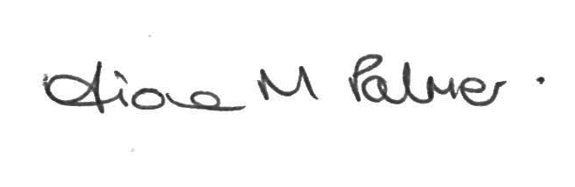
FIONA PALMER
Clerk to the Council
Enclosures:
Regulations for Castle Donington Wakes
Parish Council’s Risk Assessment
Emergency Contingency Plan
Electric Cable Covering notice
Generator notice
LPG Canister notice
Scale of Charges
Application form

