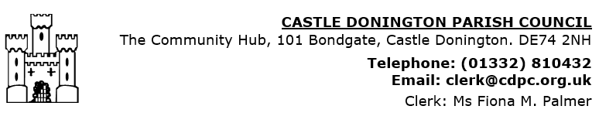

CASTLE DONINGTON WAKES

2021

SCALE OF CHARGES

|  |  |
| --- | --- |
|  | £ |
| Large rides (those which load at the same time)  e.g. Dodgems. Waltzer, Miami Trip, Twister, etc | 500.00 |
| Large single loaders  e.g. Ferris Wheel, Cake Walk, Rocker Plane, large Fun House | 300.00 |
| **Simulators**  Large  Small | 225.00  140.00 |
| Small single loaders  e.g. Small Fun House, Ghost Train, rotor rides | 200.00 |
| Helter Skelter, Slip, Swinging Gym | 135.00 |
| Kiddies’ small rides  Ball pool / soft play areas | 59.00  59.00 |
| Prize Every Time - e.g. Hook-a-Duck, Pick-a-Bag, etc  Round stalls  Side stalls – **per 10ft** | 59.00  19.00 |
| Game of Skill - e.g. Hoopla, Darts, Cranes  Round stalls  Side stalls ***–* per 10 ft** | 64.00  34.00 |
| Arcades (coin-operated) - **per 10ft**  Video games, slot machines | 69.00 |
| **Blow-up Slides**  Large  Small | 96.00  59.00 |
| Hot Dogs | 110.00 |
| Doughnut stalls | 59.00 |
| Chestnut stalls, street vendors | 29.00 |