Castle Donington parish council

Minutes of the Full Council Meeting held on Thursday 28 June 2018 at 7.30 pm at the Parish Rooms, Hillside, Castle Donington

present : Cllrs R Sizer (in the chair), M Barker-Lane, C Burton, G Dalby, N Daykin, R Else, A Saffell, A Sowter and D Wintle. Cllr R Canny-NWLDC (arrived 7.40pm), Cllr T Pendleton, PCSO K Bradley and 9 member of the Publics.

apologies: Cllrs S Ambrose-Jones (personal), C Hills (illness), R Nickless (personal) and G Roberts (personal).

DECLARATIONS OF INTEREST:
Cllr G Dalby declared a pecuniary interest in relation to Item 4c) – 895 houses.
Cllr A Saffell declared a non-pecuniary interest in the matter relating to staff wages as his daughter is employed by the Parish Council.

4032/18 POLICE MATTERS
PCSO K Bradley updated the Parish Council as per the following report.
RESOLVED: To receive the report.

CRIME FIGURES:-

Please visit this link for the most recent crime figures in the Parish:-

https://www.police.uk/leicestershire/NN43/crime/+4JZHs9/

EVENTS:
The Valley beat team will be present at the following locations for engagement with local residents during the next couple of months. We look forward to seeing you there.

Meet the Valley Beat team

Members of the Valley Beat team will be at the following events. Please come along and make us aware of any Policing issues within your community.

July 1st 2018 - 12:00-19:00- Music in the Park, Castle Donington
September 30th 2018 - 13:00-15:00- Rural Beat Surgery, Main Street, Osgathorpe

CRIME TREND:-

There have been a number of related crimes reported recently regarding the theft of garden equipment, spring/summer bedding plants and other garden/shed related items.

We urge the residents of the village to report ALL crimes, no matter how insignificant they may seem, as they may be related or linked to suspects already known.

Crime and intelligence reports are investigated by numerous departments, often relying on the Neighbourhood teams for valuable input who, with updated local knowledge assist with progression of bringing offenders to justice.


Simply call the police on 101 or use 0800 555 111 to call ‘CRIMESTOPPERS’ to pass on information about crime anonymously.


CRIME PREVENTION ADVICE:-
Garden Crime

Don't let green fingered thieves spring clean your shed.
Many people take a great deal of trouble securing their house and the property within it...but what about sheds and garages? With the array of lawnmowers, power tools, garden equipment, bicycles, sports and other valuable equipment kept in them, security measures should certainly be put in place.

- Ensure sheds and garages are in a good state of repair (make sure that the door, door frame and walls are solid and replace any damaged or rotten areas with new sections).
- Fit a good quality padlock
- Replace ordinary screws on outbuilding doors with non-return screws or coach bolts. You can also smear glue over the heads of the screws, to help stop a thief from unscrewing them.
- Ensure the hasp is bolted through the shed and into a steel plate.
- Obscure the windows of your shed or garage to prevent thieves seeing what you have inside
- Use metal rings and chains fixed to the shed frame with security screws to enable you to secure your electrical items, ladders and tools.
- Fit a battery powered alarm. These can be purchased from DIY stores.
- Postcode or property mark anything in your shed or garage that is value and might be stolen, for example, lawnmowers, garden furniture, bicycles, sports equipment.
- Take photographs of expensive items - they may be useful to police to identify the goods and return them to you, should you be unfortunate enough to have them stolen.
- Never leave garden tools and equipment outside, even if you are just popping back into the house.
- Shackle high value items together, such as bikes and lawn mowers, and ideally to the building or to a metal post cemented into the ground or ground anchor.
- Make a note of the make/model/serial number of any tools or bicycles, take photographs and keep them in a safe place
- Use signage to let others know that you have security marked your property and you are a member of a watch scheme
Theft from gardens and sheds is a problem all year round. It can become more of an issue during the spring and summer months when gardening equipment and valuable items, such as fishing tackle and bikes, are being used more regularly.
You are probably disciplined about locking your doors and windows when you leave your home, but what about your shed?

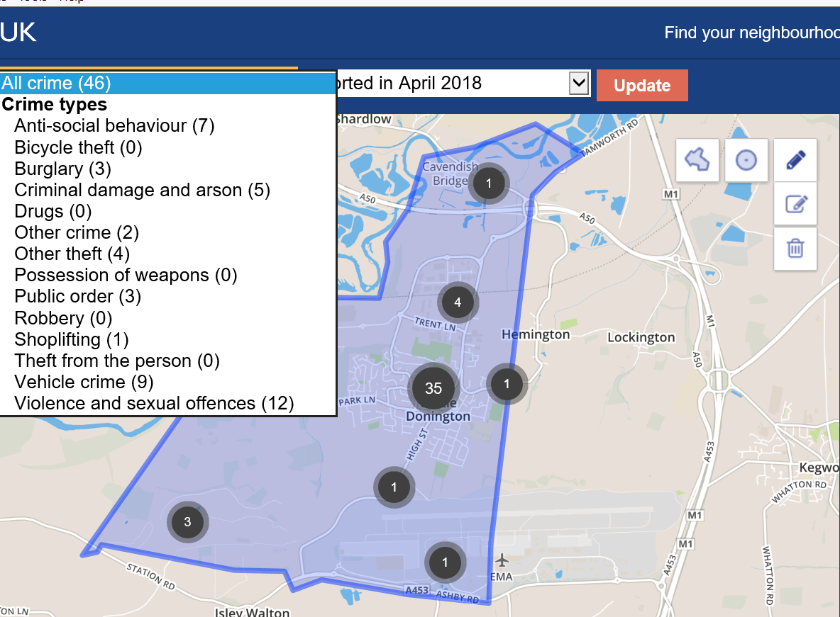
4033/18 CONFIRMATION OF THE MINUTES
RESOLVED: To receive and approve the minutes:
- Full Council – 31 May 2018
- Committees – 7 June 2018

4034/18 CHAirmans report
- St Edwards school council visit – The Chairman had presented an update to the school council. RESOLVED: To receive the information.
- Thank you received for Diamond wedding flowers from Ron and Dilys Broomfield, Cordwell Close. RESOLVED: To receive the information.
- Parish Liaison Committee – The Chairman and Clerk had attended the recent meeting with various matters on the agenda. Recycling was discussed as more requirements are needed for the current programme. GDPR training and advise is available from LRALC. Health and Wellbeing presentation – Advise was being sought as how to compile the policy with any ideas to be forwarded. Next meeting scheduled for 12 September 2018. RESOLVED: To receive the information.

4035/18 CLERKs report
- Comments Register

Complaint | Complaint received regarding parking on Hillside. Resident was interested in parking permits and wanted a line putting over dropped kerb so that they could report cars parking over dropped kerb.
Resolved | Resident was given contact for LCC regarding permits and was informed that parking over a dropped kerb is illegal regardless of a marking over it and this should be reported to the police on 101.
Complaint | Complaint received regarding trees in the church yard and cemetery
Resolved | Resident advised that tree in cemetery had already been cut back and tree in the church yard had been programmed in for later in they year.
Complaint | Complaint received regarding amount of road signs in the locality due to roadworks in area.
Resolved | Email sent to Highways England to investigate, confirmation received that all signs would be checked, and outdated signs would be removed.
Complaint | Complaint received regarding overgrown hedge on Paddock Close.
Resolved | Email sent to LCC to investigate REF SR10329554 LCC confirmed that hedge had been cut back 05/06
Complaint | Complaint received regarding Station Road. Resident requested for another lane to be added to ease traffic accessing the A50 at peak times.
Resolved | Email sent to LCC to investigate REF 10333784/ST
Complaint | Complaint received regarding traffic at the traffic lights on High Street/Bondgate junction. Resident also enquired when work would start on relief road.
Resolved | Resident was told CDPC had been informed work would start on 11June. Email sent to LCC to investigate REF 1033494/ST LCC explained that the traffic is being caused by major roadworks in the area and that the lights had been altered to aid the movement of traffic, avoid blockages in the junction therefore improve the overall safety.
Complaint | Complaint received regarding HGV breaking weight limit on Bondgate/High Street.
Resolved | Email sent to Traffic Management Office to investigate
Complaint | Complaint received regarding broken glass and weeds on Pig Alley.
Resolved | CDPC requested Lengthsman clear
Complaint | Complaint received regarding parking within central area of Castle Donington
Resolved | Email sent to LCC and NWLDC to investigate.
Complaint | Complaint received regarding deceased animal on duel carriage way leading to A50.
Resolved | Report sent to NWLDC to arrange removal. Confirmation received that member of public had taken animal to local vets.
Complaint | Complaint received regarding removal of trees close to Moira Dale Playing Fields. signage placed to say roots would be sprayed and residents had concern as there are many footpaths in the area where dogs are taken, and this could pose a risk to them and wildlife in area.
Resolved | Email sent to company to investigate
Complaint | Complaint received regarding over grown foliage on Park Lane
Resolved | Email sent to LCC to investigate REF 3132535829090
Complaint | Complaint received regarding footpath L78 being very overgrown.
Resolved | Email sent to LCC to investigate REF 3132663620532
Complaint | Complaint received regarding recycling bins on Trent Lane resident had received fine for putting rubbish on top of over flowing bin. Resident felt bins should be emptied more.
Resolved | Email sent to NWLDC to investigate
Complaint | Complaint received regarding bins on Market Place. Bins had been left there overflowing for number of weeks
Resolved | Email sent to NWLDC who confirmed they would remove bins on 21 June.
Complaint | Complaint received regarding bins on St Anns Lane. Bins left in road at all times.
Resolved | Email sent to NWLDC to investigate.

- Update on Casual Vacancy – Election has been called for by ten electors of the Park Ward. Election date set for 29 August. Option of polling cards or printed notifications are available the latter being considerably the cheaper option. Posters and forms will follow from the Returning Officer in due course. RESOLVED: To request printed notifications and receive the information.
- 895 houses – Some minor works to take place 21/22 June, with formal start to relief road and residential parcels set to commence 2 July. RESOLVED: To receive the information.
- Update from meeting with Western Power/EMA re power cable across Moira Dale – Meeting with Airport and Western Power to discuss what is needed and how this will affect the Parish Council’s land and to negotiate a commuted sum to allow them access across Parish Council land. RESOLVED: To give delegated powers to the Chairman, Vice Chairman and Clerk to negotiate a fee.
- Update re upgrade of footpath over Moira Dale to cycleway – Roxhill development. RESOLVED: Meeting to be arranged.
- Update on Music in the Park arrangements – All in to hand; help still needed from the Councillors on the day. RESOLVED: To receive the information.
4036/18 representatives’ REPORT, INCLUDING reports from LCC and NWLDC councillors
Nothing to report.

4037/18 STANDING ORDERS – TO AMEND WORDING REGARDING THE SCHEDULE OF MEETINGS
A copy of the proposed amendments had been circulated to all councillors. The Chairman updated the Parish Council on the proposed changes and the Clerk gave clarity of why meetings can be changed if deemed necessary. RESOLVED: To amend the Parish Council Standing Orders to include this amendment. Cllr A Sowter voted against the resolution.

4038/18 ACCOUNTS
- Payments scheduled for June 2018 including the payment for June wages.
RESOLVED: To approve the payments for June. Cllr A Saffell did not vote.
- Bank reconciliation as at 19 June 2018 including a list of receipts to date. RESOLVED: To receive the information.

Description | Supplier | Total
Windows | Lifestyle Home Solutions Ltd | 20,204.00
Flowers | Buddies Florist | 50.00
Helium cannister | Buddies Florist | 33.00
Pension | Aviva | 33.00
Rates Hub | NWLDC | 1,701.00
Survey | Fourstage Environmental Ltd | 540.00
Weedkiller | Hutchinsons | 191.50
Wasp killer | Killgerm Chemicals Ltd | 211.00
Signs | Leicestershire C C | 160.19
Computer software | Pear Technology | 240.00
Advertising | Rural Trader (UK) Ltd | 297.60
Computer Costs | SC IT Solutions Ltd | 30.00
Materials | Travis Perkins Trading Co Ltd | 9.82
Grounds Maintenance | Ulyett Landscapes Ltd | 202.50
Grounds Maintenance | Ulyett Landscapes Ltd | 5,473.12
May Market stall refunds | May Market stall holders | 265.00
First Aid donation | First Responders | 400.00
Broadband | BT | 114.24
Rates Cemetery | NWLDC | 35.00
Rates Office | NWLDC | 49.00
Bank Charges | HSBC | 45.48
Phone | EE | 30.35
Fuel | Martyn Lee | 74.50
Photocopier | Canon | 213.54
Site visit | EP Consulting | 990.00
Equipment | Commercial Card | 89.64
Postage | Commercial Card | 9.98
Bins | Commercial Card | 7.99
Tools | Commercial Card | 10.38
Tools | Commercial Card | 13.31
Internet charges | Heart Internet | -16.19
Gas Hub | SSE | 342.06
Electricity Sports Pavilion | SSE | 318.92
Electricity Office | SSE | 143.61
Electricity Spital Playing fields | SSE | 103.29
Gas Office | SSE | 244.59
Electricity Cemetery | SSE | 33.29
Electricity Spital Store | SSE | 137.07
Cleaning materials - General | Censol Ltd | 936.41
Leaflets | Sign it (Nottm )Ltd | 60.00
Materials | Travis Perkins Trading Co Ltd | 48.32
Historic Building report | University of Leicester | 2,550.00
Paper | Viking | 35.98
Materials | Viking | 27.79
Wages | Staff | 8,268.63
Tax and NI | HMRC | 2,183.03
Pension | Aviva | 515.84
Book Keeper | Jane Hancox | 210.00
Subscription | CPRE | 36.00
Phone | BT | 295.44
Phone | BT | 114.53
Phone | BT | 86.86
Furniture | Fiona Palmer | 60.00
Materials | Travis Perkins Trading Co Ltd | 25.10
Hanging Baskets | Plantscape Ltd | 1,647.00
Books | NALC | 37.48
Music in the Park entertainment | J D Barlow | 300.00
Music in the Park entertainment | Lindsay Newman Wood | 100.00
Music in the Park entertainment | Rolls Royce Band | 300.00
Music in the Park entertainment | Alex Anderson | 50.00
Music in the Park entertainment | Sally Renshaw | 250.00
Event help | Rosie Scott | 50.00
Event help | Robert Holman | 50.00
Music in the Park entertainment | Creature Caboodle | 240.00
Music in the Park entertainment | Michelle Furborough | 750.00
 | Totals | 52,260.19

4039/18 COMMUNITY HUB
- Update on main contract works – all going to plan, completion set for before the end of August. RESOLVED: To receive the information.
- Update on expenditure costs – RESOLVED: TO WAIVE STANDING ORDERS TO DEFER ITEM TO THE END OF THE MEETING
- To consider quotes for flooring – Four quotes had been requested for vinyl type tiles and carpet tiles; only two had been returned to date. Clerk to chase the other contractors to obtain a full comparison. RESOLVED: To give delegated authority to the Clerk, Chairman and Vice-Chairman working in conjunction with the building designer and main contractor to ensure the correct type of floor finish for the different areas of use to a limit of £18,000.
- Update on additional funding and sponsorship – Additional funding/sponsorship has been confirmed from AirLogistics, Rural Trader and Streetscape Playgrounds. Meetings arranged with other sponsors awaiting confirmation of their offers. Grant applied for from LCC Shire Grants. Very positive from the local community. RESOLVED: To receive the information.
- Update on rates appeal – Rates Challenge has been approved with circa £22,000 being refunded against fees paid. Valuation Office to set the new rateable value upon completion of the works. The Clerk was thanked for her hard work involved in obtaining this refund. RESOLVED: To receive the information.

4040/18 planning applications

PLAN NO | ADDRESS | DETAILS | OBSERVATIONS
18/00869/FUL | 44 Park Lane | Raising of roof including side roof extension, single storey rear/side extension and front porch | No objection as long as there are no neighbour objections
18/00923/FUL | 2 The Spinney | Erection of single storey front and rear extensions | No objection as long as there are no neighbour objections
18/00925/CLP | 11 Tanyard Close | Erection of single storey rear extension (application for a lawful development certificate for a proposed development) | Accept the information
18/00911/ADC | 35-37 Borough Street | Installation of 2 no. internally illuminated signs and 1 no. non-illuminated sign | STRONGLY OBJECT - to the proposed sign which is in the middle of the Conservation Area and has rear illumination this conflicts with the new Shop Front policy. If allowed this would set a precedent for other shops within the central area.
18/01058/FUL | 35-37 Borough Street | Installation of external plant equipment | No objection
18/00408/FUL | 88 Barroon | Change of use from Residential (Use Class C3) to Funeral Directors (Use Class A1) - AMENDED | No comment
18/01029/FUL | 43-45 Borough Street | Erection of single storey rear extension to serve a freezer room (retrospective) | No objection

RESOLVED: To receive the information.

4041/18 planning DECISIONS

PLAN NO | ADDRESS | DETAILS | OBSERVATIONS | DECISION
18/00416/FUL | 12 Borough Street | Change of use of second floor to a one bed apartment, single storey rear extension to hair salon/barbers and flat roof terrace and stairs to serve the first floor | No objection | Approved
18/00156/ADC | 10 Bondgate | Installation of 3 no. externally illuminated fascia signs and 1 no. externally illuminated projecting sign - amended application | OBJECT - CDPC requests that the signs are made of traditional material with borders in line within the Conservation Area and recent applications such as Castle Grill. | Approved

RESOLVED: To receive the information.

4042/18 NWLDC
Consultation on Draft Licensing Policy. RESOLVED: To receive the information.

4043/18 exclusion of the public
To exclude the Press and Public from the meeting in accordance with the Public Bodies (Admission to Meetings) Act 1960 on the grounds that publicity in respect of the following item would be prejudicial to public interest by reason of its confidential nature.

4044/18 COMMUNITY HUB
- Update on expenditure costs – The Clerk presented a breakdown of the draft costs to date. This included a list of additions and omissions which culminated in an on-budget costing for the main contract. Formal variation orders have been issued for the additions that outside of the main contract, ie the platform lift (by separate contract original). The Clerk was thanked for a fabulous job in all the work involved. RESOLVED: To receive the information.

Meeting closed 9.06 pm

Signed __________________________

Print Name _______________________

Date ____________________________

