Castle Donington parish council
Minutes of the Full Council Meeting held on Thursday 25 July 2024 at 7.00pm at The Community Hub, 101 Bondgate, Castle Donington

present : Cllrs K Bradley, C Burton, L Cope, R Else, C Hills, M Kitchener (in the chair), J Manley, P Norwell, M Rogers, A Saffell and A Sowter.

6 members of public.

ABSENT: Cllr B O’Dowd

5096/24 APOLOGIES: Cllr J Heeley (work). RESOLVED: To receive and approve the apologies.

5097/24 DECLARATIONS OF INTEREST:
Cllr L Cope declared a disclosable pecuniary interest in relation to her son’s girlfriend works for the Parish Council.
Cllr K Bradley declared a disclosable pecuniary interest in relation to his partner who works for the Parish Council.
Cllr M Kitchener declared an other registerable interest as an employee of Biffa who provide waste services to the Parish Council.
Cllr P Norwell declared a disclosable pecuniary interest in relation to family members who work for the Parish Council.
Cllr M Rogers declared an other registerable interest in relation to planning application 24/00741/LBC

5098/24 CONFIRMATION OF MINUTES
To confirm the minutes of the following meeting of the Parish Council:
- Full Council – 27 June 2024. RESOLVED: To approve the minutes.

5099/24 CHAIRMANS REPORT
Nothing to report with no meeting in August. RESOLVED: To receive the information.

5100/24 REPRESENTATIVES REPORTS INCLUDING REPORTS FROM LCC, NWLDC COUNCILLORS and POLICE
- Cllr Hills had received the EMA data for the balancing bonds and reported that there were no breaches within their limits which is expected for the summer period. A significant amount of civil engineering works are to be carried out to improve the ponds in preparation for the winter. RESOLVED: To receive the information.
- Cllr Saffell – car cruising and noisy motorbikes– the upgrade of the PSPO (Public Space Protection Order) order had been approved which has been extended to cover the whole of Castle Donington. Information as to how many vehicles had been seized under this order had been asked and currently waiting for the information. Motorcycles along the main road are an issue due to speed and noise which may not easily fall within the PSPO. RESOLVED: To request the motorcycle police to visit the Apiary on a Thursday meet night and motorcycle factory for educational talks.

5101/24 CLERK’S REPORT
- Institute of Cemetery and Crematorium Management (ICCM) – To approve the annual membership. The original request from them seems to have been lost, hence adding it here. ICCM are worth their weight in gold – Annual cost £100.00. RESOLVED: To approve the annual membership and to include the annual budget going.
- Breedon on Hill Neighbourhood Plan - The submission plan and supporting documents can be viewed here. RESOLVED: To receive the information.
- Hello Heritage – Request form NWLDC to chase up representatives from Museum to be included in this for this year. By being part of it, they are part of a bigger campaign that encourages the public to take part in heritage. There are no costs to the Museum. RESOLVED: To speak to the Museum requesting they contact NWLDC.
- Proposed conservation area designation for Donington Park. https://www.nwleics.gov.uk/pages/historic_development_reports
https://www.nwleics.gov.uk/pages/local_plan_review. Cllrs Norwell, Rogers and the Clerk to review this and make comment under delegated authority, and then reported back to Full Council in September. RESOLVED: To receive the information.
- NWLDC – Licensing application for 32 Borough Street, The Flag. Additional information requested. RESOLVED: No objection.

5102/24 TRAFFIC MATTERS
Website:
A dedicated page on the website has been created for All Things Traffic. It is constantly updated once new reports have been sent to us along with notes from the last meeting. You can find the page by clicking the link or going onto the Parish Council website and clicking on the popover.

Traffic Calming:
Work is to commence on the 27th of August.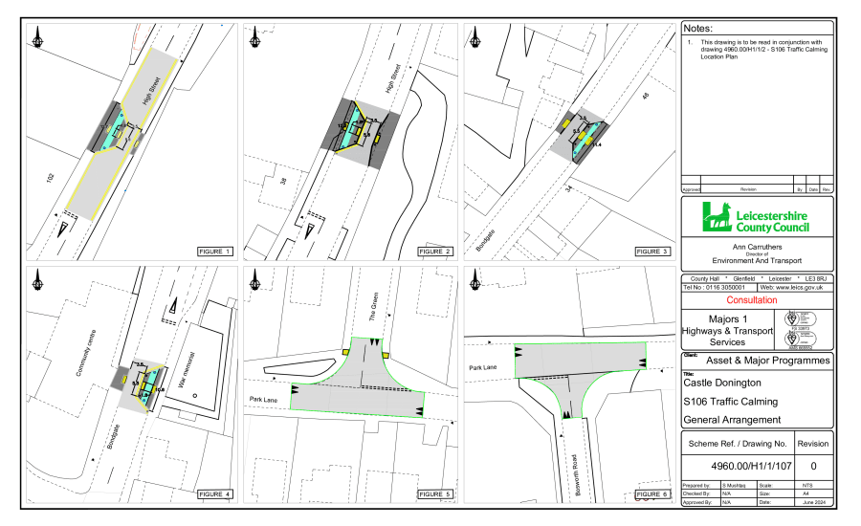
Police Traffic Survey Requested:
The Police completed 3 traffic speed surveys last November on Bondgate and the average speed recorded was 27mph. Hilltop was also completed in November 2023 with an average speed of 31.6mph, along with Broad Rushes in January 2023, with an average speed of 40mph.

Currently, Park Lane is the only area for a speed survey to take place during the school holidays this year. All other roads are listed as no survey due to pending scheme – as per LCC or no need for another survey at this stage.

Request For Average Speed Cameras:
After requesting the possibility of average-speed cameras along the Relief Road we received this response from LCC:

“With regards to your request for Average speed cameras (ASC), these are funded outside of the partnership by Leicestershire County Council, however the Police operate and enforce on our behalf. Much notice has been taken of them in Leicestershire as part of a trial that the County Councils cabinet agreed in 2017, which went operational at 7 locations throughout 2018 and 2019. Many Council Members and Parishes have asked for ASC's to be implemented within their communities to combat speeding, but also to react to general community concerns.

Cabinet members were provided with a report on the 20th October 2020 regarding the County Councils formal position to establish a Community Speed Enforcement Initiative following the trial of average speed cameras. A proposal was made to introduce community speed enforcement in communities, inclusive of a rolling programme of sites where cameras could be moved around the County. A link to the report provided to cabinet is available on the following link https://democracy.leics.gov.uk/uuCoverPage.aspx?bcr=1 However, at present the future of average speed camera installation is unknown due to the funding element.

The County Council continues to make safety improvements on its road network where this can be justified. Currently, however it is only able to make essential safety improvements, where the recorded injury accident record demonstrates that improvements should be made. With these being limited to areas with a proven casualty history higher than national average or higher than otherwise would be expected. At present the County Council's resources around road safety are being directed at remedial works at high-risk locations, which have evidence of a poor accident history, with the worst recorded personal injury accident records as reported to us by the Police.

After investigating your concerns, we can advise that there have been no personal injury accidents reported to us by the Police on the Castle Donington Relief Road and 2 accidents on Hill Top within the last 5 years, which is a good indication most motorists are aware of the road layout and are appropriately using them.
Our accident data for Station Road shows there were 4 slight personal injury accidents reported within the 30mph speed limit and 2 slight accidents reported within the 40mph speed limit within the last 5 years. It should be noted that there is no evidence to suggest these accidents were attributable to speed.

It is not easy to influence speeds of some motorists who are familiar with the highway environment and drive at a speed they consider safe for the prevailing conditions. Speed is not always a factor when accidents occur. Poor driving habits such as braking late at or on a bend and simply not paying due care and attention are just several examples. Speed limits should encourage self-compliance. We would advise all motorists to drive with care and at a reasonable speed for the road layout and encourage all parties to have caution and awareness when driving. There is nothing the County Council can do to prevent poor driving habits.

The County Council has no legal powers to take enforcement action against drivers who exceed the speed limit, and we therefore recommend you report all issues relating to speeding traffic to Leicestershire Police, who are the only authority who can act against motorists who drive above the speed limit. Residents can log their concerns using this link https://www.speedorsafety.com/community. They will then investigate commensurate with their other duties.”
Response From NWLDC About Noise Monitoring:
After requesting for noise monitoring the following has been received from Lee Mansfield at NWLDC.

“The vast majority of large or big bore exhausts are illegal for use on public roads. The fact they may have passed an MOT test is irrelevant as this only checks for exhaust gasses and emission legislation compliance. Big bore and sports exhaust systems are usually fitted to increase the sound emitted and this contravenes the Type Approval of the vehicle, which is an offence. There is no requirement for police to measure the sound level from the exhaust system, it only requires an opinion that the system is not standard and that it is noisier than a normal vehicle of the same specification. It is not an offence to sell these exhausts systems, but it is an offence to fit one to your vehicle and drive it on a public road. Motorists who do so would be reported to court and may face a fine and court costs. As the police do not need to know the sound level from the exhaust, the positioning of sound monitoring equipment will not be done by NWLDC as requested by the Parish Council. The most important thing is for reports to be submitted detailing the date, time of the issues and how it was impacting you.”

After speaking to Police Officer James Martindale he questions this as finding out the relevant noise levels could help with the case brought against a driver as hard evidence, not just his word when in court.

Village CCTV Update:
We had an update from Lee Mansfield on the 2nd July:
“Firstly the project is introduce permanent CCTV into Castle Donington is a project I have been involved in for a couple of years now and I share your frustration with the delay in getting the installation completed. At one stage in 2023 it did look like we were going to overcome the legal issues around obtaining permissions from the landowner to site the data box in our preferred location, however this did not happen. I have asked Paul Collett to work with BT and Proudcastle to find an alternative location for the data box. The project consists of six cameras, two fixed cameras and four cameras with an ability to move and tilt up and down and left and right. All cameras will be monitored from the CCTV control room at Whitwick Business Centre. The camera locations detailed in the project plan are both Borough Street and Clapgun Street, however we are happy to review their proposed location, if that is something you think would be useful.”

After this, we questioned why the number of cameras had changed and then Lee replied.

“The change to the original plan, which showed 8 cameras is camera 1 (located near to the bus stop on Bondgate) cannot be installed for technical reasons (we cannot get a good enough signal unfortunately)

Cameras 2 through to 8 on the plan you refer to remain in the plan.”

They have scheduled a site visit with BT and are going to look at the feasibility and cost of the camera within the bus station however they cannot confirm it will go ahead due to the budget.

PSPO Update:
The Parish Council has supported the new PSPO for the area of the Castle Donington and this week it is going in front of the cabinet, this meeting is scheduled for Tuesday 23rd July at 5pm.

The Last PSPO totalled 180 warnings issued by police. 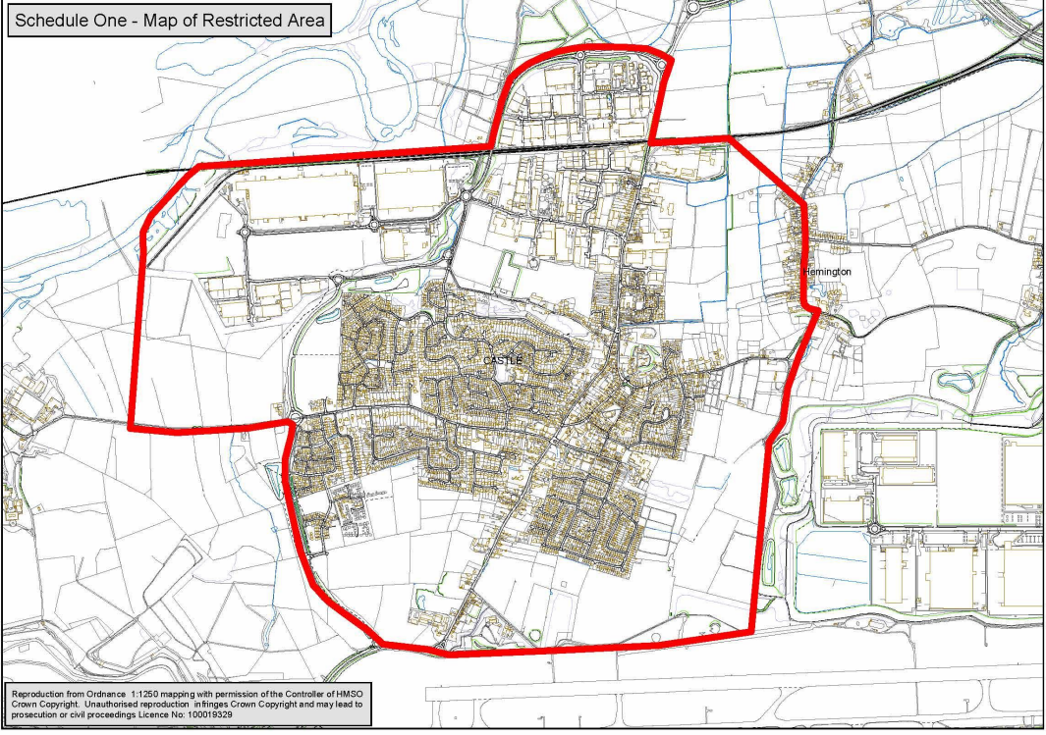
Thanks were given to The Clerk and all who helped with the comprehensive report.
RESOLVED: To request NWLDC representative and CEO to attend the next Parish Council meeting to give an update.

5103/24 ACCOUNTS
- RESOLVED: To approve payments scheduled for July as circulated to all councillors at a total cost for the month of £55,954.35.
Name | Description | Amount
RJ Executive Cleaning Solutions | Cleaning | 396.00
Screwfix Direct Ltd | Equipment | 19.99
Aldi | Cafe items | 26.12
Donington Nurseries | Consumables various | 15.99
CD Community First Responders | First Aid Kit | 140.00
Beta Electrical Contractors | Electrical Works | 49.62
Ulyett Landscapes Ltd | Grounds Maintenance | 7,116.60
ML Palnt Hire | Vehicle repairs | 116.40
NWLDC | Rates Hub | 339.00
NWLDC | Rates Hub | 1,410.00
NWLDC | Rates - Village hall | 282.00
Aviva | Pension | 33.00
Peninsula | HR services | 273.86
Water plus | Water Sports Pavilion | 82.21
Aviva | Pension | 827.66
4 Com Network Services Ltd | Phone | 134.52
SSE | Gas Hub | 416.30
SSE | Gas Hub | 249.90
EDF Energy | Electricity Cemetery | 118.34
Toolstation | Repairs | 473.37
RJ Executive Cleaning Solutions | Cleaning | 405.00
Kieron Lehrle | Fuel | 58.60
Style Midlands | Repairs | 615.60
Style Midlands | Door servicing | 300.00
Keepsafe Security Services Ltd | Alarm call out | 30.00
Chubb | alarms | 1,455.98
Viking | Stationery etc | 224.74
Continental Coffee Company | Cafe items | 60.14
Travis Perkins Trading Co Ltd | Cleaning materials - General | 120.61
St Edwards church | Hall hire | 104.50
Hutchinsons | Planting | 413.34
Continental Coffee Company | Cafe items | 72.80
G Burley &Sons | Hanging Baskets | 1,548.36
Ilkeston Fencing Ltd | Fencing Work | 9,078.13
SC IT Solutions Ltd | Computer Costs | 54.00
SC IT Solutions Ltd | Computer Costs | 108.84
SC IT Solutions Ltd | Computer Costs | 42.00
NWLDC | Legal costs | 180.00
NWLDC | Rates Cemetery | 63.00
Grenke Leasing Ltd | Cafe till | 41.99
Aldi | Cafe items | 16.43
Barclaycard | Card
Barclaycard | Bank Charges | 20.00
HSBC | Bank Charges | 49.04
Paytek Admin Services Ltd (UTP) | Bank Charges | 22.80
Cupitt and Son | Maintenance | 1,850.00
Chubb | alarms | 399.00
TML | Phone | 110.46
Jamie Christian | Maintenance | 4,200.00
RJ Executive Cleaning Solutions | Cleaning | 405.00
RJ Executive Cleaning Solutions | Cleaning | 432.00
EE | Phone | 100.96
NWLDC | Rates - Spital | 395.00
PEAC | Phone equipment | 322.80
Corona Energy | Electricity Spital Playing fields | 90.47
Corona Energy | Electricity Hub | 865.62
EMS | Card machine Fee | 15.34
Water plus | Water - village hall | 158.02
Various | Commercial Card | 653.30
Take Payments Ltd | Cafe till | 24.00
Aldi | Cafe items | 22.67
Staff | Wages | 14,895.86
Aldi | Cafe items | 6.40
Aldi | Cafe items | 18.87
Aldi | Cafe items | 1.53
Aldi | Cafe items | 36.98
coop | Cafe items | 4.45
coop | Cafe items | 11.18
Aldi | Cafe items | 29.29
Aldi | Cafe items | 1.70
Aldi | Cafe items | 20.88
Aldi | Cafe items | 1.29
Aldi | Cafe items | 9.03
Aldi | Cafe items | 10.75
Soldo | Card fee | 21.60
Bayliss Consulting | Hub costs | 900.00
Chubb | Alarm call out repairs | 314.04
Gleaming Panes Ltd | Window cleaning | 28.00
Jencourt Group | Workwear | 74.34
Viking | Stationery etc | 224.74
T H Heath Contracts Ltd | Grounds Maintenance | 1,692.00
 |  | 55,954.35

- RESOLVED: To review and receive receipts for July as circulated to all councillors at a total cost for the month of £13,225.90.
Name | Description | Amount
Barclaycard | Library expenses | 6.20
Hub Cafe | Cafe Takings | 21.70
Hub Cafe | Cafe Takings | 59.90
Hub Cafe | Cafe Takings | 95.30
Hub Cafe | Cafe Takings | 81.10
Hub Cafe | Cafe Takings | 32.70
Hub Cafe | Cafe Takings | 47.50
Hub Cafe | Cafe Takings | 36.10
Hub Cafe | Cafe Takings | 313.90
Horrobin Memorials | Memorial fees | 101.00
Kinton & Daughter Family Funeral Directors | Burial fees | 647.00
Kinton & Daughter Family Funeral Directors | Burial fees | 318.00
CDFC | Football Club Annual Fee | 943.92
Facility hirer | Bookings - Hub | 73.50
Natalie King | Allotment Key | -20.00
Facility hirer | Bookings - Spital | 63.50
Facility hirer | Bookings - Hub | 81.00
Fused Youth Club | Bookings - Moira Dale | 96.00
Slimming World | Bookings - Spital | 186.00
LCC | Urban grass cutting | 2,496.81
Facility hirer | Bookings - Hub | 69.50
Allotment holder | Allotment Rent 2024/2025 | 51.05
Barclaycard | Library expenses | 5.40
Barclaycard | Library expenses | 3.00
Hub Cafe | Cafe Takings | 57.90
Hub Cafe | Cafe Takings | 71.30
Hub Cafe | Cafe Takings | 2.20
Hub Cafe | Cafe Takings | 174.10
Hub Cafe | Cafe Takings | 62.30
Hub Cafe | Cafe Takings | 36.20
Hub Cafe | Cafe Takings | 246.08
Barclaycard | Card | 2.20
First Responders | First aid | 140.00
British Gas | Gas refund | 236.46
Hub Cafe | Cafe Takings | 15.70
Barclaycard | Volunteer shopping | 124.00
Red Dot Theatre Company | Bookings - Spital | 279.00
Barclaycard | Library expenses | 4.00
Hub Cafe | Cafe Takings | 47.30
Hub Cafe | Cafe Takings | 2.20
Hub Cafe | Cafe Takings | 228.95
Hub Cafe | Cafe Takings | 62.70
Hub Cafe | Cafe Takings | 45.70
Hub Cafe | Cafe Takings | 108.80
Hub Cafe | Cafe Takings | 59.50
Hub Cafe | Cafe Takings | 36.20
Hub Cafe | Cafe Takings | 124.50
Hub Cafe | Cafe Takings | 53.80
Hub Cafe | Cafe Takings | 81.60
Hub Cafe | Cafe Takings | 60.60
Hub Cafe | Cafe Takings | 282.82
Hub Cafe | Cafe Takings | 156.60
Barclaycard | Library expenses | 8.00
Facility hirer | Bookings - Spital
North West Leicestershire District Council | Bookings - Spital | 35.00
Central Memorials | Memorial fees | 77.00
Roger Smeeton & Co Memorials Ltd | Memorial fees | 59.00
Facility hirer | Bookings - Spital | 73.50
Facility hirer | Bookings - Hub | 92.00
Radiance Yoga UK | Bookings | 105.00
Volunteer Centre | Consumables various | 87.24
Kinton & Daughter Funeral Service Ltd | House Rent | 1,155.00
Castle Donington Cricket Club | Cricket Fees | 89.44
Chellaston Cricket Club | Cricket Fees | 97.76
Facility hirer | Bookings - Hub | 116.88
Facility hirer | Bookings - Moira Dale | 187.00
Facility hirer | Bookings - Moira Dale | 60.00
Hub Cafe | Cafe Takings | 85.50
CCLA | Interest | 2,284.79
 |  | 13,225.90

- Bank statements and bank reconciliation for July. RESOLVED: To review and approve bank statements and bank reconciliation for June.
Bank balances:
- Current account – £7,402.87.
- HSBC savings account – £207,187.48.
- Public Sector Deposit Fund (earmarked reserves) – £518,536.28.
- HSBC savings account (earmarked reserves) – £618,677.18.
- Soldo (pre-payment card) – £9.28.

5104/24 RECREATION COMMITTEE MATTERS
- Skatepark upgrade – To consider a plan of action to progress this project.
Background
The existing skatepark was installed at Spital Park 23 years ago after consultation with the young people of Castle Donington. Over the last few years, it has been re-painted and re-surfaced on a number of occasions. The style and types of equipment were those that were popular 23 years ago. The skatepark is still well used, but it has come to its life in terms of financial viability and design options.

Business Plan
The Parish Council has included the upgrade/replacement of the skatepark within its Business Plan for several years with it being funded from the Section 106 money received from the new developments.

Current position
The existing location of the skatepark is within the carpark at Spital Park playing field. It is now compromising the carpark capacity for other activities and events.
Information gathering in respect of potential different suppliers and designs for a new skatepark have been researched and investigated.
Initial discussion with the College school council has been started. The young people are keen to be involved and through collaboration will ensure a sense of pride in any new facility.
The cost of a new skatepark will necessitate the need to go out to tender through the Government Contracts Finders website as per financial regulations.
Section 106 funding is in place towards the cost of such a project as per the Business Plan. However, the cost of skateparks has risen since the Covid Pandemic and there is a need to re-consider a ballpark figure to be able to go out to tender.
Grant funding maybe possible to increase the available pot of funding. This will need the support of the young people for any applications.

RESOLVED: To approve the scope, location and tender process, ballpark figure for scheme and closing date for tender.
- 3G project – Following a recent meeting with the College, it has been confirmed that they will be submitting a planning application for the 3G in their preferred location which is nearest to the school playground. This decision was after consultation with the LCC education in relation to the potential new housing developments in the locality and the possible future expansion for additional school place. RESOLVED: To receive the information.

- Land behind Moira Dale – This area of land should be transferred to the Parish Council in the near future. Discussions are needed as to what the land is to be used for, how to get designs and advice from various bodies, and how works can be funded other than through the Section 106 funding, i.e. sponsorship and grants. A sperate informal meeting is needed to start the ball running and for the Clerk and Chairman to update on various areas that have been explored and to then be in a position to set up public consultation in the autumn. RESOLVED: To send invitations out by email.

- Sports pitch provision for the forthcoming season, update on pitch works and pitch usage. The Parish Council has been working with the existing users of its facilities to ensure pitch works are completed before the start of the new seasons. The Parish Council has been approached by additional clubs to use the facilities, however, due to capacity, staffing and unknown potential issues with the college pitch usage, only one additional club has been accepted for this season. This is Hemington Hammers junior team using a 9v9 pitch at the college. RESOLVED: To receive the information.

- West Meadow – This area of land was created as part of the planning process for the East Midlands Distribution development. Over recent years, the area has become neglected and misused, allowing for little use by the general public. Discussions with the developer are ongoing to bring this area up to a more usable state in line with the original planning condition. RESOLVED: To receive the information.

- Sports Hall provision – To receive an update and consider a quote and plan to progress a Needs Assessment in this respect.
In April a full update on why this matter was being discussed took place, including the Needs Assessment (NA) previously undertaken to assist the Parish Council in its forward plan for the Section 106 funding for recreation that it was to receive. The NA was previously undertaken in 2015 and it did include for some forward projections, however, with the continued growth and the likely impacts for further growth as part of the revision of the Local Plan, then an additional update review in relation to the provision of a sports hall was required.
The cost of this work will be in the region of £11,000 with the preferred supplier (at the previous stage in 2015, a full procurement process was undertaken).
During discussions, Cllr Saffell stated that NWLDC was already progressing a similar report and that there was a substantial amount of money earmarked for Castle Donington (£5m). It was also stated that the Clerk and Chairman of Recreation had been “going-off at a tangent off their own back”.
RESOLVED: To request confirmation from NWLDC as to the earmarking of the money and that their Needs Assessment report was already substantially along the way to being completed.
RESOLVED: That if confirmation was not received, from NWLDC that funds were earmarked for Castle Donington (as stated by Cllr Saffell) and that the consultation in respect of this matter was being progressed in a timely manner, that the Parish Council would undertake its own Needs Assessment survey in relation to the need, funding options, site suitability in respect of a sports hall.

5105/24 PLANNING COMMITTEE MATTERS
- Local Plan – To consider additional comments. A report was circulated to all councillors. RESOLVED: To submit the following additional comments:
New settlement
In principle CDPC supports the development of a new settlement rather than additional housing allocations to Castle Donington or other nearby locations. This is because the infrastructure and service provisions required to support new housing and an increased population will be better achieved from a new settlement. Infrastructure and local services are already stretched in Castle Donington. Further housing development will have a significant and detrimental impact on the locality.

A new settlement with the ability to provide the sufficient levels of infrastructure and connectivity could only be of benefit for the whole area.

It would appear the companies involved are keen to work with the existing local communities to ensure that there are minimal adverse effects whilst providing a cost effective and stylish development with sufficient provision for services and capacity to sustain it.

New settlement prioritisation
CDPC has a strong preference for the land between Worthington and Belton being prioritised for a new settlement when compared to the proposed Isley Woodhouse site. The drawbacks of the Isley Woodhouse proposal have been well documented by others and include proximity to East Midlands Airport, Donington Park, the proposed Freeport and Diseworth. New housing will be affected by noise, air pollution, mental health affects.

Deliverability
It is understood that there needs to be sufficient supply of deliverable and developable land to deliver the Council’s housing needs requirements and to ensure that a five-year supply can be maintained throughout the Local Plan period.

Having had discussions with Pegasus and other partners at recent workshops, it would appear that the suggested build rate of a new development, Isley Woodhouse, is on the very conservative side and that they would anticipate that they would easily be able to provide a build rate of at least 250 houses per year throughout the plan period.

CDPC supports the view purported by Pegasus, and noted in its submissions, in this regard.

This built rate could be adversely affected if another separate development of 1,000 houses off Park Lane were allowed as this would be aiming at the same market at the same time, thus diluting the sales capacity and thus the build rate of both developments. This would create a lose-lose scenario.

The proposed development off Park Lane will also cause an overconcentration of growth in the one area of the district.

Site allocation to support and match the Council’s ambitions for a sustainable New Settlement could be provided with the delivery of Isley Woodhouse which as proposed provides for exemplar placemaking, landscape led scheme, provision for biodiversity net gain, accessible and affordable providing the housing needs and styles appropriate for the key employment sites of the locality.

Delivering a new settlement at Isley Woodhouse will achieve the Council’s housing pipeline requirements. Delivering a new settlement at Isley Woodhouse and maximising the number of houses will meet potential future pipeline requirements without the need for further large-scale housing provision in Castle Donington. Allowing further housing development in Castle Donington will adversely affect the delivery potential of Isley Woodhouse, both in terms of overall numbers and rate of delivery.

Castle Donington or Ashby for further large-scale housing provision

Reports to the Local Plan Committee have suggested that Castle Donington and Ashby are comparable when it comes to deciding housing allocations. This is based on the fact that they are both categorised as Key Service Centres and therefore it has been offered that there is a fine balance between the two locations. While the two locations are categorised similarly, it is simply ludicrous to suggest that, in reality, they are similar. The balance is not fine.

In reviewing the documents hitherto submitted, CDPC strongly insists that the proposed settlement hierarchy fails to take the current differences into account including the level of choice and size of service provision between the two locations.

The need for a Principal Town is understood, however, the level of services and infrastructure in Castle Donington does not reflect those of Ashby. This is true now, in the near future and in the medium term when considering potential for improvement.

A separate hierarchy position for Ashby on its own merit is required. The recent methodology of the recent settlement survey is clearly flawed as it does not reflect reality and masks the full extent of the distinction between Ashby and Castle Donington.

CDPC’s view is that all settlements should be reassessed to fully take into account each service available and the type of service in order to fully understand the role of individual settlements. A common-sense view should ultimately prevail, and the Local Plan should be based on up-to-date assessments.
Where there is a choice between Ashby or Castle Donington for further large-scale housing provision, CDPC’s evidence-based view is that Ashby should be chosen.
Increase of housing provision in Castle Donington – further comments
Another large-scale housing development off Park Lane would, yet again, be a piecemeal development, not allowing for the necessary infrastructure to support the increased numbers of people. There will be no provision within a Section 106 agreement to provide for secondary education (due to the proposed agreed policy plan guidelines), yet the college in Castle Donington is already struggling for capacity and level of service provision, especially since being transferred to a through school – 11-16 years.

The implementation of another 1,000 houses on the other services, especially doctors (the GP surgery is currently closed due to staffing problems) and chemist and other local village services will not be able to cope. The proposed development area is at odds and physically separated by the Relief Road to the rest of the built development and the local centre and services. It is likely to become a dormitory style development with no community spirit. Transport will always be needed to get to the existing services and local centre. This will increase the carbon emissions rather than reduce them.

The implementation of another piecemeal development will have increased and major effects of the existing highway provision but will not allow a sufficient need as a standalone development (new settlement) to provide for the increased levels and improvements to the highway infrastructure.

An additional development of 1,000 will only increase the lack of sustainability for Castle Donington without the ability to negate the issues, whereas a larger development – Isley Woodhouse will be able to sustain and provide for necessary strategic highway works and improvements and also the other needs in relation to schooling and health facilities.

The District Council is currently consulting on a parking review to bring forward charges for the carparks in the district. As the village stands this will have an adverse impact on needs of the local community to access services. Add on to this another 1,000 houses and no other provision for new services and it will have a catastrophic adverse effect on those living and working in the local community.

Housing affordability
New housing should be affordable for local workers. Specific provision may be needed to achieve this over and above that which may be required by national guidelines.

Highways
When considering the impact to highways and works required to ensure the road network can support the developments, a strategic and holistic view must be taken including all housing proposals, freeport proposals and other large developments. A piecemeal approach, whereby minor amendments are introduced for a particular large project will be potentially disastrous. Highways upgrades should be complete prior to any large-scale building works.

- High Street conservation area review. Discussion took place at informal meeting and councillors were asked to consider if there were any comments they wanted to make in relation to this review. Copy circulated to all councillors and available on NWLDC website. A number of suggestions were made in the discussions with the Conservation officer, who was going to take away and amend the draft document accordingly. RESOLVED: To receive the update report.
- High Street – street naming. To consider alternative options to put forward the developer and NWLDC. Discussion took place and it was felt that the name Bailiffs Mead should remain taking in to account the history of the name and that it is in the conservation area. RESOLVED: To request the name of Bailiffs Mead remains and to add a plaque to explain the history of the name.

- To consider the following planning applications:
PLAN NO | ADDRESS | DETAILS | OBSERVATIONS
24/00727/OUTM | Land South of A453 Ashby Road North of Hyams Lane | Outline planning permissions (means of access from 453 fixed; all other matters reserved for future determination) for the construction of employment floorspace (use classes B2/B8) with ancillary (integral) offices (use class E(g)(i)); and associated infrastructure including earthworks, internal estate road, parking and landscaping (all) | ..\..\..\Meetings\Clerks reports\2024\July\Planning application 24-00727-FULM.docx
24/00766/FUL | 2 Shields Crescent | Erection of two storey side and front extension and single storey front extension | No objection however CDPC would request that the neighbour’s objection requesting an opaque window is taken into consideration
24/00751/LBC | 67 High Street | Listed Building Consent for internal and external alterations including alterations to windows, doors and external detailing and the inclusion of an external heat pump for plot no 2 | Object until the Conservation Officers concerns are addressed
24/00805/FUL | 13 Clapgun Street | Lime render to rear elevations | No objection
24/00620/ADC | Plot 3B, Arundel Avenue | Display of 1 no. internally illuminated letterset sign | No objection
24/00741/LBC | James Farmer Almshouses27-45 The Biggin | Replacement of all windows to the front and rear elevations from single glazed units to wooden mock sash double glazed units (Listed Building Consent) | No objection
24/00852/FUL | Beauty Temple, 17 Market Street | Retrospective change of use from offices (Use Class E(g)(i)) to Beauty Salon (Use Class Sui Generis) | No objection
24/00872/ADC | Unit 1, Wilders Way, Kegworth, Segro site | Display of 1 no. internally illuminated totem sign and the retention of 2 no. internally illuminated fascia signs (northern and western elevations), 2 no. non-illuminated fascia signs (eastern and southern elevations) and 2 no. internally illuminated totem signs previously approved under application 19//01000/ADC | No objection
RESOLVED: To make the comments as detailed above.

- To receive the following permission notices:
PLAN NO | ADDRESS | DETAILS | OBSERVATIONS | DECISION
24/00543/FUL | 20 Fox Road | Erection of single storey rear extension | No objection | Approved
24/00528/FUL | 22 Clapgun Street | Installation of three replacement windows to front elevation | No objection | Approved
24/00529/LBC | 22 Clapgun Street | Installation of three replacement windows to front elevation | No objection | Approved
24/00501/LBC | 17 Market Street | External and internal alterations (amended scheme to 19/02445/LBC) | Object  - Support Conservation Officer and neighbour concerns  - Highway concerns due to no parking spaces on site  - Over intrusive and loss of amenity for neighbours  - Concern that previous consents are not complied with therefore any breaches please ensure appropriate enforcement action is taken | Approved
RESOLVED: To receive the above permission notices.

Meeting closed 8.32 pm

Signed __________________________

Print Name ______________________ Date ________________________

Site plan.
Draft tender document.

