Castle Donington parish council

Minutes of the Full Council Meeting held on Thursday 22 February 2018 at 7.30 pm at the Parish Rooms, Hillside, Castle Donington

present : Cllrs R Sizer (in the chair), S Ambrose-Jones, C Burton, G Dalby, N Daykin, R Else, D Groom, G Roberts, A Saffell, A Sowter and D Wintle. Cllr T Pendleton-LCC, Cllr R Canny-NWLDC, Cllr D Harrison-NWLDC, PCSO K Bradley and 6 members of the Public.

apologies: Cllr C Hills (illness).

aBSENT: Cllr M Barker-Lane.

DECLARATIONS OF INTEREST:
Cllr S Ambrose-Jones declared a non-pecuniary interest in planning applications 18/00049/FUL and 18/00156/ADC
Cllr N Daykin declared a non-pecuniary interest in planning applications 18/00049/FUL and 18/00156/ADC
Cllr A Saffell declared a non-pecuniary interest in the matter relating to staff wages as his daughter is employed by the Parish Council.

To waive standing orders to move item 9 Planning Applications for discussion after item 2 Approval of Minutes with resident participation.

3927/18 POLICE MATTERS
- PCSO K Bradley updated the Parish Council
RESOLVED: To receive the report:

CRIME FIGURES: -

Please visit this link for the most recent crime figures in the Parish:-

https://www.police.uk/leicestershire/NN43/crime/+4JZHs9/

CRIME PREVENTION ADVICE:-

“Lock up and light up”.

The daylight hours have now reduced during the winter months and we would like to remind residents to take steps to reduce the attraction of their properties being in darkness and appearing to be easy targets for burglary. If your property appears occupied then it is less likely to be targeted. There are a number of devices you can obtain to assist you in keeping your property lit during the hours of darkness such as appliance timers and “fake TV” type devices. Please make use of your home alarm systems and look out for your neighbours. Remember to enter / update your property on www.immobilise.com

North West Leicestershire has seen an increase in the number of thefts of Vehicle Registration Plates. ALL residents are reminded that the Local Police Teams have an arrangement with Coalville Tyre and Exhaust to fit Tamper Proof Screws FREE OF Charge.

Coalville Tyre & Exhaust
206 Central Road
Hugglescote
Coalville
LE67 2FG

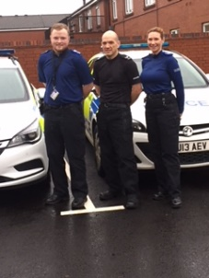
INSPECTOR BHAKTA’S NEWS February 2018

Welcome to the first blog of 2018.
I’m sure you may have noticed we have relocated to our new premises alongside our colleagues from Leicestershire Fire and Rescue Service.
Even though we have been on the move we haven’t taken our eye off the ball, here’s a roundup of the many things we have been working on:

Christmas Celebrate Safely
Our Christmas ‘Celebrate Safely’ Campaign was a lot of hard work but well received. The police, North West Leicestershire District Council (NWLDC) and Leicestershire Fire and Rescue Service worked together with Pubwatch; local businesses and communities to make our towns and villages a safer and more secure place to be. Hermitage FM also helped us by sending out some key safety messages.

There was also a joint operation between NWLDC licensing and the police to check on taxis and private hire vehicles. In total 19 vehicles were referred to the testing station for examination by mechanics. Their findings were:
- 11 were found with defects
- One plate was removed and suspended
- 10 required re-inspection at the depot
- All drivers were in possession of their badges
Andy Cooper NWLDC Licensing lead said; “This was the busiest operation we have ever run”.

For anyone who follows www.facebook.com/NorthWestLeicsPolice/ you would have seen myself and Sergeant Ian Weston appealing for our residents to nominate a vulnerable person to receive a crime prevention pack, the response was amazing and between this appeal and the events we attended managed to hand out at events over 500 personal safety, vehicle crime and burglary prevention packs. (Castle Donington Co-Op were the local involved business).
We are grateful to NWLDC Community Safety Team who part funded the packs and the police volunteers that packed a lot of bags.

Drink Drive Campaign.
North West Special Police Constables led on the National Drink Drive Campaign. On the launch date 1/12/17 they administered four road tests in Ashby. Three people had alcohol in their system having had a drink after work but were below the police limit. One male was arrested and later charged. It was disappointing to learn he had a previous conviction for drinking and driving.
On 2/12/17 the specials undertook a morning after initiative. No breath tests were administered however one male was arrested for driving whilst under the influence of drugs. Officers are now equipped with road-side drug testing kits.

Across the force area we arrested a total 99 people for being unfit behind the wheel during December including 21 for drug driving:
- 35 of these arrests were made following a road traffic collision
- 33 of the arrested drivers were aged 25 or under
- Over a third of the arrests were made in Leicester (37) along with significant numbers in Charnwood (21), North West Leicestershire (12) and Hinckley & Bosworth (9)
- The highest road side breath tests was 141, over four times the legal limit

Jonathan Clarkson, spokesperson for the Leicester, Leicestershire and Rutland Road Safety Partnership said, “The number of arrests is significantly up on December 2016, when we saw 50 people arrested, including 46 drink and 4 drug.”

Recent arrests, summonses and charges
George Ellul, 49 years old of Hermitage Court Whitwick appeared in Court on 21/11/17 where he was sentenced to 13 weeks imprisonment for possession of Class ‘A’ drugs, burglary and breach of his suspended sentence order.
41 year old William Ritchie of Price Street Coalville appeared in Leicester Crown Court on the 19th January and was sentenced to a total of 4 years for two burglaries.
Three people have been charged and remanded in custody in connection with a series of ATM attacks across the East Midlands and neighbouring counties last year:
- Heathan Hall, 27, of Copt Oak, Markfield,
- Wayne Smith, 35, of Manor Road, Barlestone,
- Swaly Price, of no fixed address

Neighbourhood Priority Team
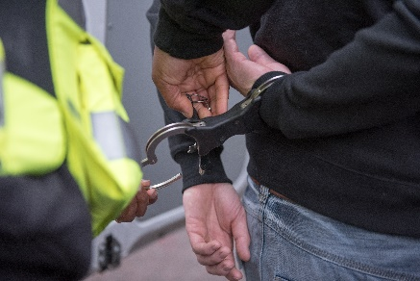
Since 4th January, North West Neighbourhood Priority Team officers have been conducting both high visibility and plain clothed patrols around Measham and the Bardon area. So far they have arrested two people for burglaries, one of which has been charged and the other is still under investigation. Other arrests included: two for theft from motor vehicles, one for drink drive and five people were stopped and search after being found in an abandoned building.

It was a little disappointing that despite all this activity in North West Leicestershire, crime for December 2017 rose slightly by 6.9%. However we performed much better than the force overall which is up 17%. That made us feel it was worth the long hours.

Nationally crime is up 22 % and regrettably Leicestershire Police is following that trend. We are however mindful that changes to our crime reporting methods coupled with encouraging people to report hate crime, sexual offices, child sexual exploitation, human trafficking and domestic violence will increase the figures.

Information Initiative

From 23rd January a new campaign is being launched across Leicester, Leicestershire and Rutland to encourage people to keep vital personal and medical information in a bottle in their fridge.
Each bottle comes with two stickers which should be stuck on the inside of the front door and on the fridge door which should alert you to the fact that there is a bottle in the fridge with information in it.
Finding that information will save a lot of time and give you quick useful information about the person if they have gone missing or something has happened – in fact it could help us save a life. You can pick up bottle from the Front Enquiry Desk at North West Leicestershire District Council.

Meet your beat team
Over the coming months we will be holding beat surgeries across the area, why not pop along and meet your local officer, perhaps raise any concerns you may have.

21/03/2018 1730hrs Belton Primary School

21/03/2018 1930hrs Coleorton - The Moorlands

14/04/2018 1030hrs Sawley Marina

02/06/2018 1030hrs Kegworth Fun Day – Sideley Park

24/06/2018 1100hrs Breedon Village Fete

01/07/2018 1300hrs Music in the Park – Castle Donington
Details of further surgeries can be found at https://leics.police.uk/local-policing

I hope you have found my blog interesting reading.
Don’t forget you can follow us on Twitter @NWLeicsPolice and Facebook NorthWestLeicsPolice
Helena Bhakta
Commander - North West Leicestershire Neighbourhood Policing Area
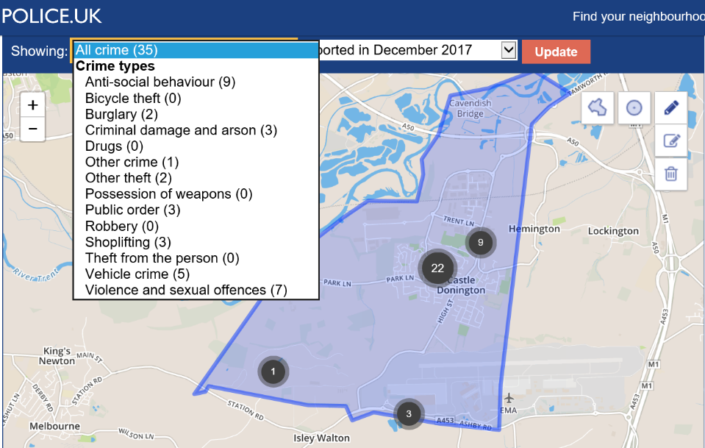

3928/18 CONFIRMATION OF THE MINUTES
RESOLVED: To receive and approve the minutes with the following amendments:
- Full Council – 1 February 2018 – Declaration of Interest for Cllr A Sowter– add “Cllr A Sowter left the room at this point and took no part in the discussion”.
- Committees – 8 February 2018 – amend item 007/18 a) ii. Music in the Park resolution to: - To accept the quote for £2140 including additional speakers.

3928/18 planning applications

PLAN NO | ADDRESS | DETAILS | OBSERVATIONS
18/00156/ADC | 10 Bondgate | Installation of 3 no. externally illuminated fascia signs and 1 no. externally illuminated projecting sign | OBJECT - proposed signage is almost twice the size of the existing signage therefore obtrusive, not in keeping within a conservation area or compliant with NWLDC guide lines.
18/00049/FUL | 10 Bondgate | Change of use from a shop (Class A1) to a hot food takeaway (Class A5); installation of extraction/ventilation equipment and other external alterations - amended application - additional noise report available | OBJECT - the Parish Council objects as per the comments already submitted on 1 February 2018. In addition following a recent review of the traffic arrangements on the junction of Market Street/Bondgate the Highway Authority have further reduced the number of available car parking spaces on Market Street by 3.
18/00159/ADC | Donington Court, Herald Way, East Midlands Airport | Display of two non-illuminated signs to front elevation of building | No objection
18/00197/FUL | 73 Shields Crescent | Erection of two storey rear extension | No objection
RESOLVED: To receive the information.
3929/18 planning DECISIONS

PLAN NO | ADDRESS | DETAILS | OBSERVATIONS | DECISION
17/01386/VCIM | DHL Aviation Building | Variation of conditions 2,3,4,5,7,8,13,14,15 and 18 along with removal of conditions 9 and 19 of 15/00319/FULM |  | Approved
17/01806/FUL | 38 Ferrers Close | Erection of a two storey side extension | OBJECT - over intensive development of site | Approved
17/00991/FULM | Donington Hall | Erection of a single storey industrial building extension to the Manufacturing Centre of Excellence building | No objection however CDPC would expect an archeological assessment to be carried out prior to permission being granted. | Approved
17/01818/FUL | 113 Park Lane | Single storey front and rear extensions with conversion of existing garage and internal alterations | No objection | Approved
17/01706/ADC | Donington Park Race Circuit, Donington Park | Installation of internally illuminated pylon |  | Approved
18/00047/AIR | Dakota Road, East Midlands Airport | Proposed relocation of the Hunger Hangar Café (consultation by East Midlands Airport) | No objection | Approved

RESOLVED: To receive the information.

3930/18 CHAIRMANS REPORT
- Update on meeting with LCC re High Street junction and Section 106 £250k – Cllr R Sizer updated the Parish Council on the meeting: -
  - Discussion took place regarding the Section 106 monies and it was stated that circa £150k is still available for improvements to the area. RESOLVED: LCC is to confirm to the Parish Council as where the Section 106 monies have been spent and confirm that £150k is still available.
  - Signalling at the junction has been altered to create a four-way changing sequence; the installation of a box junction at the bottom of Market Street/Bondgate, both of which are to improve pedestrian safety and create a more even spread of the traffic congestion. The lights are “smart” traffic lights but are having to cope with excessive traffic due to Smart Motorways and Roxhill development for the SRFI; the junction is 100% over capacity it was designed for. A number of complaints have been received regarding the build-up of traffic on High Street and Bondgate and Park Lane. LCC confirmed the lights were being monitored and will be continued to do so for a period of time, with timings adjusted and are now set to the maximum of traffic movement. RESOLVED: To receive the information.
- Development off Carnival Way – The Parish Council has concerns about this application, due to its location within the village and not on preferred HGV routes. It was confirmed that no highways comments have been received by NWLDC Planning. Alternative locations for the development are preferred due to their ability to use the HGV routes around the village and not through it. RESOLVED: To invite the developer to the next Full Council meeting and to write to Ian Nelson, NWLDC, insisting that they chase for the LCC highways comments.

3931/18 CLERKS REPORT
- Comments Register. RESOLVED: To receive the information.
Complaint | Complaint received regarding toilet doors at Spital Pavilion. Complainant said that member of the public had become trapped.
Resolved | CDPC Groundsman visited site to check locks all doors can be opened from the outside and inside.
Complaint | Complaint received regarding car driving on Spital Playing Field
Resolved | CCTV footage reviewed and dealt with by the police
Complaint | Complaint received regarding overgrown and fallen hedging on High Street
Resolved | Report sent to LCC to investigate REF FS66379496
Complaint | Complaints received regarding state of West Meadow e.g. broken fencing and deep ruts
Resolved | Email sent to land owner to rectify CDPC will await confirmation of works to be carried out
Complaint | Complaint received regarding lack of grit bins on Spitfire Road Estate. Resident was concerned for safety in wintery conditions.
Resolved | CDPC explained that as the Spitfire Road Estate has not yet been adopted as part of the highway and for this reason LCC would not consider putting grit bins on the road. CDPC also contacted the developer who stated they had no provision to install grit bins or deal with adverse weather.
Complaint | Complaint received regarding damage caused to the electricity box outside Methodist Church.
Resolved | Email sent to Church to inform. Church was aware and had turned off supply.
Complaint | Complaint received regarding the number of cars parking closely to the junction on Tanyard Close. Resident asked if double yellow lines could be extended as there had been a lot of near miss accidents at the junction.
Resolved | Email sent to LCC REF 696426 LCC commented saying that the parked cars could add to traffic calming and that double yellow lines would not be placed in this area. Any cars considered to be park dangerously should be reported to the police.
Complaint | Complaint received regarding white lines not being reinstated at Darsway
Resolved | Email sent to LCC to investigate REF 2191350219190
Complaint | Complaint received regarding children playing ball games and causing damage.
Resolved | CDPC suggested resident should contact school if known or parents.
Complaint | Complaint received regarding dangerous and inconsiderate parking on Eastway and damage being caused to verges by parking vehicles. Resident requested that parking bays be put in.
Resolved | Email sent to LCC regarding damage to verges and request for parking bays. Evidence of parking sent onto police.

- Ground clearance works for the relief road are due to be undertaken starting with the Hilltop to Park Lane section. RESOLVED: To receive the information.
- Parish Liaison Working Group – The Clerk attended this recently to look at ways of improving / continuing to ensure the experience meets everyone needs. NWLDC is keen that the Parish Liaison meeting are parish led and interactive. They are looking for more input from parishes. Shortening the meetings was discussed but it was felt that the current format worked well, but they may have one meeting that is more of a showcase event of services that can be provided by NWLDC or other service providers. It is also proposed that there may be a newsletter in between meetings to ensure relevant information is sent out in a timely manner. RESOLVED: To receive the information.
- Grants are available from NWLDC to promote 100th Anniversary of WW1; Parish Council and other groups can apply. The British Legion has been advised and will be looking to utilise it. RESOLVED: To receive the information.
- Airport Parking – Free parking at the airport has been communicated to local licensing authorities to encourage the use by taxis in particular instead of parking on grass verges. RESOLVED: To receive the information.
- Lamp post poppy scheme by NWLDC – small grants are available to encourage poppies to be put up and around the district. The matter was discussed at the British Legion meeting recently and the preferred option is for the Parish Council to facilitate this as last year and try and raise additional funds for the British Legion, plus ensuring that poppies are put up and taken down at the appropriate times. RESOLVED: To receive the information.
- £50k grant from NWLDC; the second payment of the agreed £100k for community projects in the Northern Parishes is being progressed by the Chief Executive, Bev Smith. RESOLVED: To receive the information.
- New bus service is being implemented between Ilkeston and the airport via Trent Lane and Darsway with an hourly service between 6.00am and 11.00pm. RESOLVED: To receive the information.
- Street Trading application from for A & S Catering had been received which was e-mailed to all Councillors for comment. RESOLVED: No objection.
3932/18 REPRESENTATIVES REPORT
Cllr A Saffell updated the Parish Council on the recent visit to the Planning department at NWLDC by LGA “Peer Challenge”, the aim of this to have an in depth look at the planning service and give a critical friend’s view of the strengths, weakness and opportunities of it. RESOLVED: To receive the information.
3933/18 ACCOUNTS
- Payments scheduled for February 2018 including the payment for February wages.
RESOLVED: To approve the payments for February. Cllr A Saffell did not vote.

Cheque No | Description | Supplier | Total
DDFeb01 | Electricity Hub | SSE | 81.09
DDFeb02 | Pension | Aviva | 33.00
DDFeb03 | Council Tax - Cemetery House | NWLDC | 130.00
DDFeb04 | Phone | BT | 281.64
DDFeb05 | Bank Charges | HSBC | 16.18
3172 | Alarm call out | Keepsafe Security Services Ltd | 24.00
3173 | Computer Costs | SC IT Solutions Ltd | 30.00
3174 | Grounds Maintenance | Ulyett Landscapes Ltd | 5,365.80
3175 | Gravel | Travis Perkins Trading Co Ltd | 22.90
3176 | Donation | Castle Donington & District Twinning Assoc | 500.00
CommCard | Chain saw parts | L & S Engineers Ltd | 119.29
CommCard | Legionella Equipment | Electronic Temperature Instruments Ltd | 266.00
CommCard | Legionella Signs | Seton | 22.51
3177 | Conference expenses | SLCC Enterprises Ltd | 150.00
104942 | Land registry fees | HM Land Registry | 40.00
104943 | Land registry fees | HM Land Registry | 40.00
Commcard | Internet charges | Heart Internet | 16.19
DDFeb06 | Phone | EE | 29.16
3178 | Fuel | Martyn Lee | 84.40
3179 | Padlocks | AA Locksmiths (East Midlands) | 90.00
3180 | Book Keeper | Jane Hancox | 240.00
3181 | Fire Alarm Service | Interserve Fire Services Ltd | 90.00
3182 | DPA/FOI | LARALC | 70.00
3183 | Architect fees | Mark Blood | 15,852.38
3184 | Tree Report | NWLDC | 1,704.00
3185 | Catholic Car park | NWLDC | 460.55
3186 | Painting at Spital park pavilion | Travis Perkins Trading Co Ltd | 414.10
3192 | Wages | Staff salaries | 7,256.99
3193 | Tax and NI | HMRC | 1,947.92
DDFeb08 | Pension | Aviva | 300.14
 |  | TOTAL | 35,678.24

- Bank reconciliation as at 19 February 2018 including a list of receipts to date. RESOLVED: To receive the information.

3934/18 GROUNDS MAINTENANCE WORK AT THE community LIBRARY
The Parish Council contractor undertook this work last year at a cost of £75.00 per cut. RESOLVED: To undertake this additional work until the Community Library relocates to the Community Hub later in the year.

3935/18 COMMUNITY HUB
- Update on main and other contracts and timelines
  - Main contract works – All the various financial/legal/planning bits are being pulled together with an expected start date of mid-March. RESOLVED: To receive the information.
  - Separate to the main contract, specialist lift to the first floor for the purposes of disabled access. Two quotes have been received at a cost of £14,255k and £15,990k. The Clerk advised that both quotes and companies seemed capable of undertaking the work. RESOLVED: Approved the lower quote of £14,255k. RESOLVED: The Clerk is also applying for grants from Community fund at East Midlands Airport and the Big Lottery towards this cost.
  - Archaeological report and watching brief, to be undertaken by Leicester University which will commence when main contract works commence at an approximate cost of £7,500, based upon 5 days watching brief and associated reports. RESOLVED: To receive the information.
  - Building designer/contract administrator is also liaising with the preferred contractor for a programme of works and construction phase H&S paperwork. The Clerk is to speak to the Parish Council insurers to confirm what information they need from the Contractor and how and who the insurance of the building will be with during the construction phase, as per the normal JCT contract form. RESOLVED: To receive the information.
- Update on planning conditions (archaeological and windows) – The building designer/contract administrator is undertaking the necessary works to comply with Building Regulations and conditions of the planning permission, in particular, the archaeological works and window designs. RESOLVED: To receive the information. The building designer/contract administrator is progressing the necessary quotes for the replacement windows, as per the advice given by NWLDC planning conservation officer.
- Update on user groups / agreements / fees – User groups have been pushing for a meeting. Now that the Parish Council has the final plans and draft user agreement a meeting of the Joint Working Group will be arranged over the next few weeks. RESOLVED: To receive the information.
- DCLG (Ministries of Communities & Local Government) – the Borrowing Approval application had been queried by the officer. Additional information (photos, consultation documents) were submitted and the application progressed for approval.
- Update on grant applications – Grant applications are being progressed for the disabled lift and toilets. Further applications may be made for the provision of audio visual equipment and the kitchen.

3936/18 LCC
- Early Help Review – Consultation survey: www.leicestershire.gov.uk/earlyhelp which is for a new service to support vulnerable children aged 0-19 and their families with a closing date of 22 April 2018. RESOLVED: Councillors to complete the survey.

3937/18 TO REVIEW AND ADOPT CCTV POLICY
Model draft CCTV policy has been received from NWLDC Safer Partnership officer. This was re-drafted to suit Castle Donington Parish Council. RESOLVED: Approved to adopt the policy.

3938/18 NOTICE OF APPLICATION FOR REGISTRATION OF A PERSON IN ADVERSE POSSESSION - b149, land lying to the north of park lane
This is unregistered land adjacent to Bentley Road open space and Merchantman Mews. David Ward, Wilson Bowden and Paul Shanley, Clowes development have signed a statutory declaration to register the land to Clowes Development (UK) Ltd. RESOLVED: To receive the information.

3939/18 lralc
LRALC newsletter no 1, 2018. RESOLVED: To receive the newsletter.

Meeting closed 9.20 pm

Signed __________________________

Print Name _______________________

Date ____________________________

