Castle Donington parish council

Minutes of the Full Council Meeting held on Thursday 2 November 2017 at 7.30 pm at the Parish Rooms, Hillside, Castle Donington

present : Cllrs C Hills (in the chair), M Barker-Lane, G Dalby, N Daykin, R Else, D Groom, R Nickless, G Roberts, A Saffell, R Sizer, A Sowter and D Wintle. PCSO K Bradley and Cllr R Canny (NWLDC). 1 member of the Public.

apologies: Cllrs C Burton (personal) and S Ambrose-Jones (work).

DECLARATIONS OF INTEREST:
Cllr G Roberts declared a pecuniary interest in the matter relating to payments to his company.
Cllr A Saffell declared a non-pecuniary interest in the matter relating to staff wages as his daughter is employed by the Parish Council.
Cllr C Hills declared a non-pecuniary interest in the matter relating the grant to the Museum for which is the treasurer.

3871/17 POLICE MATTERS
- Update on local issues, including crime figures
RESOLVED: To receive the report:

Please visit this link for the most recent crime figures in the Parish: -

https://www.police.uk/leicestershire/NN43/crime/+4JZHs9/

CRIME PREVENTION ADVICE: -

“Lock up and light up”

The daylight hours are now reducing as we near the winter months and we would like to remind residents to take steps to reduce the attraction of their properties being in darkness and appearing to be easy targets for burglary. If your property appears occupied, then it is less likely to be targeted. There are a number of devices you can obtain to assist you in keeping your property lit during the hours of darkness such as appliance timers and “fake TV” type devices. Please make use of your home alarm systems and look out for your neighbours. Remember to enter / update your property on www.immobilise.com


GARDEN CRIME
Don't let green fingered thieves spring clean your shed.
Many people take a great deal of trouble securing their house and the property within it...but what about sheds and garages? With the array of lawnmowers, power tools, garden equipment, bicycles, sports and other valuable equipment kept in them, security measures should certainly be put in place.
Property
Gardening tools and garden furniture are not cheap - what's more they are very saleable items for the thief. Don't make it easy for them to be stolen and remember that tools stolen from your shed could be used to burgle your house.

- Postcode or property mark anything in your shed or garage that is value and might be stolen, for example, lawnmowers, garden furniture, bicycles, sports equipment.
- Take photographs of expensive items - they may be useful to police to identify the goods and return them to you, should you be unfortunate enough to have them stolen.
- Never leave garden tools and equipment outside, even if you are just popping back into the house. It only takes minutes for an opportunist thief to take them.
- Consider fitting a pair of garage door locks that are fitted either vertically or horizontally and can be locked both from the inside and outside of the garage.

GOOD NEWS:-

Inspector Bhakta’s autumn 2017 update
Welcome to my autumn update with a round-up of what has been happening in and around North-West Leicestershire since my last blog and what exciting things we have coming up.

Tackling vehicle crime

Travelling criminals have been targeting vans to steal tools. North West Leicestershire Community Safety Partnership has supported the purchase of PIR’s (mini alarms). Our PCSO’s have been handing these out as part of vehicle crime prevention packs to our Trades people. We have also offered a tool marking service. We are grateful to Harlow’s, Taylors & Wickes Builder Merchants that have hosted us.

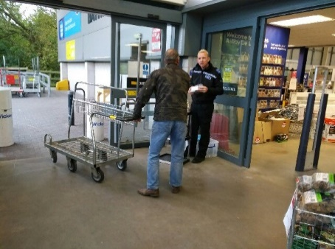

We are promoting were possible take tools into the house, if not park doors tightly against a wall or another vehicle, to make it harder for thieves.

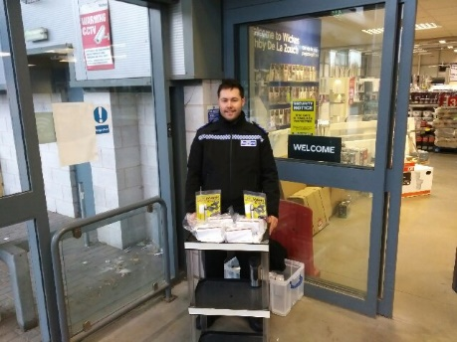
We understand how distressing and inconvenient vehicle crime can be. The more security you put in to your vehicle the less attractive it will be. Protect your vehicle with recommended products.
For more help and advice visit our website at https://leics.police.uk/advice-and-information/crime-prevention/vehicle-crime
You can report suspicious incidents on 101, if you know who is stealing or selling stolen property call us. Or you can report anonymously to Crime Stoppers at:
https://crimestoppers-uk.org/?gclid=CNaVsKCL8tUCFYO77QodjCQLnw
Denying criminals use of our roads

On Monday 2/10/17 & Tues 3/10/17 we ran Operation Humous to deny criminals the use our roads. Our Neighbourhood officers worked with other agencies at several locations across Leicestershire, including North West Leicestershire.
We arrested 7 people, for burglary offences, theft of motorbike, thefts and damage. We also seized a further 7 vehicles with either no insurance or tax.

Tackling Anti-Social Behaviour

On the Evening of Sunday 8/10/17 and overnight
Our Special Constables ran Operation Urge.
This paid attention to reported anti-social behaviour due to
‘car cruisers’ around the Castle Donington area and also
young people gathering in cars at Ashby. A few young people were advised about the community concerns, requested to be considerate, albeit on this occasion those we spoke to did not appear to be involved in ASB.
This summer we have issued 48 ASB advice and/or warning letters to young person’s causing a disturbance near to the Bath Grounds in Ashby.
We continue to discourage the purchase and use of off road bikes. Often it is young people ‘trespassing’ on land and committing traffic violations by riding on paths and roads. NWLDC kindly included an article in their tenancy magazine and with the help of our volunteer we have been delivering leaflets in areas affected, where we believe some riders are locals.
We have given Section 59 notices (seizure of vehicles used in manner causing alarm, distress or annoyance) to 4 offenders

Traffic matters

The Traffic Management Department lead on Community speeding concerns. On occasions they ask for support at some locations where it is assessed not requiring enforcement vans. Our Specials have been providing further support to address community concern over speeding. They have completed checks in High Street/ Hill Top Castle Donington (B6540), Rawdon Road Moira, Ryecroft Road, Hemington, B5324 Belton, Bosworth Road Measham, Atherstone Road/ Burton Road Measham, Ibstock Road Ellistown, Spring Lane Swannington, B586 Measham Road Moira, Pisca Lane Heather, Mill Lane Heather and Leicester Road Ashby.
Speeding concerns can be report at speed@leicestershire.pnn.police.uk

Screening for Drug Driving

Driving under the influence of drugs is regrettably a growing national problem. We are currently training our officers in use of the new roadside testing kits.

Public Safety

On 7/9/17 the Police, NWLDC licensing department and the Driver Vehicle Standard Agency (DVSA) ran checks on taxi and public service drivers near to East Midlands Airport. A total of 138 licensed vehicles were inspected.
One vehicle was seized as the driver was uninsured. Four vehicles received prohibition notices. Two drivers were reported for no road tax and another was issues with a fixed penalty notice for a tyre significantly below the legal limit. Notifications were also issued regarding minor defects.

Domestic Abuse

Tackling Domestic Abuse is a national priority for the Home Office, Police, Neighbourhood Watch and Crimestoppers.
Neighbourhood Watch is working with Crimestoppers to raise awareness about domestic abuse and what our supporters and volunteers can do to help prevent and report it.
We would be grateful if you could spend just 3 minutes completing this survey, the results of which will help us to signpost people to the right place to report their concerns. Your responses are completely anonymous.

You can complete the survey by clicking on the link below.
https://www.surveymonkey.co.uk/r/NWN-DV-Survey

Halloween, Trick or treat

Halloween can be a lot of fun. We do ask our young people and
parents to respect that not everyone wants to take part.
Some people can also find it frightening, particularly the elderly.
We know we can count on the support of our shops not to sell eggs
and flour to young people planning to use it for the wrong purpose.
Many will be display posters to this effect.
If you don’t want trick or treaters at your house you can collect a
sign for your window from NWLDC police desk or down load & print one off from our website.
https://leics.police.uk/information-and-advice/library/posters

Educating North West Leicestershire

Stephenson College, Youth Service Impact Team, the police and North West Leicestershire Community funded and provided workers to run a 10 week Girls Project. It introduced attendees to work related education whilst offering education on risky behaviours.
Those that successfully completed the course culminated in an awards ceremony and a parade of their artistry in the use the ‘make-up’ techniques they had learnt. I had the honour of presenting certificates to ‘Stars’ that could have been cast from West end show. Their commitment was rewarded with some professional beauty products.
Importantly all of the girls that attended and applied for a course successfully secured a place that includes work placements. Research shows that those involved in apprenticeships are less likely to become involved in crime.

The staff that arranged and ran this course were nominated for the Police & Crime Commissioners Neighbourhood team of the year award and were highly commended runners up. Well done Janet Pallett (King Edward), Helen McNulty (Impact), Matt Suffolk, Elena Chambers & Luke Broughton (Police) and Jane Harwood Stephenson College.

Thank you to Storey Arms public house, Osgathorpe

Who hosted a beat consultation and engagement event. PC Jason Underwood was very pleased with the support from local councillors and residents. He provided crime prevention information to 25 people and gave information on how to join Neighbourhood Watch
https://leics.police.uk/advice-and-information/information-zone/neighbourhood-watch
Coalville Police Station
The new extension being added to LFRS building to accommodate Police Officers is progressing well.
. 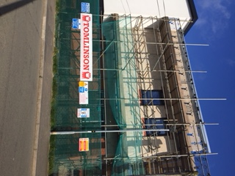 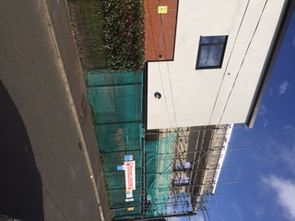 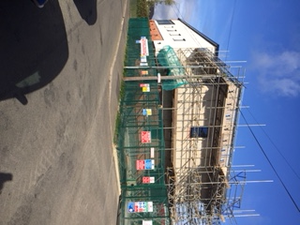
New officers:
I am pleased to welcome some new police community support officers to the team:
PCSO Tiffany Lloyd, PCSO Samuel Carter, PCSO Lynette Rose, PCSO Dale Collington and PCSO Robin Benson
They are undergoing their training and you will see them about in company with our experienced staff. Why not visit our local Policing page and find out who your dedicated Neighbourhood officer is and how to contact them. https://leics.police.uk/local-policing

That’s all for now, whatever your plans have fun but don’t to forget
‘Celebrate Safely’

Helena Bhakta
Commander – North West Leicestershire Neighbourhood Policing Area
You can follow me on twitter: www.twitter.com/nwleicsnpa
or visit our Facebook page: www.facebook.com/NorthWestLeicsPolice/
Lorry Watch
Working with the Parish Council, having been made aware of perceived HGV travelling through the village, the beat team are closely monitoring the situation and with the launch of the ‘Lorry Watch’ scheme are pleased to report that a number of residents have passed comment on the noticeable reduction in HGV movements.

Operation Obedience

Following a number of complaints from residents with regard to Vehicle ASB in and around the Station Rd and the Broad Meadows/EMDC Trading Estates the beat team gathered informative and valuable intelligence which enabled the hard targeting the problem as part of Op Obedience which has so far been successful if somewhat a major demand on deployable resources.

The team get assistance from Special Constables and are pleased to report further vehicles have been stopped and dealt with appropriately since in addition to those previously reported.

The area is remains on the EMOps Traffic brief who will be carrying out patrols at the appropriate times.

This has now been given a beat priority – there have been some 80+ reports of vehicle ASB in the last year, and as such, the Beat Team are working closely with NWLDC in applying for a High Court Injunction (with the power of arrest) to ban ‘Car Cruise’ type ASB District wide. PCSO Bradley is currently collating and creating a combined file for presentation to the District Council’s Legal Team in preparation for a court appearance.

This Sec222 Injunction has been used successfully by a number of City and County Councils across England and Wales.

PREVENT

“PREVENT is safeguarding against terrorism,

SAFEGUARDING is everyone’s responsibility.”

Working with partner agencies and neighbouring Parish Councils local key members of the community have been invited to attend a PREVENT initiative event which will discuss and explain Cyber/Internet Safety/Child Exploitation and the Prevent Duty in more detail.

Prevent is aimed at stopping people becoming radicalised and to support those at risk and most importantly to provide safeguarding interventions to those in need! In doing this many Prevent qualified individuals provide training to schools in order for teachers to recognise signs of radicalisation and what factors may make certain people more vulnerable. All schools are taught the Fundamental British Values (age appropriate depending on year group) in order to educate and protect ALL generations and encourage them to respect others.

It is important to raise awareness in the local communities, in the exercise of their functions and their need to have due regard to prevent people from being drawn into terrorism. This sounds very high level and convoluted, but there is a proven need locally to raise awareness of Cyber and Internet Safety, Child Exploitation and Radicalisation.

Everyone should have a willingness to understand/learn about these dangers in order to safeguard those most vulnerable.

Members of our local Police Force and NWLDC will provide sessions on Cyber/Internet Safety/Child Exploitation and the Prevent Duty with a chance for local groups and people to network and promote their own groups during the break.

The idea is to raise awareness of the need and then to help facilitate and promote the work within the schools through the plays put on by AlterEgo – “Going to Extremes and Chelsea’s Choice” and ensure that as many parents, carers and residents get the chance to access and view this information.

The event will be held on Tuesday 14th November at 7pm-9pm at The Spital Pavilion, Castle Donington, DE74 2NQ.

Arrival 6.30pm for tea, coffee and networking.

As an important member of your local community we hope that you accept that safeguarding is EVERYONE’S responsibility and that you and your colleagues will be able to attend.

Please confirm your attendance by Monday 6th November 2017, to either clerk@breedonparishcouncil.org.uk/

parishcouncil@lwdpc.org.uk/

clerk@cdpc.org.uk.
This event was made possible by the parish councils listed above; the local Police Team and NWLDC.

WE’D LIKE TO MEET YOU

We hold regular beat surgeries and engagement events.
Monday 6th November 5pm – St Hardolph’s School (Parents evening)

Saturday 9th December 1pm – Belton Beat Surgery at Convenience Store

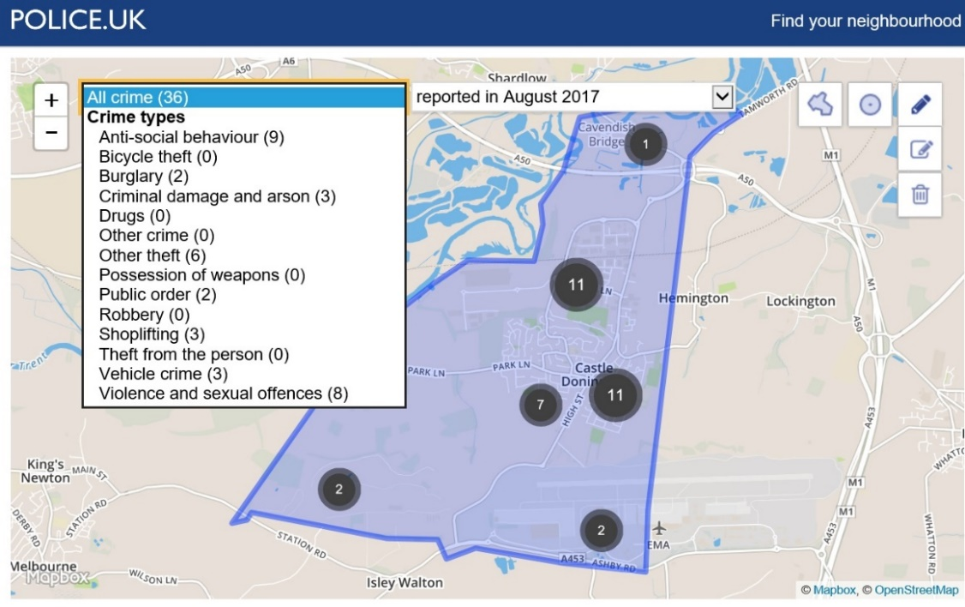

3872/17 CONFIRMATION OF THE MINUTES
RESOLVED: To receive and approve the minutes subject to the following amendments:
- Full Council – 28 September 2017
3854/17 d) Should read – that several meetings had been cancelled lately and there had been resignations culminating in no recent meetings.
3858/17 – Remove the word iron
3859/17 – Include to plant new trees for future use
- Community Hub Working Party – 24 October 2017
3/17 – Bottom point should read this area will be filled…..
3873/17 CLERK’S REPORT
- Comments Register: RESOLVED: To receive the information.
18 September | Complaint |  | Complaint received regarding lack of footpath on grassed area on Canberra Close.
 | Resolved |  | CDPC confirmed that no footpath was to be installed as other routes were available
25 September | Complaint |  | Complaint received regarding hedger cuttings left on Stonehill.
 | Resolved |  | Email sent to NWLDC to resolve.
02 October | Complaint |  | Complaint received regarding rats affecting surrounding properties on Station Road and Spital playing fields.
 | Resolved |  | Report sent to NWLDC to investigate.
03 October | Complaint |  | Complaints received regarding dog fouling on Spital playing fields resident had evidence.
 | Resolved |  | CDPC forwarded resident on to NWLDC.
05 October | Complaint |  | Complaint received regarding lorry causing damage to sign and bollard whilst in a weight restricted area
 | Resolved |  | Report sent to LCC to request repair of sign and bollard
06 October | Complaint |  | Complaint received regarding hedge on Lothian Place encroaching onto the pavement and making access difficult
 | Resolved |  | Report sent to LCC to investigate and rectify.
13 October | Complaint |  | Report form received regarding HGV weight limit breach on Station Road.
 | Resolved |  | Email sent to traffic management officer to investigate.
24 October | Complaint |  | Complaint received regarding bins on Wakefield Court not being returned
 | Resolved |  | CDPC contacted NWLDC to resolve
 | Update |  | Update received from LCC with regard to Lamp post on Footpath L92 saying works have been completed.
 | Update |  | Update received from LCC with regard to lamp out on Hillside confirming works have been completed

- Approving of committee minutes:
At last month’s meeting, it was reported that minutes from a committee meeting should be approved only by the committee and thus if they are presented at Full Council they should only be received. This is per LRALC newsletter 4.
Upon further investigation, I would suggest that this advice is incorrect or at best open to interpretation.
The actual statutory guidance states:
“The draft minutes of a meeting must be formally approved by the next suitable meeting and duly signed by the chairman of the meeting ………….”
This could obviously be interpreted in a number of ways, but the statutory guidance states “suitable meeting” therefore my advice is that it is totally acceptable for all minutes to be approved at the next full council meeting as is the current practice. RESOLVED: To receive the information.
- Traders Meeting – First meeting of the new Traders Group. Presentation given by Lindsey Newman-Wood on the benefit of Social Media. Very interesting and informative. Something that the Parish Council could also benefit from. She explained about identifying target audiences, building relationships, improving customer services, paying for services such as the “Boost a Post”, etc.
The Traders also discussed about a “virtual tour” of their premises using YouTube platform. This is something that the PC could do for the village, its services/premises and the village businesses? Not sure how, but worth investigating.
Also, Google My Business is something that can enhance the way people find your business service.
Facebook needs to be used more to get more visitors etc. It can be used in conjunction with SnapChat and should create “stuff” people will like/interest – not just the formal stuff – sometimes a light-hearted picture/caption can get people’s attention better than full page of words! Encourage people to share, by perhaps using a competition?
Marks and Spencer attended the meeting and are keen to be involved.
The Traders are looking at creating a leaflet that outlines the village centre and all the businesses. Phil from Once Removed is working on this. Marks and Spencer have offered to share the leaflet once produced, share any information about business, leaflet etc, information put on power points, etc via their screen within the facility of in the canteen.
The Parish Council Christmas Cheer event was discussed and how the Traders can become involved this year and in the future. This year they are to include all shops to open and participate in the shop window competition and kid’s competition. Create publicity that will advise customers that they are looking at doing late night shopping experience. In the future, they have realised that there are opportunities to do more and expand the experience for their customers. RESOLVED: To receive the information.
- The East Midlands Gateway Infrastructure Team has given the Parish Council a contribution of £1,000 to towards Christmas festivities in the Parish. RESOLVED: To receive the information.
- Clerk and Cllr Ambrose-Jones attended a small lunch meeting at the Priest House given by the Airport. EMA is keen to have an open dialogue with its closest neighbours and they believe that face to face opportunities are a good way to keep in touch. Very enjoyable and informative and also a chance to meet other clerks and chairman. RESOLVED: To receive the information.
- The Clerk attended Annual Conference. Very informative and interesting discussions, although the new two-day format didn’t seem to catch enough of the major speakers that have been present before. Information gained that may help with providing a transport scheme for the Hub, will be very useful. RESOLVED: To receive the information.
- The Clerk, Deputy and Admin staff all attended Project Griffin training session put on by the Police. Very informative training session highlighting the need to be aware about Cyber Crime, Terrorism etc. RESOLVED: To receive the information.
- Ulyett Landscapes – A new grounds maintenance manager has been appointed – Craig Clapperton is moving on and Fred Parker is taking over. Fred is currently the head groundsman; therefore, a new head groundsman will need to be appointed too. Once all the new people are in post, a meeting will be arranged to introduce them to the Parish Council’s grounds man. RESOLVED: To receive the information.
- Cemetery House – Discussions have taken place with the prospective new tenants; draft terms of reference have been issued and a draft agreement has been sent to the tenant’s solicitor. The amount of rent was agreed as suggested at the last meeting with the aim that the new tenants can move in as soon as is practicable. Various health and safety reports need to be undertaken i.e. asbestos, electrical, gas and these will be completed over the next few weeks. RESOLVED: To receive the information.
- Parish Rooms – A number of viewings have taken place, from interested parties looking for residential conversations, to different types of business, etc. One offer has been made, considerably lower than the asking price, so they were told to go away and reconsider as the offer was not acceptable. RESOLVED: To receive the information.
- Meeting with Miller Homes regarding the application for 895 houses off Park Lane. The development should recommence early 2018; the main delays have been around the sale contracts on the various parcels of land within the application site. The strategic landscape plan is currently being prepared and should be ready by the end of the month. The bypass road will be started at the Hill Top end and be built in full; there will be no additional road closures. The housing development itself, will commence early to mid-2018 and will necessitate some construction vehicles to access off Park Lane; they are still working with NWLDC in terms of the construction traffic plan. Questions were asked about the public open space (pitch area – off High Street) as to the suitability of the site to provide for 2 full size pitches, and changing rooms and when this site might become available to utilise. It may be possible to renegotiate the terms of the Section 106 to obtain this provision. The traffic calming/sign schedule/design was discussed and what has already been approved or designed and how this might help provide a safe crossing to the new Community Hub. Copies of the approved Phase 1 and the up to date Masterplan were requested; these will be sent by email and hard copy. RESOLVED: To receive the information.
- £20,000 for Seven funding for a 3G pitch. The time has lapsed for this project due to the changes with funding from the Football Foundation being able to support. Although, the Parish Council could potentially apply for an extension, it is unlikely that a project could be completed in the extension period. Currently options are being investigated that would allow another “project” to be applied for, perhaps something at the Community Hub via the same scheme or whether the Parish Council can enter in to a dialogue to obtain a similar amount, but from another pot available at NWLDC. RESOLVED: To receive the information.
- £20,000 for Seven funding for the Library – They are looking to ask for an extension due to the move to the Hub. RESOLVED: To receive the information.
3874/17 CHAIRMAN’S REPORT
- Christmas dinner social for Parish Councillors/staff – Further venue suggestions were made and update to be given once investigated. RESOLVED: To receive the information.

3875/17 Representatives' Reports, including reports from LCC and NWLDC councillors
    - East Midlands Gateway – Roxhill/Sergo – Community Liaison Group
A453 contraflow scheduled to be removed October 30th (will then take one week to repair central reservation, crossing points and crash barrier) so will be two lane dual carriageway again from November 6th. Entrance to site will be from the roundabout on A453, i.e. its official entrance from this time. (not Church Street, Lockington).
At this time works to junction 24 roundabout will commence and starting at A6 and working its way round the junction. This is scheduled to go on for a year. Chances are Castle Donington will suffer as before when junction 24 work was done, expect this for 12 months.
M1 Smart motorways is due to finish in December 2018. After this time we should expect traffic flows to be considerably better.
Kegworth bypass now commenced by a company called Buckingham.
The bridge over the M1 is being built in a field in Kegworth and will be installed over a long weekend in May. It will be driven into place, although an engineering marvel we are advised it is not a spectator sport as it will take 36 hours to put in place. M1 will be closed for 4 days. Highways England would prefer this to be Bank Holiday weekend but events at Donington Park suggest it won’t be.
Ashby Road will close in May and thereafter only be accessible to buses, bicycles and pedestrians.
To date 1.8 million M³ of soil has been moved, as reported before the need to have the depth dug for the railway means additional bunding at the edge of the site. Grass seed to southern border already started and it is hoped shrubs and trees will be planted in December.
Roxhill remain hopeful that building work on Units 1 & 2 (unofficially Amazon and Nestlé) will commence in January.
Final train operator to be chosen in next quarter from a short list of 3. RESOLVED: To receive the information
    - LCC – Big discussions. Cllr Sizer and the Clerk attended this event. This was a follow up from some earlier meetings with Parish Councils. Very little was gleaned from the discussions, as after the initial discussion centring around the fact that the LCC still needs to make savings, most attendees raised issues and concerns that were personal to their parish. RESOLVED: To receive the information
    - Cllr A Saffell reported about the NWLDC decision to approve a new leisure centre in Coalville; he explained about the costs and funding and advised that this project would take until 2018 to come to fruition. RESOLVED: To receive the information.
    - Cllr C Hills reported on several issues surrounding the Section 106 for the 275-house development off Park Lane. The library has had issues in that it was forced to spend money or lose it; money spent by LCC when it is earmarked for Castle Donington; highways money that has not been spent and it is unclear as to where this money is or what has been done with it. RESOLVED: To receive the information with forthcoming updates in due course.

3876/17 ACCOUNTS
- Payments scheduled for October 2017 including the payment of October wages. RESOLVED: To approve the payments for October 2017 including the payment of wages.
- Bank reconciliation as at 19 October 2017 including a list of receipts to date. RESOLVED: To receive the bank reconciliation and list of receipts as at 19 October 2017.

Voucher/ Cheque No | Description | Supplier | Totals
Refund | Electricity Hub | British Gas | -547.15
 | Bank Charges | HSBC | 30.09
3018 | Poppies | Royal British Legion | 150.00
3019 | Scribe Licence | Scribe 2000 Limited | 584.40
3020 | Computer Costs | SC IT Solutions Ltd | 30.00
3021 | Grounds Maintenance | Ulyett Landscapes Ltd | 5,365.80
3022 | Advertising | Rural Trader (UK) Ltd | 595.20
3023 | Painting at Spital park pavilion | Travis Perkins Trading Co Ltd | 70.80
104926 | Flowers | Buddies Florist | 25.00
3024 | May Market help | Robert Holman | 50.00
3025 | Fencing Work | Ilkeston Fencing Ltd | 4,260.00
3026 | Materials | Melton Hardware Ltd | 259.20
3027 | Trade Reuse/Container Hire | NWLDC | 2,166.06
3028 | Signs | Sign it (Nottm) Ltd | 168.00
3029 | Conference expenses | SLCC Enterprises Ltd | 444.00
3030 | Materials | Travis Perkins Trading Co Ltd | 84.11
3031 | Fuel | Martyn Lee | 85.15
3032 | Music in the Park | Fiona Palmer | 153.27
3032 | Cleaning materials - Office | Fiona Palmer | 2.35
3033 | Cleaning materials - Spital | Censol Ltd | 524.50
3034 | Stationery etc | Viking | 102.77
3034 | First Aid Kit | Viking | 40.25
3034 | Stationery etc | Viking | 69.54
3034 | Stamps | Viking | 56.00
CCard | Curtain pole | Poles Direct | 443.56
CCard | Portable toilets | Perfect Associates Ltd | 283.79
CCard | Door handles | Screwfix Direct Ltd | 131.96
Ccard | Internet charges | Heart Internet | 16.19
DDOct01 | Telephone | BT | 269.68
DDOct02 | Telephone | BT | 105.95
DDOct03 | Telephone Spital | BT | 84.88
DDOct04 | Electricity | SSE | 422.25
DDOct05 | Gas Office | SSE | 46.96
DDOct06 | Electricity | SSE | 87.29
DDOct07 | Electricity | Eon | 39.44
DDOct08 | Council Tax - Cemetery House | NWLDC | 127.65
DDOct09 | Rates Community Hub | NWLDC | 1,653.00
DDOct10 | Rates Cemetery | NWLDC | 32.00
DDOct11 | Rates Office | NWLDC | 45.00
DDOct12 | Water office | Water plus | 62.50
DDOct13 | Water Spital Store | Water plus | 18.45
DDOct14 | Mobile Phone | EE | 29.16
 | Electricity | SSE | -27.94
 | Electricity | SSE | -6.86
DDOct15 | Pension | Aviva | 33.00
3035 | Keys | AA Locksmiths (East Midlands) | 12.00
3036 | Sound system | Consultec | 50.00
3037 | Accountancy Fees | Grant Thornton UK LLP | 1,920.00
3038 | Temporary Staff | Jane Hancox | 300.00
3039 | 1st aid | Elliot Frampton | 550.00
3040 | Hanging Baskets | Plantscape Ltd | 1,117.80
3041 | Advertising | Rural Trader (UK) Ltd | 384.00
3042 | Road closure order | Trinity Mirror Publishing Ltd | 1,086.17
3043 | Stationery etc | Viking | 68.22
104927 | Grant St Edwards | St Edwards Friends of the School Assoc | 500.00
3044 | Wages | Staff | 7,746.49
3050 | Tax and NI | HMRC | 1,915.40
 | Pension | Aviva | 280.29
3051 | Help at events (Wakes & Xmas) | Robert Holman | 100.00
 |  | Totals | 34,697.62

3877/17 to consider grants
  - St Edwards church – Annual grant for lighting. Additional information has been received from the treasurer confirming that they had only received of the grant for 2016-17 and none for 2017-18. RESOLVED: To not approve a grant of £400 towards the cost of lighting the church for 2016-17 (£300 approved last month without the full facts) as this funding had not gone in to the pot when the Precept was set for this year. RESOLVED: To approve £525.00 for the clock maintenance and lighting for 2017-18.
  - Rural Community Council – Annual subscription. RESOLVED: To approve the annual subscription of £50.00.
  - CD Museum – Annual grant. Copy of accounts seen. RESOLVED: To approve the annual grant of £1250.00.

3878/17 Community Hub
- Update on change of use and new build planning application was approved on 13 October 2017. RESOLVED: To receive the information.
- Update on the Mechanical and Electrical design scheme. No further update, meeting arranged for 6 November 2017. RESOLVED: To receive the information.
- Update on full building contract tender process and timelines. No further update, meeting arranged for 6 November 2017. RESOLVED: To receive the information.
- Report on most of these matters contained in Working Party minutes. RESOLVED: To receive the information. Next meeting will be on 6 November 2017.
- VAT – The partial exemption calculation is progressing, and everything looks on track. The discussion around how VAT will be applied on the Community Hub in such a way that it allows for it to be reclaimed on the redevelopment have concluded (subject to anything that might be raised when the partial exemption is complete). This means that the building will need to be registered to charge VAT on all room hiring; the Library and Volunteer Centre will be charged a “peppercorn” – basically a £1.00 to the VAT is minimal. Private lettings of the main function room will incur VAT to be charged at the standard rate, currently 20%. RESOLVED: To receive the information.
- Legal agreement – Discussions are taking place with the legal team currently, now the VAT situation has been resolved. A draft head of terms will be drawn up and given to the users. This is likely to be a “work in progress” for a while. RESOLVED: To receive the information.

3879/17 PLANNING APPLICATIONS
RESOLVED:
17/01480/CLE | Stable Grange, Kings Mills, Park Lane | Certificate of lawful existing use as C3 (dwelling house) | No objection
17/01583/FUL | 7 Monteith Place | Erection of a two storey side and rear extension | No objection as long as no neighbour objections
17/01598/NMA | 35 Hastings Street | Non-material amendment to planning permission 15/01172/FUL to allow for amendment to back door positioning and window arrangement and the addition of 2 no. roof lights | No objection

3880/17 PLANNING DECISIONS
RESOLVED:
17/00804/FUL | 4/6 Borough Street | Alterations to shop to provide additional floor space, revised lobby, replacement side windows and carport to store | CDPC is unable to submit comment due to the relationship with the owner | Approved
17/01170/TCA | 51 Bondgate | Felling of 4 no. trees (Unprotected trees in a conversation area) | No objection - Polite request that trees are replaced | Approved
17/01206/RET | 7 The Hollow | Retrospective application for the retention of single storey rear extension | Objection - unsuitable style extension within a conservation area and not in keeping with surrounding buildings | Approved
17/01135/ADC | DHL Aviation Building | Display of non-illuminated signage comprising a refurbished aeroplane tail fin | No objection | Approved
17/00814/FUL | Tudor Inn Hotel | Change of use from Pub to Parish Community Centre, erection of single storey storage building including demolition of existing garage, extension to function suite, replacement windows, removal of tree in Conservation area and use of car park for farmers market | For information only | Approved
17/01076/FUL | 38 Ferrers Close | Erection of two storey side extension | No objection | Refused
17/01259/FUL | 12 Borough Street | Erection of a single storey rear extension | No objection - as longs as in style and appropriate materials within conservation area | Approved
17/01287/RET | 101 Bondgate | Retrospective engineering works to alter the ground levels and erection of retaining wall, fence and creation of new vehicle parking area with access off The Spittal (Resubmission) | No objection | Approved

3881/17 Correspondence
- NWLDC Local Plan – The Inspector has now issued his final report: https://www.nwleics.gov.uk/pages/local_plan_examination. RESOLVED: To receive the information.
- NWLDC – Parish Liaison – Does the Parish Council have items it would like to include on the next agenda? Plus does the Parish Council have anything it would like to include in the 12-month celebration of partnership working? RESOLVED: To receive the information.
- British Legion – Invite to Remembrance Day Parade and evening service on Sunday 12 November; plus update on parade stewarding issues. The Parade is being supported by the Leicestershire and Rutland 4x4 Response Team and Marks and Spencer staff, including ex-servicemen. RESOLVED: To receive the information.

Meeting closed 8.55 pm

