Castle Donington parish council

Minutes of the Full Council Meeting held on Thursday 1 February 2018 at 7.30 pm at the Parish Rooms, Hillside, Castle Donington

present : Cllrs R Sizer (in the chair), S Ambrose-Jones, M Barker-Lane, C Burton, G Dalby, R Else, G Roberts, A Saffell and A Sowter. Cllr R Canny, NWLDC, Cllr D Harrison, NWLDC and 1 member of the Public.

apologies: Cllrs N Daykin (illness), D Groom (illness), C Hills (illness), R Nickless (work) and D Wintle (illness). Cllr T Pandleton, LCC (work). Police (illness).

DECLARATIONS OF INTEREST:
Cllr S Ambrose-Jones declared a non-pecuniary interest in planning applications 18/00049/FUL and 18/00094/FUL
Cllr G Roberts declared a pecuniary interest in relation to a cheque payable to his company
Cllr A Saffell declared a non-pecuniary interest in the matter relating to staff wages as his daughter is employed by the Parish Council.
Cllr R Sizer declared a non-pecuniary interest in planning decision 17/01676/FUL
Cllr A Sowter declared a pecuniary interest in relation to planning application 18/00094/FUL. Cllr A Sowter left the room at this point and took no part in the discussion.

3917/18 POLICE MATTERS
- No one present from the Police, the Clerk gave an update on the report.
RESOLVED: To receive the report:

Crime Figures:-
Please visit this link for the most recent crime figures in the Parish:-

https://www.police.uk/leicestershire/NN43/crime/+4JZHs9/

CRIME PREVENTION ADVICE:-
“Lock up and light up”.
The daylight hours have now reduced during the winter months and we would like to remind residents to take steps to reduce the attraction of their properties being in darkness and appearing to be easy targets for burglary. If your property appears occupied then it is less likely to be targeted. There are a number of devices you can obtain to assist you in keeping your property lit during the hours of darkness such as appliance timers and “fake TV” type devices. Please make use of your home alarm systems and look out for your neighbours. Remember to enter / update your property on www.immobilise.com

North West Leicestershire has seen an increase in the number of thefts of Vehicle Registration Plates. ALL residents are reminded that the Local Police Teams have an arrangement with Coalville Tyre and Exhaust to fit Tamper Proof Screws FREE OF Charge.

Coalville Tyre & Exhaust
206 Central Road
Hugglescote
Coalville
LE67 2FG
MEET THE BEAT TEAM-:
08/02/18 1230hrs Castle Donington College
21/03/2018 1730hrs Belton Primary School
21/03/2018 1930hrs Coleorton - The Moorlands
14/04/2018 1030hrs Sawley Marina
02/06/2018 1030hrs Kegworth Fun Day – Sideley Park
24/06/2018 1100hrs Breedon Village Fete
01/07/2018 1300hrs Music in the Park – Castle Donington
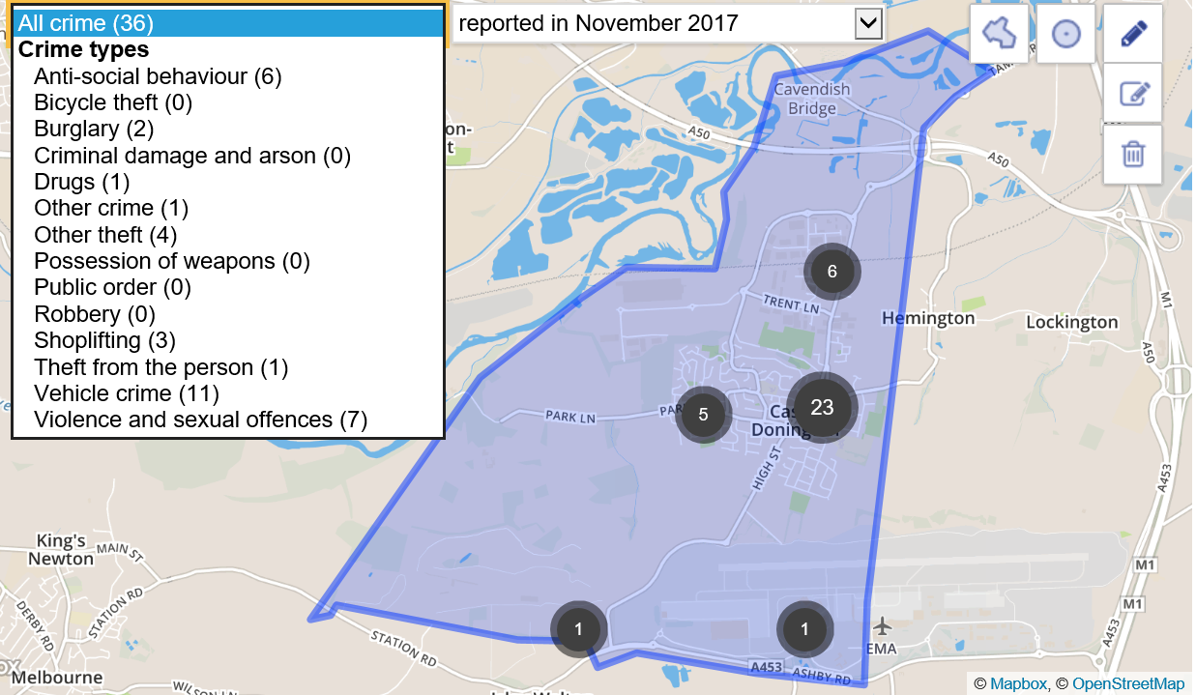
3918/18 CONFIRMATION OF THE MINUTES
RESOLVED: To receive and approve the minutes:
- Full Council – 21 December 2017
- Full Council – 24 December 2017
- Full Council – 25 January 2018

3919/18 CHAIRMANS REPORT
- Meeting with LCC re High Street junction and Section 106 £250k – the meeting is scheduled for Monday 5 February to discuss the history, ideas of how to improve the junction, monies etc. The Clerk to update at next meeting. RESOLVED: To receive the information.

3920/18 CLERKS REPORT
- 895 Houses/Relief Road – the Clerk advised that the section of relief road from Hilltop to Park Lane is due to start February/March and houses to commence being built around March/April with works scheduled for approximately 20 months. RESOLVED: To receive the information.
- Letter of thanks had been received from the Sailors and Soldiers for the Small Grant received. RESOLVED: To receive the information.
- An invitation from Atithi restaurant for Councillors and staff to attend the premises had been received however the premises are currently closed. RESOLVED: To receive the information.
- £20,000 for Seven Grants – the Parish Council extension of grant for 3G has been declined as project will not be able to progress within the timescales; however, the Library has had its grant carried forward, therefore, the Parish Council needs to carry forward the matched funding for this grant as previously agreed. RESOLVED: To receive the information.
- Letter of thanks had been received from the Royal British Legion on behalf of the Lamp Post Poppy Campaign. This raised in the region of £5000 throughout Leicestershire, a great achievement in its first year. RESOLVED: To receive the information.
- Letter of thanks for the grant given to Citizens Advice Leicestershire had been received. RESOLVED: To receive the information.
- Letter of thanks had been received for Diamond Wedding Flowers presented to Mr and Mrs Pegg. RESOLVED: To receive the information.
- Street Trading application from Hardy Mobile – To confirm the comments made to the Licencing Authority in that the Parish Council has no objections to this renewal (Comment had been requested from councillors by email). RESOLVED: To receive the information.
- Parish Liaison meeting – Minutes now available at https://www.nwleics.gov.uk/pages/parish_liaison. RESOLVED: To receive the information.
- Untidy Premises – Old HSBC building – following complaints received from residents regarding the old HSBC building being untidy etc this was reported to NWLDC who advised that although there are two covers on the old ATM spaces, and some fly posting, this is insufficient to justify enforcement action in the opinion of the Environmental Protection officer at NWLDC. Also, there was no clause included in the original planning application to “make good” the ATM space if subsequently removed. RESOLVED: To receive the information.
- EMA – Has approved sponsorship towards Music in the Park, Christmas Cheer and the provision of a new notice board at the hub in the sum of £750. RESOLVED: To receive the information.
- Final payment from Tesco bags grant scheme in the sum of £2500 had been received as part of the Teqball and gym equipment project at Spittal Park. RESOLVED: To receive the information.
- Snow Warden Scheme – The Parish Council has requested additional areas to be cleared around the village as part of this scheme; these have been approved by LCC. RESOLVED: To receive the information.
- Grit bins – At the last meeting it was resolved to purchase two bins to be placed on the Spitfire Road estate with the LCC maintaining these. However, LCC will not approve the siting of these bins and the maintenance of them until the estate has been formally adopted. Locations on Parish Council owned land are not suitable to place bins in the interim. When the estate is adopted, the Parish Council will apply to have bins placed appropriately. RESOLVED: To receive the information.
- Office sale – lenders valuation had been completed and planning is progressing. RESOLVED: To receive the information.
- Cemetery House – rental agreement documents are complete and in the post for signature on receipt. RESOLVED: To receive the information.
3921/18 REPRESENTATIVES REPORT
- Roxhill meeting – Cllr S Ambrose-Jones report on meeting:
“During and after the meeting at Roxhill we spoke to Rebecca Henson and she confirmed that she would support the re-phasing of the Park Lane/Delven Lane traffic lights and asked if you, Fiona, can confirm who you've been speaking to about it.

We also had a conversation about the cycle path route and Rebecca believes another meeting needs organising on it. FYI she was saying that the route through our allotments meant traversing a third party's property. Bob and I questioned this with her after the meeting as we both believed the Roxhill land borders ours even at the allotments, is this not the case?

FYI Rebecca understands the issue of a tarmac path through a sports field, but because there is 'right of way' LCC does not need to change anything to put the path there. Currently there is no right of way on our proposed alternative. This is not insurmountable, but it did make me think that by doing this we are making a public footpath through the allotments which might not go down well. I am not saying we shouldn't put it there, just that there will be something to 'manage' when we do.

FYI – Kegworth PC has a major project that once the bypass is open they want to totally alter the village entrances at both ends, to make something which really shows that vehicles are entering a village. Although they have the £200k from Roxhill & NWLDC this is a £1 million project!

Update notes:
- A453 modifications just about all done, entrance to site from there opens Monday 22nd January
- Landscaping has started
- First 2 units (allegedly Amazon & Nestle) close to signing, after which buildings will start
- Two more parties very seriously looking which might start by Summer (overall Roxhill are ahead of expectations on building adoptions)
- Work on the rail terminal to start late Spring/early Summer
- Ashby Road will shut in early May until late August
- Whatton Road was closed on 09/01 and will re-open late March
- The M1 is scheduled to be closed on Friday May 11 (my birthday) until late Sunday 13th for the new bridge to be wheeled into place
- With a contingency if something happens (e.g. Motorway accident) the following weekend
- Both EMA and DP are happy as this will not impact on their busier Bank Holiday weekends in early and late May.”
- Volunteer Centre – Minutes of meeting held 15 January available from the Clerk or website. RESOLVED: To receive the information.
- Purple Flag Scheme – Cllr A Saffell advised that Ashby de la Zouch had been awarded the Purple Flag Scheme under a trial process with no charge. Cllr A Saffell advised that following a meeting with NWLDC clarification had been sought as to what was needed in order to qualify. However, if Castle Donington were to look at qualifying then there would be a potential cost involved. RESOLVED: Cllr A Saffell is to review the scheme regulations and criteria and look at what Castle Donington needs to put in place to perhaps meet the requirements in the future.
3922/18 ACCOUNTS
RESOLVED: To receive the information.

Cheque No | Description | Supplier | Total
 | Bank Charges | HSBC | 15.85
3131 | Electrical Works | Beta Electrical Contractors | 220.31
3132 | Electrical Works at the Spital | Beta Electrical Contractors | 159.48
3133 | Electrical Works | Beta Electrical Contractors | 203.57
3134 | Damp proof course | Castle Damp & Timber | 2,150.00
3135 | Annual contract | Chubb | 650.14
3136 | Workwear | Jencourt Group | 188.40
3137 | Road closure order | LCC | 600.00
3138 | Advertising | Rural Trader (UK) Ltd | 446.40
3139 | Computer Costs | SC IT Solutions Ltd | 30.00
3140 | Mats | Target Pest Control & Hygiene Ltd | 112.80
3141 | Materials | Travis Perkins Trading Co Ltd | 45.08
3142 | Grounds Maintenance | Ulyett Landscapes Ltd | 5,365.80
3143 | Stamps | Viking | 49.49
3144 | Hoover parts | Viking | 19.07
3145 | Architect fees | Mark Blood | 1,320.00
3146 | Tree works | Taylors Tree Care | 2,960.00
104940 | Flowers | Buddies Florist | 25.00
3147 | VAT advice | Elysian Associates | 1,140.00
3147 | VAT advice | Elysian Associates | 600.00
3148 | Leaflets | Sign it (Nottm )Ltd | 172.60
Adj | mileage | Fiona Palmer | 216.00
Adj | mileage | Fiona Palmer | 157.50
Adj | mileage | Jayne Mitchell | 18.90
CommCard | Cleaning materials - General | Co-op | 13.93
CommCard | Internet charges | Heart Internet | 16.19
CommCard | Computer software | Freshdesk | 132.03
CommCard | Stationery | Amazon | 3.60
CommCard | Materials | Amazon | 10.95
3149 | Cleaning materials - General | Viking | 37.93
3150 | Prizes & refreshments Xmas event | Fiona Palmer | 14.00
3150 | Postage | Fiona Palmer | 4.40
3150 | Refreshments | Fiona Palmer | 6.20
DDJan10 | Rates Cemetery | NWLDC | 32.00
DDJan11 | Rates Office | NWLDC | 45.00
DDJan12 | Phone | EE | 29.16
3156 | Wages | Staff wages | 6,920.51
3157 | Tax and NI | HMRC | 1,788.59
DDJan13 | Pension | Aviva | 300.14
104941 | Parish Council Contribution | CD Sports & Social Club | 494.93
3158 | Minibus - farmers market | CD Volunteer Centre | 30.00
3159 | NDEPC | Talk Green Ltd | 180.00
3160 | Dog Bins etc | Target Pest Control & Hygiene Ltd | 961.20
3161 | Stationery | Viking | 9.59
3161 | Cleaning materials - Legionella | Viking | 12.67
3162 | Glasses | Fiona Palmer | 18.00
3162 | Card | Fiona Palmer | 3.95
3163 | Electrical Works | Beta Electrical Contractors | 282.00
3163 | Electrical Works | Beta Electrical Contractors | 250.84
3164 | Electrical Works | Beta Electrical Contractors | 249.36
3165 | Electrical Works | Beta Electrical Contractors | 761.76
3165 | Electrical Works | Beta Electrical Contractors | 113.28
3166 | Asbestos removal | M J W Asbestos Removal Services Ltd | 867.00
3166 | Asbestos removal | M J W Asbestos Removal Services Ltd | 867.00
3167 | Book Keeper | Jane Hancox | 277.50
3168 | Christmas Lights | MK Illumination UK Ltd | 10,711.20
3169 | Christmas Lights | MK Illumination UK Ltd | 250.12
3170 | Christmas Lights | MK Illumination UK Ltd | 238.80
3171 | Advertising | Rural Trader (UK) Ltd | 297.60
 |  |  | 43,097.82

- Payments scheduled for January 2018 including the payment for January wages.
RESOLVED: To approve the payments for January. Cllr A Saffell did not vote.
- Bank reconciliation as at 19 January 2018 including a list of receipts to date. RESOLVED: To receive the information.

3923/18 REQUEST FOR A GRANT TOWARDS THE FUNDING OF 35TH ANNIVERSARY CELEBRATION OF THE TWINNING BETWEEN CASTLE DONINGTON AND GASNY
The Clerk updated the meeting on the proposals for the 35th Anniversary celebrations with an estimated total cost of £2500. The accounts had already been provided and £500 had previously been given from the Small Grant Scheme. RESOLVED: The Parish Council approved to give £500 from the General Grant Fund (S137 payment).

3924/18 COMMUNITY HUB
Positive meeting had taken place with Keller Construction the preferred contractor from the tender process for the refurbishment of the hub and an estimated start of middle March was given with a 24 week schedule on a turnkey operation. The building design engineer is to check final details and a Letter of Intent is to be sent. RESOLVED: To receive the information.

3925/18 planning applications

PLAN NO | ADDRESS | DETAILS | OBSERVATIONS
17/01888/AIR | East Midlands Airport, Beverley Road, Castle Donington | Proposed car park relocations and extensions (consultation by East Midlands Airport) | No objection - decision after e-mail consultation with Councillors due to deadline for comment submission
17/01890/TPO | 11 Dovecote | Works to trees (protected by TPO) and unprotected trees in a conservation area | No objection
18/00006/FUL | 28 Tipnall Road | Erection of a single storey side extension | No objection
18/00047/AIR | Dakota Road, East Midlands Airport | Proposed relocation of the Hunger Hangar Café (consultation by East Midlands Airport) | No objection
18/00031/FUL | Land to rear of 107 and 109 Park Lane | Demolition of existing domestic garage and erection of two storey detached dwelling | No objection
18/00049/FUL | 10 Bondgate | Change of use from a shop (Class A1) to a hot food takeaway (Class A5); installation of extraction/ventilation equipment and other external alterations | OBJECT - the Parish Council feels it will have a detrimental effect on residents with Health & Safety, Environmental and Highways issues. Lack of parking, exit on to a major road, parking on double yellow lines, location of extraction unit too close to residential properties, already an excessive number of takeaways within the village and inappropriate / inadequate advertising of planning application.
17/01782/LBC | 6 Apiary Gate | Demolition of outbuilding | No objection
18/00094/FUL | 10 Clapgun Street | Demolition of outbuilding and construction of conservatory | No objection

3926/18 planning DECISIONS

PLAN NO | ADDRESS | DETAILS | OBSERVATIONS | DECISION
17/01676/FUL | 8 Cheribough Road | Single storey rear extension including demolition of existing conservatory | No objection as long as there are no neighbour objections | Approved

RESOLVED: To receive the information.

Meeting closed 8.17 pm

